Field Grown Tomatoes for Processing
Case Study

Introduction to Processing Tomatoes
Field-grown processing tomatoes are an important agricultural crop used to produce tomato paste, peeled tomatoes, diced tomatoes, and a wide range of tomato-based food products. Processing tomatoes varieties are specifically bred for mechanical harvesting, high yields, and efficient industrial processing.
Processing tomatoes are grown throughout the world, with aseptic tomato paste traded as a global commodity. Aseptic tomato paste is produced by sterilising both the tomato paste and it’s packaging separately before combining them in a sterile, airtight environment. This process eliminates harmful microorganisms, allowing the product to maintain its flavour, colour, and quality for 18–24 months without refrigeration.
In New Zealand, Heinz Wattie's is the only remaining processor of field-grown tomatoes. At its Hastings facility, approximately 35,000 metric tonnes of tomatoes are processed each season into tomato paste, as well as peeled and diced tomatoes for canning. While this volume represents only a small proportion of New Zealand's total demand for tomato paste and canned tomatoes, it generates tens of millions of dollars in local economic activity through land use, agricultural inputs, transport, manufacturing, and employment.
The New Zealand processing tomato industry operates in a highly competitive global market where imported tomato paste and canned tomatoes are readily available at relatively low cost. Maintaining local production therefore depends on efficient processing operations, including modern evaporator systems and a reliable supply of steam, typically generated using natural gas, to achieve the high temperatures required for concentration and sterilisation.
Key learning outcomes: Students will be able to
- Describe the importance of the processing tomato industry in Hawke's Bay.
- Explain why Hawke's Bay provides suitable conditions for growing processing tomatoes.
- Describe the stages involved in growing a commercial processing tomato crop, from seedling production to harvest.
- Explain how technology, such as GPS-guided machinery, irrigation systems, and mechanical harvesters, improves commercial tomato production.
- Describe how growers use sustainable practices, including crop rotation, Integrated Pest Management (IPM), biological control, and responsible agrichemical use, to protect crops and the environment.
- Discuss the challenges facing processing tomato growers.

Supporting resources
- Growing Fresh Market Tomatoes Case Study
- Wattie’s cuts more Hawke’s Bay crops (WS)
- Wattie's whopper tomato harvest (WS)
- Activity You are crop agronomist
- Field grown tomatoes CoO.
- Field trip to Field grown tomato (WS)
- Processing Tomatoes questions (WS)
PowerPoints
- Field Grown Processing Tomatoes
- Tomato plant and types
- Tomato P & D management.
References
- Fact sheets on diseases https://www.tomatoesnz.co.nz/biosecurity/endemic-pest-fact-sheet/
- Nutrient Management for Vegetable Crops in New Zealand
Websites
- HeinzSeeds https://www.kraftheinz.com/heinzseed/products
Acknowledgment
Thank you to Heinz Wattie's for providing the information, photos, and videos showcasing how field-grown tomatoes are grown for processing.
Recommendations
Within each case study there are multiple activities for students to complete. We recommend you select the activity or activities that best suit your students.
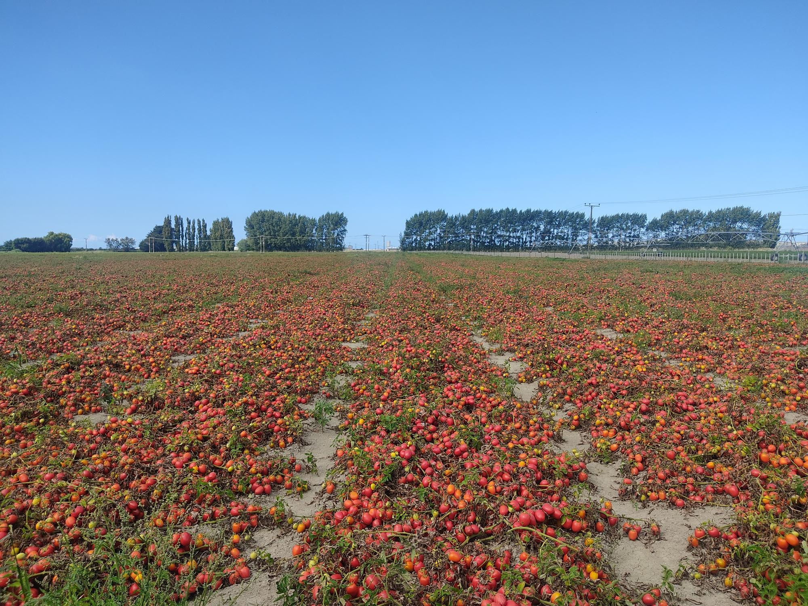

Processing Tomatoes in Hawke's Bay
Processing tomatoes are a frost-sensitive annual crop grown outdoors during the summer months, with the growing season extending from mid-October to April. In New Zealand, commercial production is concentrated in Hawke's Bay, where the warm, dry climate, long sunshine hours, and fertile alluvial soils provide ideal conditions for high-yield field production. The crop is grown specifically to supply the Heinz Wattie's processing facility in Hastings, the country's only remaining processor of field-grown tomatoes.
The industry uses determinate (bush) tomato cultivars, which are genetically bred to grow to a predetermined size before producing a concentrated flush of fruit. This growth habit offers several advantages for commercial production, including reduced crop management, minimal pruning or removal of side shoots, and uniform fruit ripening. Because the majority of the fruit matures over a relatively short period, determinate tomatoes are ideally suited to large-scale mechanical harvesting.
Key characteristics of determinate processing tomatoes include:
- Bushy, compact growth habit.
- Growth to a fixed plant size.
- Concentrated and uniform fruit ripening.
- Excellent suitability for mechanical harvesting and industrial processing.
Most processing tomatoes are Roma or plum-type varieties, although cultivars range in shape from round and blocky to elongated. These varieties are selected because they produce firm, fleshy fruit with relatively low moisture content and high soluble solids, making them highly efficient for processing into tomato paste, peeled and diced canned tomatoes, sauces, soups, baked beans, and other tomato-based products.
Cultivar selection is based on both agronomic performance and processing requirements. Growers and processors select varieties that are well suited to Hawke's Bay's climate and growing season while meeting strict quality specifications, including:
- High soluble solids (°Brix) for improved paste yield.
- High viscosity for paste production.
- Deep red colour and high lycopene content.
- Firm fruit suitable for peeling and dicing.
- High processing yields.
- Strong resistance to common tomato pests and diseases.
- Consistent field performance and harvestability.
Plant breeding plays a critical role in the processing tomato industry. Hundreds of cultivars have been developed worldwide to suit different climates, disease pressures, and market requirements. Breeding programmes continually improve yield, fruit quality, disease resistance, and processing efficiency. In New Zealand, hybrid seed is supplied by HeinzSeed or / and HM. Clause, global breeders and suppliers of hybrid tomato varieties developed specifically for the processing industry. These commercial cultivars are bred to maximise processing performance while maintaining reliable yields under commercial field conditions.
Under commercial growing conditions in Hawke's Bay, processing tomato crops typically produce an average yield of approximately 105 tonnes per hectare. Seasonal yields generally range from 80 to 130 tonnes per hectare, depending on climatic conditions, irrigation management, soil type, cultivar selection, disease pressure, and overall crop management. Achieving consistently high yields requires careful integration of variety selection, crop nutrition, irrigation scheduling, pest and disease control, and timely harvesting.
The combination of Hawke's Bay's favourable growing environment, specialised hybrid cultivars, and modern production practices enables New Zealand growers to consistently produce high-quality processing tomatoes that meet the stringent quality requirements of Heinz Wattie's manufacturing operations while remaining competitive in the global processing tomato industry.
For information on determinate tomato and cultivars refer to
- Growing Fresh Market Tomatoes Case study
- PPT Tomato plant and types slides 5,6, 19-21

Growing Process Tomatoes
Note:
The following information on growing field grown process tomatoes commercially is purposefully generalised. For specific growing requirements information contact and visit a local grower.
The Field Trip to Field grown tomato worksheet provides a set of questions that you can revise to suit your class and the purpose of the field trip.

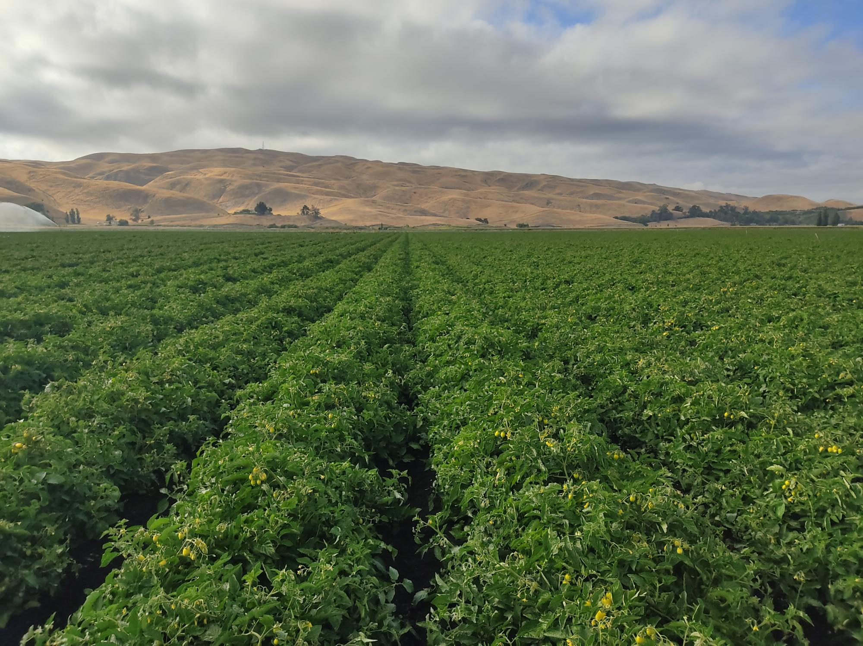
Calendar of operation for seasonally grown field tomatoes for processing
Crop establishment
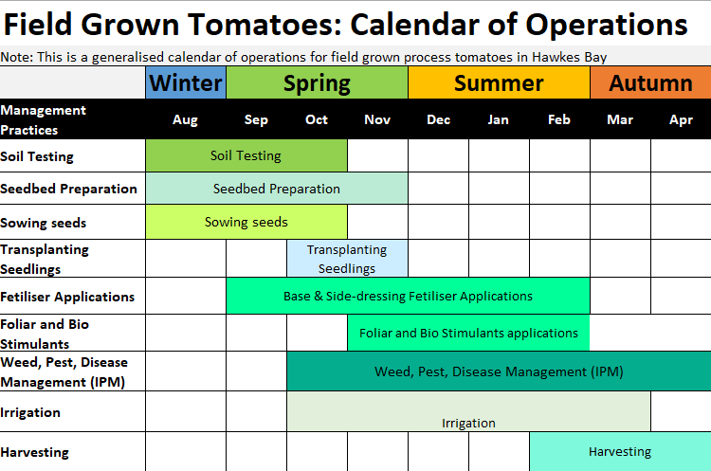
Field Grown Process Tomato Crop Calendar of Operations
Seasonal Crop October to April
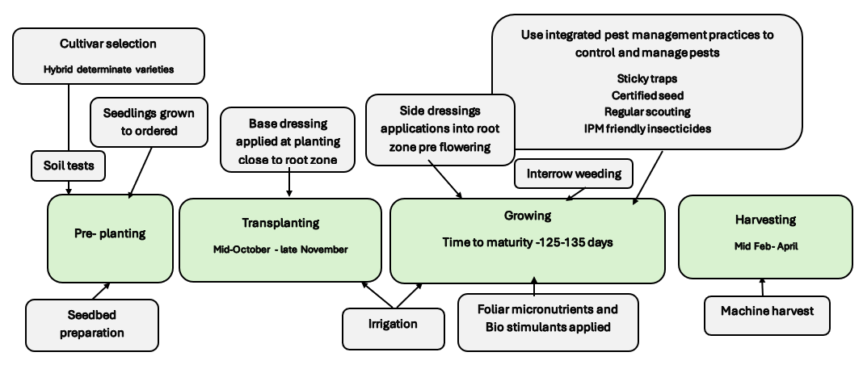
Note:
The calendar of operations outlines the key management practices involved in growing field grown tomatoes for processing. While specific practices may vary slightly among growers depending on the tomato cultivar, and available resources, the overall production system follows a similar pattern.

Processing Tomato Varieties
Processing tomato growers use non-genetically modified organisms (GMO) hybrid varieties developed specifically for the processing industry. Seed is primarily sourced from HeinzSeed, a leading United States-based tomato breeding company, and HM. Clause, an international vegetable seed breeder. These companies develop cultivars that are tailored to different growing environments and processing requirements.
When selecting a variety, growers and processors consider a range of agronomic and quality characteristics, including:
- Maturity period.
- Yield potential.
- Plant architecture and suitability for mechanical harvesting.
- Disease resistance.
- Field holding ability (the ability of ripe fruit to remain on the plant while maintaining quality before harvest).
- Fruit colour and internal colour development.
- Soluble solids (°Brix).
- Fruit firmness.
- End-use suitability, such as tomato paste, peeled tomatoes, or diced tomatoes.

One of the main cultivars grown for Heinz Wattie's in Hawke's Bay is H3402, a HeinzSeed hybrid that has been successfully cultivated for more than 20 years. Its combination of high yield, excellent processing quality, and consistent field performance has made it a reliable variety for New Zealand growing conditions.
The H3402 cultivar is particularly well suited to tomato paste production because of its high soluble solids, firm fruit, excellent colour, and favourable juice viscosity. These characteristics improve processing efficiency by increasing paste yield while producing a product with consistent colour, texture, and quality.

H3402 Cultivar Characteristics
Characteristic | Description
Maturity | Mid-season
Growing conditions | Adapted to both humid and arid environments
Disease resistance | VFFNP (resistant to Verticillium wilt, Fusarium wilt races 1 and 2, root-knot nematodes, and bacterial speck)
Fruit shape | Blocky to oval
Fruit size | Medium
Plant size | Large
Fruit colour | Normal external colour with excellent internal colour development
Fruit firmness | Very high
Soluble solids (°Brix) | High
Juice viscosity (Bostwick) | 12.9 cm, indicating high gross viscosity suitable for paste manufacture

Information on other cultivars refer to PPT Tomato plant and types slides, 19-21

Seedbed preparation
A well-prepared seedbed is essential for establishing a successful processing tomato crop in Hawke's Bay. Tomatoes require a deep, friable soil that provides good root penetration, uniform moisture retention, and adequate drainage. Seedbeds are prepared by cultivating the soil to produce a fine, level tilth that encourages rapid transplant establishment, uniform emergence, and even crop growth. Hawke's Bay's free-draining silt loam and alluvial soils are well suited to tomato production, provided soil compaction is minimised and drainage is maintained, as tomatoes are highly susceptible to waterlogging.
Processing tomatoes also perform best when grown on fresh ground, and a three-year crop rotation is standard practice in Hawke's Bay. Rotating tomatoes with non-host crops helps reduce the build-up of soil-borne diseases, nematodes, and pests, while also improving soil structure and maintaining long-term soil fertility. Before planting, soil tests are carried out to determine nutrient requirements and soil pH, with an optimum pH of approximately 6.0–6.8 for nutrient availability and healthy root growth. Pre-plant fertilisers are then applied according to soil test recommendations close to the root zone. Raised beds are commonly formed to improve drainage, increase soil temperature, and facilitate efficient irrigation and mechanical harvesting. A well-prepared, weed-free seedbed provides the foundation for uniform crop establishment, healthy root development, and high yields required for commercial tomato processing.

Growing
Seedling production and transplanting
Processing tomatoes are established from greenhouse-raised seedlings rather than being direct-seeded into the field. Tomato seed is sown into cell trays at specialist commercial nurseries during late winter, where seedlings are grown under carefully controlled conditions to produce strong, healthy plants for transplanting.
Seedlings are raised from August through to October, with transplanting into the field taking place from October to late November once the risk of damaging frosts has reduced. As tomatoes are highly frost-sensitive, the earliest plantings are typically made in fields with the lowest frost risk and favourable soil temperatures to maximise establishment and early growth.
The time required to produce transplant-ready seedlings varies considerably throughout the season. The first seedlings, sown in late winter, require approximately 65 days to reach transplant size due to cooler temperatures and lower light levels. As spring progresses and temperatures and day length increase, seedling growth accelerates, reducing the nursery production period to around 30 days by mid-October.
Following transplanting, the crop typically requires 125–135 days to reach harvest maturity, depending on the cultivar and seasonal growing conditions. A combination of early-, mid-, and late-maturing cultivars is planted to spread harvest over an extended period and ensure a continuous supply of fruit to the Heinz Wattie's processing factory. Harvest generally begins in mid-February and continues through April, allowing fruit to be processed at optimum maturity and quality.

Nutrient management
Good nutrient management is essential for producing high-yield, high-quality processing tomatoes in Hawke's Bay. Before planting, growers conduct comprehensive soil tests to determine soil fertility, nutrient levels, and soil pH. The results are used to develop fertiliser recommendations specific to the paddock and the crop being planted. Tomatoes generally perform best in soils with a pH of approximately 5.5–6.5, where nutrients are readily available for strong root growth and plant development.
Processing tomatoes are a heavy-feeding crop and require significant amounts of nutrients, particularly nitrogen (N) and potassium (K). Hawke's Bay has a wide range of soil types, from fertile alluvial silt loams to peat soils. While many soils are naturally fertile, some peat soils are low in available potassium and require higher potassium applications to achieve optimum yields and fruit quality.
Before transplanting, a compound NPK fertiliser is applied using GPS-guided equipment, placing the fertiliser accurately within the planting zone where developing roots can readily access nutrients. This precision application improves fertiliser efficiency, reduces waste, and promotes uniform crop establishment.
Nitrogen (N) is important for early plant growth, leaf development, and overall plant health. However, excessive nitrogen encourages vigorous vegetative growth, delays fruit ripening, reduces soluble solids and paste quality, and can increase the proportion of green fruit at harvest. To better match crop demand, nitrogen is commonly applied in split applications, with a base dressing before planting followed by side-dressing during crop growth.
All commercial processing tomato crops are typically side dressed pre flowering, with fertiliser placed directly into the root zone. This ensures nutrients are available during the rapid growth and early fruit development stages when crop demand is greatest.
Potassium (K) is the most important nutrient for tomato yield and fruit quality. Tomatoes require more potassium than any other nutrient, with seasonal requirements typically ranging from 250 to more than 350 kg/ha. Potassium improves fruit size, colour development, firmness, soluble solids (°Brix), and juice viscosity, all of which are essential for efficient tomato paste production.
Phosphorus (P) supports early root development, flowering, and plant establishment. Calcium (Ca) and Magnesium (Mg) are important during flowering and fruit development, with adequate Calcium helping to prevent blossom-end rot. Sulphur (S) is also required throughout the growing season to support healthy plant growth.
Commercial growers commonly use Yara compound fertilisers, which supply major nutrients together with essential micronutrients. Foliar applications of micronutrients and biostimulants are also widely used throughout the growing season to correct minor nutrient deficiencies, improve plant health, enhance stress tolerance, and support crop performance during periods of rapid growth or environmental stress.
Water management is closely linked with nutrient uptake. Processing tomatoes in Hawke's Bay are irrigated because seasonal rainfall is generally insufficient to meet crop water requirements. Water stress reduces nutrient uptake and limits plant growth, while excessive irrigation or poor drainage can damage roots, reduce nutrient availability, and lower yields.
Typical seasonal nutrient requirements for field-grown processing tomatoes in New Zealand are approximately:
- Nitrogen (N): 100–200 kg/ha
- Phosphorus (P): 50–100 kg/ha
- Potassium (K): 250–350+ kg/ha
Successful nutrient management relies on regular soil testing, precision fertiliser placement, correct fertiliser timing, side-dressing during crop growth, and balancing nutrient supply with irrigation and crop demand. By integrating these practices, Hawke's Bay growers consistently achieve high yields while meeting the strict fruit quality standards required by Heinz Wattie's processing operations.

Weed management
Effective weed management is essential for producing high-yield, high-quality processing tomatoes. Weeds compete with tomato plants for sunlight, water, nutrients, and space, reducing crop growth, yield, and fruit quality. They can also harbour insect pests and plant diseases, increasing, the risk of crop damage and reducing overall crop performance.
Commercial growers use an integrated weed management approach that combines crop rotation, seedbed preparation, cultivation, herbicides, mechanical weeding, and regular field monitoring. Maintaining a weed-free crop during the early stages of growth is particularly important, as young tomato plants are less competitive and are more vulnerable to weed competition.
Inter-row mechanical weeding is an important part of weed management in processing tomatoes. Removing weeds between the rows reduces competition for water and nutrients while eliminating host plants that can support insect pests and disease organisms. Mechanical weeding also reduces reliance on herbicides and contributes to more sustainable crop production.
Modern cultivation equipment fitted with GPS-guided steering systems has greatly improved the accuracy of inter-row cultivation. Precise guidance allows machinery to work very close to the crop rows with minimal risk of damaging tomato plants, increasing weed control efficiency while reducing labour and operating costs.
Regular crop monitoring enables growers to identify emerging weed problems early so they can be managed before they affect crop growth or interfere with mechanical harvesting. By integrating cultural, mechanical, and chemical control methods, growers can maintain clean paddocks, maximise yields, improve harvesting efficiency, and produce high-quality fruit that meets the strict requirements of Heinz Wattie's processing operations.

Irrigation
Field-grown processing tomatoes in Hawke's Bay require careful irrigation management because natural rainfall during the growing season is insufficient to meet crop water requirements. Tomatoes typically require around 400 mm of water throughout the growing season, while average spring and summer rainfall provides only about 275 mm, creating a significant water deficit. To maintain healthy plant growth, maximise yields, and produce high-quality fruit, growers use scheduled irrigation to supply water at key stages of crop development.
Processing tomatoes are established from greenhouse-raised seedlings rather than being direct-seeded. Transplanted seedlings establish quickly, allowing the crop canopy to close earlier, which improves water use efficiency, reduces weed competition, and promotes more uniform crop growth.
All commercial processing tomato crops in Hawke's Bay are irrigated using centre pivot or hard hose irrigator systems. These systems allow growers to apply water efficiently and accurately according to crop demand, soil moisture levels, and weather conditions. Irrigation scheduling is carefully managed to avoid both water stress and excessive soil moisture, as either can reduce yield and fruit quality.
A reliable water supply is essential for tomato production. Hawke's Bay benefits from a large underground aquifer that provides irrigation water for many growers. In addition, some growers have invested in on-farm water storage schemes, allowing them to store water when supplies are plentiful and ensuring irrigation is available during dry periods or when water restrictions apply.
Water management is closely linked to nutrient uptake and plant health. Insufficient irrigation reduces nutrient availability, plant growth, fruit size, and yield, while excessive irrigation or poor drainage can damage roots, increase nutrient losses, and encourage disease development.
As the crop approaches harvest, irrigation is usually stopped approximately three weeks before mechanical harvesting. This pre-harvest water cutoff helps concentrate sugars and soluble solids (°Brix), improve fruit firmness, and produce tomatoes that meet the quality specifications required for tomato paste and other processed products.
Careful irrigation management throughout the growing season is essential for producing consistently high yields and supplying Heinz Wattie's with high-quality processing tomatoes that meet strict manufacturing standards.

Pest and disease management
PPT Tomato P & D management - Slides 29-35
New Zealand's cooler, wetter climate creates different pest and disease challenges compared with major tomato-growing regions such as California and the Mediterranean. In Hawke's Bay, seasonal variations in temperature, rainfall, and humidity can favour the development of bacterial and fungal diseases, making effective pest and disease management essential for maintaining high yields and fruit quality.
Globally, tomato breeding programmes place a strong emphasis on developing cultivars with improved resistance and tolerance to important diseases and pests. In many of the world's major processing tomato regions, limited crop rotation increases the build-up of soil-borne diseases, creating strong selection pressure for resistant cultivars. As a result, modern hybrid processing tomatoes combine high yield and processing quality with resistance to a range of important diseases.
The main disease risks for field-grown processing tomatoes in Hawke's Bay include bacterial speck, Alternaria (early blight), and occasional outbreaks of late blight. Key insect pests include the tomato potato psyllid (TPP) and tomato fruitworm, both of which can reduce plant health, yield, and fruit quality if left unmanaged.
An important part of New Zealand's biosecurity system is the importation of certified disease-free seed. All imported tomato seed must undergo comprehensive testing for important viruses before entering the country.
Commercial growers use an Integrated Pest Management (IPM) approach that combines prevention, monitoring, biological control, and targeted chemical control. IPM practices include:
- Selecting disease-resistant cultivars.
- Rotating crops to reduce soil-borne diseases and pest populations.
- Regular crop scouting and monitoring.
- Conserving beneficial insects and biological control agents.
- Applying approved crop protection products only when required.
Regular crop monitoring is a key component of IPM. Since the establishment of tomato potato psyllid (TPP) in New Zealand, growers routinely monitor crops using yellow sticky traps and weekly leaf inspections. Monitoring allows pest populations to be detected early so that control measures can be timed accurately, reducing unnecessary insecticide applications while maintaining effective pest control.
Modern pest management programmes use IPM-compatible insecticides, such as Benevia®, Movento®, and Oberon®, which are selected to effectively control target pests while minimising impacts on beneficial insects where possible.
Biological control has also become an important component of TPP management. The Tamarixia parasitoid wasp has been released in New Zealand as part of the response to tomato potato psyllid. The wasp parasitises psyllid nymphs, and parasitised insects are now commonly observed in tomato crops and surrounding host plants. Field observations suggest that Tamarixia has contributed to reducing overwintering TPP populations in many growing areas.
Food safety and environmental stewardship are integral to commercial tomato production. Most growers are certified under recognised Good Agricultural Practice (GAP) programmes and must comply with New Zealand legislation, industry standards, and crop assurance requirements. Agrichemicals must always be applied according to the product label, with detailed spray diaries maintained throughout the season. Following harvest, tomato crops are routinely tested for maximum residue levels (MRLs) to ensure produce complies with New Zealand food safety standards.
In some cases, legislation allows approved off-label use of agrichemicals on minor crops where appropriate permits or approvals exist. However, growers must still comply with all label directions, Environmental Protection Authority (EPA) requirements, and applicable maximum residue limits.
By combining resistant cultivars, certified disease-free seed, regular monitoring, biological control, responsible agrichemical use, and strict quality assurance programmes, Hawke's Bay growers can minimise pest and disease risks while consistently producing high-quality processing tomatoes for Heinz Wattie's manufacturing operations.

Do
Activity 8: Biosecurity risk challenge PPT Tomato P & D management Slide 40

Harvesting
Harvesting is a critical stage in the production of processing tomatoes, as fruit must be harvested at optimum maturity to achieve the required quality standards for Heinz Wattie's manufacturing operations. Processing tomatoes grown in Hawke's Bay are determinate cultivars, which are bred to produce a concentrated and uniform crop. This characteristic allows efficient mechanical harvesting, with a large proportion of fruit reaching processing maturity within a short timeframe.
Following transplanting into the field from October to late November, the crop typically requires 125–135 days to reach harvest maturity, depending on cultivar selection and seasonal growing conditions. A range of early-, mid-, and late-maturing varieties are planted to extend the harvest window and provide a consistent supply of tomatoes to the Heinz Wattie's Hastings processing facility. Harvest generally begins in mid-February and continues through to April.
Processing tomato cultivars are selected for specific harvesting characteristics, including suitable plant architecture, concentrated fruit ripening, high yield potential, and strong field-holding ability. Field holding refers to the ability of ripe fruit to remain on the plant while maintaining quality before harvest, allowing growers flexibility in timing harvest operations and ensuring fruit is delivered at the required processing quality.
Commercial yields in Hawke's Bay average approximately 105 tonnes per hectare, with seasonal yields typically ranging from 80 to 130 tonnes per hectare depending on weather conditions, soil type, irrigation, cultivar performance, pest and disease pressure, and overall crop management.
Mechanical harvesting is used to efficiently remove the mature fruit from the field while minimising damage and maintaining quality. The harvested tomatoes are transported directly to Heinz Wattie's for processing into products such as tomato paste, peeled tomatoes, and diced tomatoes. Effective coordination between growers, harvesting operations, and the processing facility ensures that high-quality fruit is delivered at the correct maturity and processed within the required timeframe.

Do
- Wattie's whopper tomato harvest (WS)
- Activity: You are the crop agronomist

Challenges facing commercial processing tomato growers
Commercial processing tomato growers face several significant challenges that impact the long-term sustainability and competitiveness of the industry.
Land availability is one of the greatest challenges. Tomato production requires suitable cropping land with access to reliable irrigation and appropriate soils. However, growers face increasing competition from urban expansion and higher-value permanent horticultural crops, which has reduced the availability and increased the cost of suitable land.
Rising input costs are also placing pressure on growers. Inflation has increased the cost of key production inputs, including agrichemicals, fertilisers, fuel, labour, and machinery. These higher costs increase the financial risk associated with growing an annual crop, particularly when adverse weather events, such as cyclones, droughts, or flooding, can significantly reduce yields or damage crops.
Crop rotation is another challenge, as suitable rotation options for processing tomatoes are limited. Maintaining a healthy rotation is important for managing soil-borne diseases and pests, but growers must balance this requirement with the availability and profitability of alternative crops.
The industry also operates in a highly competitive global market, where lower-cost imported tomato products and overseas manufacturing can put pressure on New Zealand-grown tomatoes. Current economic conditions often favour cheaper imports, making it challenging for local growers and processors to remain cost competitive while maintaining high standards of quality, traceability, and domestic production.

Do
- Processing tomatoes comprehension questions (WS)
- Wattie’s cuts more Hawke’s Bay crops (WS)

