Growing Fresh Market Tomatoes Commercially in New Zealand Case Study
Teachers’ Guide
Introduction
Tomatoes are one of the most popular foods in the world and are eaten in many different ways. They are healthy because they contain vitamins, minerals, and antioxidants. Although many people think tomatoes are vegetables, they are actually a fruit because they grow from the flower of the tomato plant and contain seeds.
Tomatoes are also an important part of New Zealand’s horticulture industry. They are grown across the country both outdoors and inside large glasshouses or greenhouses. Greenhouse-grown tomatoes are mainly produced for the fresh food market, so people can buy fresh tomatoes all year round. Some tomatoes are also exported to other countries. Outdoor tomatoes are commonly grown in regions such as Hawke's Bay and Gisborne, where the warm climate is suitable for growing crops. These outdoor tomatoes are mostly used for processing into products such as canned tomatoes, sauces and soups.
In recent years, the New Zealand tomato industry has grown and changed as more people have become interested in specialty tomatoes. These include vine-ripened tomatoes, cherry tomatoes, cocktail tomatoes, and plum tomatoes. Specialty tomatoes are popular because they come in different shapes, colours, and flavours, and are often seen as fresher and tastier. Today, tomatoes are an important food crop that supports New Zealand growers, businesses, and consumers.
Supporting resources
Key learning outcomes: Students will be able to
- Briefly describe the history and origins of tomatoes.
- Identify members of the Solanaceae (nightshade) family and use a simple dichotomous key to classify them.
- Compare determinate and indeterminate tomato plants and explain why each type is grown for different purposes.
- Describe the end uses of commercially grown field tomatoes.
- Explain why tomatoes are grown in greenhouses and describe the conditions needed for growing a high-quality crop.
- Explain why commercial tomato plants are grafted and describe the roles of the rootstock and scion.
- Describe the management practices used to grow tomatoes in a high-tech greenhouse from planting to harvesting.
- Identify the main pests and diseases of tomatoes and explain how growers use Integrated Pest Management (IPM) to control them.
- Explain how bumblebees pollinate tomato flowers and why.
- Briefly discuss the challenges tomato growers are facing and the impact on their business.

- Growing Fresh Market Tomatoes Case Study
- Activity 1 The journey of the tomato (WS)
- Activity 3 Bumblebee
- Activity 6. Supermarket investigation.
- Activity 7 Challenges facing growers.
- Activity 9 Why did tomato prices change.
- Growing indoor tomatoes (WS)
- Tomato growing terminology.
- Indoor grown tomatoes CoO.
- Field Trip to Indoor Tomato (WS).
- Field trip to Field grown tomato (WS)
- J.S Evers tomatoes Tasman (WS).
Challenges
- Tomato industry develops hygiene guidelines (WS)
- NZ tomato growers face rising energy costs (WS)
- Indoor food production - Crisis L2 (WS)
- Indoor food production - Crisis L3.
PowerPoints
- Solanaceae vegetables.
- Growing indoor Tomato
- Tomato plant and types.
- Tomato P & D management
- Grafted Tomatoes.
- Bumble Bee.
Videos
- Growing tomatoes in NZ https://www.youtube.com/watch?v=FiPtMUS6osA
- Just the Job - Hothouse Vegetable Production Careers
- J. S Evers tomatoes Rural Delivery https://www.youtube.com/watch?v=IU4kruzmx80
- A bumble bee buzz A bumblebee buzz-pollinates a tomato flower
- Revitalising IPM in greenhouse tomatoes https://www.youtube.com/watch?v=mJ2Es-GDUsk&list=PLyWjTzcyS3kuOPeQllQIIqgubEoBbvVAG&index=1
- Tips on dealing with spot pest https://www.youtube.com/watch?v=LGHbVJ7vW78&list=PLyWjTzcyS3kuOPeQllQIIqgubEoBbvVAG&index=2
- How to Scout https://www.youtube.com/watch?v=its2VWumx00&list=PLyWjTzcyS3kuOPeQllQIIqgubEoBbvVAG&index=3
- How to use Engytatus: https://www.youtube.com/watch?v=K3FMGFJm-zo&list=PLyWjTzcyS3kuOPeQllQIIqgubEoBbvVAG&index=4
- TomatoesNZ Whitefly control as part of an IPM for greenhouse tomatoes https://www.youtube.com/watch?v=ofNIAH-b-8k&list=PLyWjTzcyS3kuOPeQllQIIqgubEoBbvVAG&index
Websites
- TomatoesNZ
- NZ Hothouse
Other resources
- Topic 6 Vegetable Plant Structure
- Additional activities from Junior unit of work Plant Form and Function .
References
- Biobees https://www.biobees.co.nz/pages/tomato
- Fact sheets on diseases https://www.tomatoesnz.co.nz/biosecurity/endemic-pest-fact-sheet/
Recommendations
Within each Case study there are multiple activities for students to complete. We recommend you select the activity or activities that best suit your students.
Find out what your students know.
Ask selected questions to find out what students know about tomatoes and growing tomatoes in New Zealand.
- Is a tomato a fruit, a vegetable, or both? Why do you think that?
- What colours can tomatoes be?
- Which plant family do tomatoes belong to?
- What do tomato plants need to grow and produce fruit?
- Where in New Zealand do you think tomatoes are grown commercially outdoors?
- Why are tomatoes grown in large greenhouses?
- Why do supermarkets want tomatoes to be similar in size and colour?
- What would happen if New Zealand could not grow enough tomatoes?
- How do hydroponic systems grow tomatoes?
- How do pests and diseases affect tomato crops?
Fun Fact:
Tomatoes used to be called “poison apples” in Europe because people thought they were dangerous to eat! The tomatoes weren’t poisonous — the problem was that wealthy people ate them from pewter plates, and the acid in the tomatoes caused lead from the plates to mix into the food, making people sick.

Fun Fact:
There are more than 10,000 varieties of tomatoes grown around the world! They can be tiny like marbles, huge like grapefruits, and come in colours including red, yellow, orange, green, purple, brown, and even striped.

The History of Tomatoes
Tomatoes originally grew wild in the Andes Mountains of South America, in areas that are now part of Peru, Ecuador, and Chile. These early tomatoes were small, sour berries and looked very different from the large, juicy tomatoes we eat today.
Around 500 BC, tomatoes were taken to Mexico, where they were grown and improved by the ancestors of the Aztec and Mayan civilizations. The Aztecs called the fruit “tomatl,” which means “fat water,” and they used tomatoes in many of their meals and sauces.
In the early 1500s, Spanish explorers brought tomato seeds back to Spain after conquering Mexico. From Spain, tomatoes slowly spread throughout Europe.
However, many Europeans were afraid to eat tomatoes at first. Tomatoes belong to the Solanaceae family, also known as the nightshade family, which includes some poisonous plants such as deadly nightshade. Because of this connection, people believed tomatoes might also be poisonous.
Some wealthy Europeans became sick after eating tomatoes, which increased these fears. Historians now think this may have happened because the acid in tomatoes reacted with lead plates that rich people used at the time. This reaction caused lead poisoning, not the tomatoes themselves.
Because people were suspicious of them, tomatoes were often grown only as decorative garden plants for nearly 200 years.
By the 1700s, people in Italy and other Mediterranean countries began using tomatoes in cooking. They soon became popular in sauces, soups, and pasta dishes. During the 1800s, tomatoes spread across Europe and then to Asia, Africa, and the Middle East.
Today, tomatoes are one of the most widely eaten foods in the world. They are used in many popular foods such as pizza, pasta sauce, salads, soups, and tomato sauce. Tomatoes are also an important crop in New Zealand’s horticulture industry, where they are grown both outdoors and in greenhouses for domestic use, processing and export.

Activity 1. The journey of the tomato (WS)
- Discussion questions
- Timeline task

Activity 2: Solanaceae vegetables - Use PowerPoint -Solanaceae vegetables
- Make a list of vegetables in the solanaceae family.
In groups discuss,
- What do these vegetables have in common?
- What other plants belong to the solanaceae family

Dichotomous key
- Discuss what a dichotomous key is.
Note: A dichotomous key is a scientific tool used to identify organisms or objects by choosing between two contrasting, observable characteristics at each step. It acts as a guide, narrowing down options to help classify specimens such as plants or animals.
See Topic 3 - Identification and Classification of vegetables for more information and examples.

- Create a dichotomous key to identify vegetables in the Solanaceae family.

Tomato Production in New Zealand
Tomatoes are an important horticultural crop in New Zealand and are grown for both the fresh and processing markets. Most fresh tomatoes are produced in large, modern greenhouses so they can be grown all year round, even during winter.
Today, tomato growers use advanced indoor growing systems such as twin-skin plastic houses and Dutch-style greenhouses. These structures help control temperature, light, water, and humidity, allowing plants to grow more efficiently and produce high-quality fruit.
Over the last 20 years, the number of tomato growers in New Zealand has decreased. This is mainly because modern technology is expensive, so only larger and more advanced businesses can afford to invest in it. Although there are fewer growers (140), the growing operations themselves are often much bigger and more productive.
Most tomato-growing operations range from about 3,000 to 10,000 square metres in size. Some larger businesses cover between 1 and 5 hectares, while a few of the biggest operations have as much as 20 hectares of greenhouses.
Because these high-tech greenhouses cost a lot to build and run, growers need to produce large amounts of tomatoes with consistent quality to make a profit and supply supermarkets throughout the year.

Specialty tomatoes
The biggest growth in the tomato industry has come from specialty tomatoes. These include:
- Vine-ripened tomatoes
- Tomatoes sold “on the vine”
- Cherry tomatoes
- Cocktail tomatoes
- Plum tomatoes
Many of the tomato varieties grown in New Zealand originally came from the Netherlands, which is famous for its advanced greenhouse technology and plant breeding.
Specialty tomatoes are sold in different ways, including on trusses, in trays, in bags, or loose. Consumers often prefer these tomatoes because they are colourful, sweet, and full of flavour.
Even though specialty tomatoes are becoming more popular, standard round loose tomatoes are still widely grown and sold.
Not all tomatoes in New Zealand are grown indoors. Some are grown outdoors in regions such as Hawke's Bay and Gisborne. These tomatoes are mainly used for processing rather than fresh eating. Each year, around 60,500 tonnes of processing tomatoes are grown in these regions. They are usually turned into tomato paste, canned tomatoes, sauces, and other food products. About 650 hectares of land are used for outdoor tomato production, and this amount is expected to stay stable in the future.
Adapted from TomatoesNZ

Tomato plant growth types
PPT Tomato plant and types.
Tomato plants have two main growth forms, determinate and indeterminate. These growth habits affect how the plants are managed and their suitability for different types of commercial production.
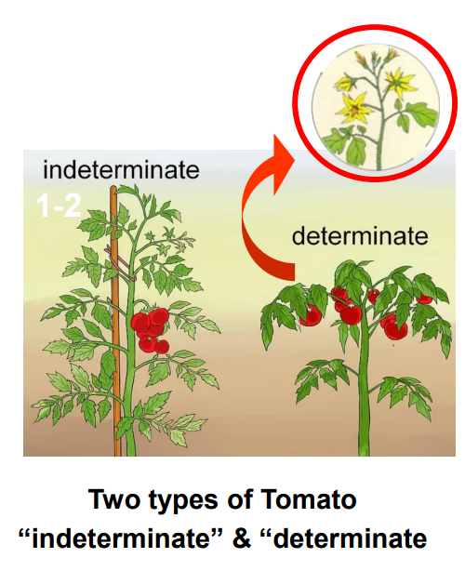

Determinate tomatoes (Bush type)
Determinate tomatoes grow to a fixed height of about 0.5–1 metre, forming a compact, bushy plant. Once the plant reaches its full size, it produces most of its flowers and fruit at the same time. The fruit usually ripens within 2–3 weeks, making these tomatoes ideal for processing into products such as sauces, soups, and canned tomatoes.
Determinate plants require less maintenance because they do not need regular pruning or removal of side shoots (laterals). Their compact shape and concentrated fruit ripening make them well suited to mechanical harvesting in large-scale commercial cropping operations.
Key features
- Bushy and compact growth habit
- Grow to a fixed size
- Fruit ripens over a short period
- Require less pruning and training
- Suitable for processing and machine harvesting

Indeterminate tomatoes (Vining type)
Indeterminate tomatoes continue growing throughout the season and can reach heights of 1.8–3 metres or more. They produce flowers and fruit continuously along a central vine, resulting in a longer harvesting period.
These plants require support such as stakes, or strings. Growers must regularly remove side shoots (laterals) and train the vines to improve airflow, plant health, and fruit production. Because they produce fruit over an extended period, indeterminate tomatoes are commonly grown in commercial greenhouses for year-round supply and fresh-market sales.
Key features
- Tall, vining growth habit
- Continue growing throughout the season
- Continuous fruit production
- Require pruning, training, and support
- More labour intensive
- Suitable for greenhouse and fresh-market production
Comparison of determinate and indeterminate tomatoes.
Feature | Determinate | Indeterminate
Growth Habit | Bushy | Vining
Plant Height | 0.5-1m | 1.8-3m
Growth duration | Fixed size | Continuous
Fruit production | Short period | Continuous
Maintenance | Low | High
Harvest method | Machine harvesting | Hand harvesting
Main commercial use | Processing | Fresh market

Do: Test yourself quizzes and test your questions.

Determinate
Indeterminate
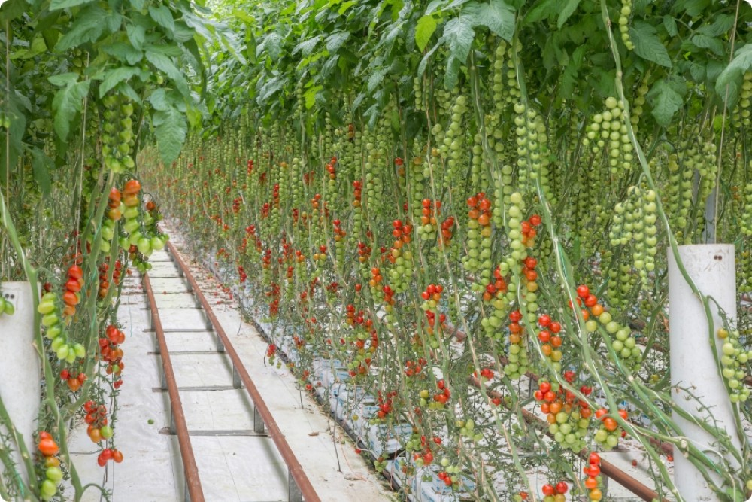
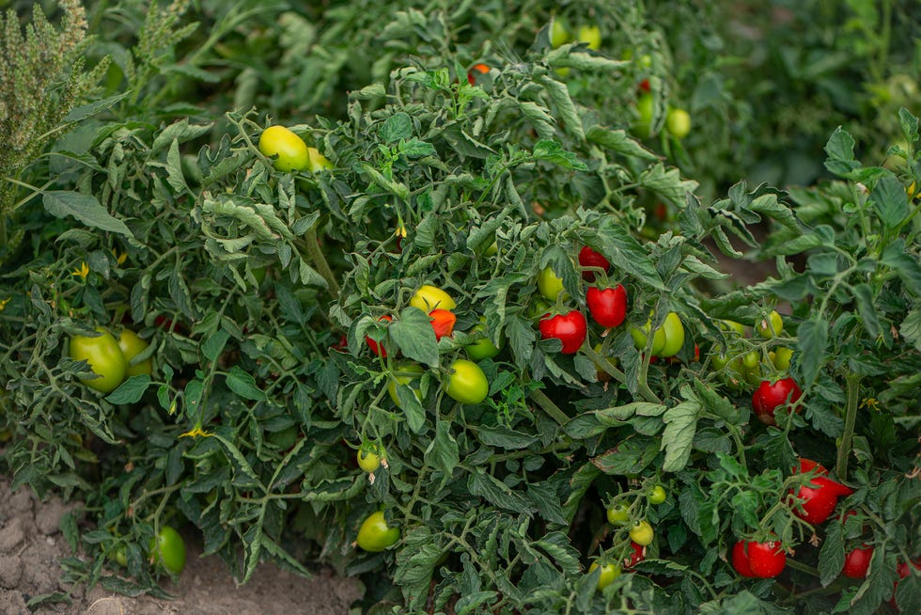

Types of tomatoes grown commercially
Fresh-market tomatoes
Fresh-market tomatoes in New Zealand are produced predominantly in protected greenhouse systems using hydroponic production. Most commercial cultivars are modern Dutch-bred hybrids selected for superior flavour, appearance, yield, shelf life, disease resistance and suitability for intensive greenhouse production. Advances in breeding have significantly expanded the range of tomato types available, reflecting consumer demand for improved eating quality, convenience and premium specialty products.
Commercial greenhouse production includes traditional loose medium-round tomatoes, large truss (vine-ripened) tomatoes, Campari tomatoes, cherry and grape tomatoes, cocktail truss tomatoes, baby Roma, Roma, Romano and specialty cultivars such as Strawberry Tom. These cultivars are marketed for a range of domestic fresh-market segments, from everyday consumption to premium snacking and gourmet products. Some cultivars are also selected specifically to meet export market requirements, including fruit quality, consistency, firmness and postharvest shelf life.

Processing tomatoes
Outdoor tomato production is concentrated in regions with favourable summer climates, particularly Hawke's Bay, where determinate field-grown cultivars are grown specifically for the processing industry. Unlike fresh-market tomatoes, processing cultivars are bred for agronomic and processing characteristics, including concentrated and uniform ripening, suitability for mechanical harvesting, high soluble solids, firm flesh, disease resistance and high processing yields.
Roma and plum-type tomatoes dominate processing production because of their dense flesh, lower moisture content and high solids, making them well suited for the manufacture of canned tomatoes, tomato paste, sauces, soups, baked beans and other processed tomato products. Proprietary cultivars developed for processors such as Wattie's have also been bred to maximise natural sugar content, lycopene concentration and processing efficiency while maintaining consistent yields under field conditions.

Growing requirements
Tomatoes are a warm-season crop that require full sun and temperatures between 15°C and 30°C for optimal growth. They are highly sensitive to frost, which can severely damage or kill plants.
Commercial outdoor tomato production is therefore seasonal, typically taking place from late spring through summer to avoid frost risk. While tomatoes grown in high-tech greenhouses can be produced year-round, as the controlled environment maintains ideal growing conditions.

Growing tomatoes indoors
Watch:
- Just the Job - Hothouse Vegetable Production Careers
- Growing tomatoes in NZ https://www.youtube.com/watch?v=FiPtMUS6osA
- J. S Evers tomatoes Nelson Rural Delivery https://www.youtube.com/watch?v=IU4kruzmx80
- J.S Evers tomatoes Tasman Information (WS).
Note:
The following information on growing tomatoes commercially in a high-tech greenhouse is purposefully generalised. This case study will cover the growing of a Dutch hybrid grafted tomato crop. For specific growing requirements and regional information contact and visit a local grower.
The Field Trip to Indoor Tomato worksheet provides a set of questions that you can revise to suit your class and the purpose of the field trip.
Field Trip to Indoor Tomato (WS)
Do: Field trip tasks- senior students

Tomatoes are grown in high-tech greenhouses to enable year-round production under carefully controlled environmental conditions. Sophisticated computer technology plays a vital role in managing the growing environment. Sensors continuously monitor factors such as temperature, humidity, light intensity, carbon dioxide concentration, a water and nutrients. This data is sent to centralised control systems, which automatically adjust environmental conditions to maintain optimum growth and maximise yields.
Careful management of both light and temperature is essential for successful tomato production. Light intensity directly affects the rate of photosynthesis and therefore the amount of sugars produced by the plant. Temperature influences the rate of respiration, determining how much of these sugars are used for energy and how much remains available for growth, flowering, and fruit development.
Temperature and humidity are controlled automatically through ventilation, heating, and cooling systems. Ventilation systems open and close as needed to regulate air movement, humidity, and temperature, while heating systems maintain suitable temperatures during cooler conditions. These carefully controlled conditions help maximise plant growth, reduce plant stress, and improve fruit quality.
To ensure continuous fruit production, greenhouses are maintained within an optimum temperature range during both the day and night. Tomatoes flower best when daytime temperatures are between 21–29°C and nighttime temperatures remain between 15–21°C. Maintaining these temperatures promotes healthy flowering, fertile pollen, and successful pollination, all necessary for producing high yields of high-quality fruit.
White plastic reflective mulch is placed on the ground beneath the plants to reflect and scatter light throughout the crop canopy. This increases light interception by the leaves, improving photosynthesis and encouraging more even plant growth throughout the greenhouse.
Water and nutrient supply are also carefully managed using controlled recirculated fertigation system. These systems deliver precise amounts of water and dissolved nutrients directly to the root zone according to the crop’s growth stage and requirements. This improves nutrient uptake efficiency, reduces waste, and supports healthy plant growth and fruit development.
Carbon dioxide (CO₂) concentration is another key factor influencing photosynthesis. In densely planted greenhouses, CO₂ levels can drop below optimum levels during the day because plants rapidly absorb CO₂ while photosynthesising. To prevent this, growers use ventilation systems or CO₂ enrichment systems to maintain adequate carbon dioxide concentrations. Increased CO₂ levels enhance the rate of photosynthesis, leading to faster plant growth, improved fruit set, and higher overall yields.

Note
Growing tomatoes in a greenhouse requires substantial upfront investment in infrastructure and production inputs before any crop is harvested. These establishment costs are incurred well in advance of revenue generation and include greenhouse construction, irrigation and climate control systems, growing media, grafted seedlings, labour and other essential production inputs.

Calendar of operation for commercial production of indoor tomatoes
Note:
The calendar of operations below outlines the key management practices involved in growing tomatoes in a high-tech greenhouse. While specific practices may vary slightly among growers depending on the tomato cultivar, greenhouse technology, and available resources, the overall production system follows a similar pattern. In most commercial high-tech greenhouse operations, tomatoes are grown continuously for approximately one year, from planting until the greenhouse is replanted with a new crop.

Indoor Grown Tomato Crop Calendar of Operations
(1 calendar year from planting to replanting)

Crop establishment
PPT Indoor Tomato Production

Cultivar selection
PPT Grafted Tomatoes.
A range of hybrid Dutch grafted tomato cultivars is grown to meet the diverse requirements of both domestic and export markets. Selected tomato cultivar seedlings are propagated and grafted by a commercial nursery onto vigorous, disease-resistant rootstocks. Each rootstock is grafted with two scions. The rootstock provides enhanced plant vigour and resistance to soil-borne diseases, while the scions produce fruit with the quality, size, flavour, and other characteristics required by consumers and target markets.
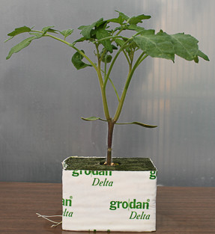
The grafted plants are supplied in individual cubes of soilless growing media, such as coco coir or rockwool. These substrates provide excellent drainage, aeration, and root support while minimising the risk of soil-borne diseases. They also enable precise management of water and nutrient delivery, promoting healthy root development, consistent plant growth, and high fruit yields.
Dutch hybrid tomato cultivars are internationally recognised for their high yields, excellent fruit quality, resistance to key diseases, and extended shelf life. Developed through advanced breeding programmes by leading Dutch seed companies, such as Rijk Zwaan and Enza Zaden, these cultivars dominate commercial greenhouse tomato production worldwide due to their superior productivity, uniformity, and ability to meet the quality requirements of both domestic and export markets.

Site preparation
Before a new tomato crop is planted, the greenhouse is thoroughly cleaned and sterilised to remove any pests, diseases, or plant material remaining from the previous crop. This helps prevent contamination and reduces the risk of disease outbreaks in the new plants.

Growing

Seedlings
When delivered to the greenhouse, the seedlings are transplant at carefully measured spacings into slabs of sterile soilless growing media such as coco coir or rockwool. Although the media contain little or no nutrients, they provide ideal conditions for root growth. All essential minerals and water are supplied directly to the plants through a carefully controlled hydroponic nutrient solution throughout the growing season.
The seedlings are usually around 55-60 days old when delivered to the grower and are often already flowering. This reduces the time required before the first harvest and allows earlier fruit production.
As the tomato plants grow, they are clipped onto support strings suspended from overhead wires. Training the plants vertically keeps them upright and evenly spaced, maximising light interception and improving air circulation throughout the crop. Good airflow helps reduce humidity and disease risk, while the open plant structure also improves access for pollination and harvesting.

Training
Tomato plants are trained vertically on support strings that can be gradually lowered and repositioned as the crop grows and fruit is harvested. By the end of the growing season, a single tomato plant may reach up to 18 metres in length.
Regular twisting and layering, removal of side shoots (laterals), and de-leafing are essential crop management practices that keep plants evenly spaced and prevent overcrowding. These practices maximise light interception throughout the canopy, improving photosynthesis and supporting higher fruit yields.
Maintaining an open plant structure also improves air circulation within the crop, helping to reduce humidity levels and lower the risk of fungal diseases and pest infestations. In addition, better airflow and spacing make pollination, crop monitoring, spraying, and harvesting easier and more efficient.
Truss clips are used to support tomato trusses and keep them in a stable position. They help prevent the truss from bending or kinking, ensuring a continuous flow of water and nutrients to ensure the developing fruit grow evenly.

Nutrient and water management
In commercial greenhouse tomato production, water and mineral nutrients are supplied through an automated monitored fertigation system, in which nutrients are dissolved in irrigation water and delivered directly to the root zone. Because greenhouse tomato crops may remain productive for 12 months or longer, nutrient management must be carefully adjusted throughout the plant’s growth stages to maximise fruit yield, quality, and plant health.
Tomatoes require a continuous supply of essential macronutrients, including Nitrogen (N), Phosphorus (P), and Potassium (K), as well as Calcium (Ca) and Magnesium (Mg). These nutrients are commonly supplied through a dual-tank fertigation system, which injects nutrient solutions into the main irrigation line. The nutrient-rich water is then delivered to individual plants through drippers, ensuring precise and efficient nutrient uptake.
Maintaining the correct pH of the nutrient solution is critical for nutrient availability and root health. In greenhouse tomato production, the pH is typically maintained between 5.5 and 6.0 to ensure nutrients remain soluble and can be readily absorbed by the plants.
Water requirements increase as the crop grows and environmental conditions change. On average, a mature greenhouse tomato plant uses between 1.5 and 2.5 litres of water per day, increasing to 3.0–4.0 litres per day during hot summer conditions when transpiration rates are highest.
Modern greenhouse production systems use sensors and computer-controlled technology to continuously monitor environmental conditions, including temperature, relative humidity, solar radiation, light intensity, and the electrical conductivity (EC) and pH of the nutrient solution. Using this real-time information, the fertigation system automatically adjusts irrigation frequency, irrigation volume, and nutrient concentrations to match the crop's changing requirements. Excess nutrient solution (runoff) is collected, sterilised using technologies such as ultraviolet (UV) treatment or ozone, adjusted to restore the required nutrient balance, and then recirculated through the irrigation system. This closed-loop approach improves water and fertiliser use efficiency, reduces production costs, and minimises nutrient losses to the environment.

Pest and disease management
PPT Tomato P & D management
Commercial greenhouse tomato production allows growers to produce high yields throughout the year. However, the warm temperatures, high humidity, dense plant growth, and continuous cropping systems used in greenhouses can also create ideal conditions for pests and diseases to spread quickly. If these problems are not managed, they can reduce plant growth, fruit quality, and overall crop yield.
Tomato crops can be affected by many different problems, including insect pests, fungal diseases, bacterial diseases, viruses, and plant disorders. Common insect pests include whiteflies, caterpillars, tomato-potato psyllid (TPP), thrips, and two-spotted spider mites. These pests damage plants by feeding on leaves and stems, reducing plant strength and growth. Some pests can also spread viruses, such as Tomato Spotted Wilt Virus (TSWV).
Fungal diseases are a major concern in greenhouse tomatoes. Diseases such as Botrytis (grey mould), powdery mildew, and Fusarium wilt can spread quickly when humidity is high and airflow is poor. Bacterial diseases, such as bacterial canker, can spread through infected plants, contaminated tools, and contact with workers. Viral diseases, including Pepino mosaic virus (PepMV) and Tomato Spotted Wilt Virus (TSWV), are difficult to control once plants are infected. Prevention is the best approach and includes using disease-free seeds, healthy plants, good hygiene practices, and resistant or tolerant tomato varieties.
Some tomato problems are not caused by pests or diseases. Physiological disorders, such as blossom end rot, can occur when plants do not receive enough calcium or experience irregular watering and environmental stress. These problems reduce fruit quality and can make tomatoes unsuitable for sale.
Growers manage pests and diseases using Integrated Pest and Disease Management (IPM). IPM combines different control methods to keep crops healthy while reducing the need for chemical sprays. Environmental control is an important part of IPM. Growers manage temperature, humidity, airflow, and irrigation to create conditions that reduce disease development. Keeping humidity below 85% and preventing water condensation helps reduce fungal and bacterial problems.
Biological control uses beneficial organisms to control pests naturally. For example, Encarsia formosa is used to control whiteflies, while Phytoseiulus persimilis helps control spider mites. Bumblebees are used for pollination and allow growers to avoid pesticides that can harm beneficial insects.
Growers also use softer pest control products, such as horticultural oils and insecticidal soaps, to reduce pest numbers while protecting beneficial insects. Good hygiene is essential and includes cleaning tools, removing infected plant material, using foot baths, placing sticky traps, and regularly checking plants for early signs of problems.
Chemical sprays may be used when pest or disease levels become too high and other control methods are not enough. Only approved products are used, and they are applied carefully to reduce harm to beneficial organisms and slow the development of pesticide resistance.
Successful greenhouse tomato production relies on prevention, early detection, and a combination of control methods. By managing the environment, using biological controls, maintaining good hygiene, and selecting resistant varieties, growers can produce healthy tomato crops with high-quality fruit.

Pollination
PPT Bumblebees
Watch: A bumblebee buzz-pollinates a tomato flower
Tomato flowers are self-fertile because they contain both male and female reproductive parts. Most tomato varieties are mainly self-pollinated, especially those with short styles, although cross-pollination can still occur.
Unlike many flowering plants, tomato flowers do not produce nectar, so they attract fewer insect pollinators. Their pollen is enclosed inside tube-shaped anthers and can only be released through vibration. Bumblebees are highly effective pollinators because they use a method called “buzz pollination” or sonication. The bee grips the flower and rapidly vibrates its flight muscles, shaking pollen out of the anthers.
Buzz pollination is essential in commercial tomato production because it improves fertilisation, resulting in a higher fruit set, more seeds, and larger, heavier fruit with better quality. Growers can identify successful pollination by looking for brown bruising or bite marks on the flower cone left by the bees during pollination.
Wind may provide enough vibration for some outdoor tomato pollination, but in glasshouses there is usually not enough air movement. For this reason, bumblebees are widely used in greenhouse tomato production. Honeybees are less effective because they cannot perform buzz pollination.
Temperature and humidity strongly affect pollination success. The ideal temperature for pollen tube growth is around 21°C. Pollination becomes poor below 10°C or above 38°C. Temperatures above 30°C can dry out the stigma, reduce pollen viability, and cause flowers to abort before fruit develops. Bumblebee activity is also reduced when temperatures rise above 28–30°C, so growers must carefully manage greenhouse conditions.
The number of bumblebee hives required depends on the size of the glasshouse and the tomato variety grown. Cherry and cocktail tomatoes produce more flowers per square metre than larger-fruited varieties, so they require higher bee populations. In some situations, growers may need two to three times more hives for these varieties.
Bruised tomato flower
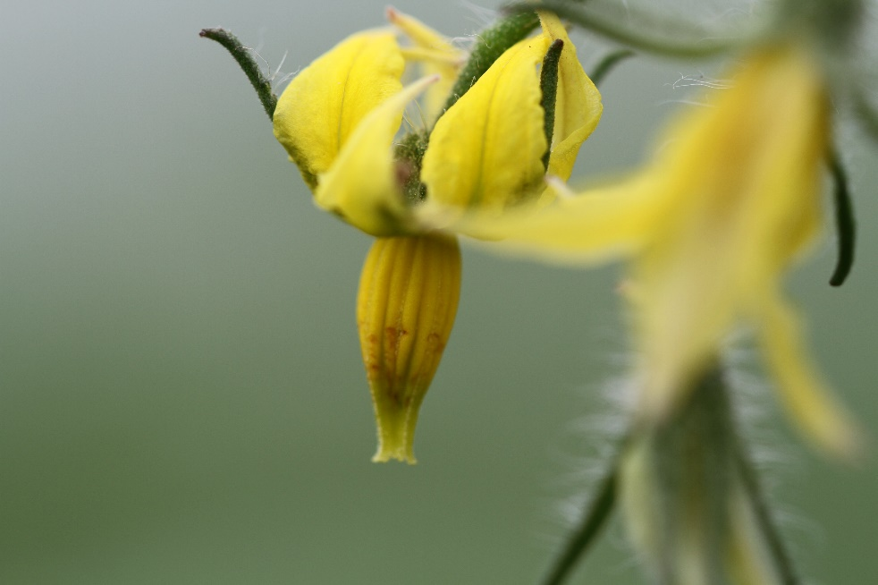
In New Zealand glasshouse production, the main species used is Bombus terrestris, also known as the buff-tailed or large earth bumblebee. Commercial colonies are supplied year-round to provide reliable pollination and improve tomato yield and fruit quality.
Activity 3: Bumblebees.

Harvesting
The first tomato harvest usually begins 7–9 weeks after transplanting into the greenhouse, depending on the variety and growing conditions. Tomatoes are typically hand-harvested daily to ensure fruit is picked at the correct stage of ripeness, quality, and flavour.
Depending on the tomato variety and market requirements, fruit may be harvested individually or as complete trusses. Careful handling during harvest helps prevent bruising and maintains fruit quality. After harvesting, tomatoes are sorted, graded, packed, and prepared for distribution according to size, colour, quality standards, and consumer preferences before being supplied to markets.

Activity 4: Create a flowchart
Create a flowchart showing the journey of a tomato from seed to supermarket. Use the following to help you.
- Sowing tomato seeds
- Tomato seedlings
- Grafting seedlings
- Planting grafted seedlings
- Training tomato plants
- Pollination
- Harvesting
- Grading
- Packaging
- Transport
- Supermarket

Activity 5: Identify and label parts of a greenhouse growing tomatoes
PPT Growing indoor tomatoes Slide 22
Do: Growing indoor tomatoes (WS)
Activity 6: Investigating different types of tomatoes sold in supermarkets and how packaging helps protect, market, and sell fresh tomatoes

Challenges
New Zealand's indoor greenhouse tomato industry is under significant pressure from a combination of rising production costs, energy uncertainty, increasing regulation, and escalating biosecurity risks. The sector relies heavily on natural gas to heat greenhouses during winter and to provide carbon dioxide that enhances plant growth. However, declining domestic gas reserves and sharp increases in gas prices have dramatically increased operating costs, placing the economic viability of many commercial growers at risk. At the same time, growers are expected to invest in decarbonisation initiatives and comply with an expanding range of environmental and regulatory requirements, adding further financial pressure to businesses that already operate on tight margins.
Alongside these economic challenges, the industry faces an unprecedented biosecurity threat from Tomato Brown Rugose Fruit Virus (ToBRFV), one of the most destructive diseases affecting tomato crops worldwide. Since the virus was detected in Australia in 2024, New Zealand growers have been preparing for its likely arrival by strengthening on-farm hygiene protocols and supporting enhanced border controls. A ToBRFV outbreak could result in severe crop losses, reduced productivity, and substantial costs associated with containment and eradication. While fresh tomato imports from Australia are subject to strict biosecurity measures, including irradiation and compliance programmes, the ongoing movement of tomatoes highlights the importance of maintaining robust border protections. Together, energy insecurity, rising costs, regulatory obligations, and biosecurity threats represent a significant challenge to the long-term sustainability and competitiveness of New Zealand's greenhouse tomato industry.

Watch: Tomato crisis: NZ temporarily slams door on Aussie imports | 1News on TVNZ+

Activity 7: Challenges facing tomato growers
In groups
- Read the information about the challenges facing New Zealand's greenhouse tomato industry.
- List the four main challenges faced by tomato growers.
Challenge | How could it affect growers or consumers?
Rising energy costs | Greenhouses cost more to heat, so tomatoes may become more expensive.

- For each challenge, explain how it could affect tomato production or consumers.
- Choose one challenge and suggest one way growers or the government could help solve it.
- Share your ideas with the class.

Individually
- Which challenge do you think is the biggest threat to New Zealand's tomato industry? Explain your answer using evidence from the reading.

Activity 8: Biosecurity risk challenge-PPT Pest & disease management Slide 32
Scenario: A Queensland Fruit fly has been found.
Divide class into the following groups
- Growers
- Government
- Supermarkets
- Scientists
- Consumers
Each group explains:
- What they are worried about?
- What should happen next?

Activity 9: Why did tomato prices change?
Do selected worksheets
- Tomato industry develops hygiene guidelines (WS)
- NZ tomato growers face rising energy costs (WS)
- Indoor food production - Crisis L2 (WS).
- Indoor food production - Crisis L3.

Activity 10: New report
Write or record a 2-minute news report on a topic that impacts or could impact tomato production in New Zealand.
Topic ideas:
- Rising tomato prices
- Tomato virus threat
- New greenhouse technology
- Bumblebees helping tomato growers

Activity 11: Design challenge
In groups, students design a robot that could:
- Harvest tomatoes
- Remove side shoots
- Detect ripe fruit
- Check for disease
- Detects pests
Groups must explain how their robot works.

