Activity 9: Why did tomato prices change?
Learning objectives
Students will:
- Interpret data from a table.
- Create and analyse a line graph.
- Calculate changes and percentages.
- Identify trends and suggest reasons for changes in prices.

Background
Tomato prices can change throughout the year because of factors such as weather, growing conditions, supply and demand, transport costs, and seasonal production.
The table below shows the weighted average price of tomatoes per kilogram from February 2025 to February 2026.
Month | Weighted average /1kg
Feb 2025 | 3,87
Mar 2025 | 4.46
Apr 2025 | 5.53
May 2025 | 8.73
Jun 2025 | 13.55
Jul 2025 | 14.22
Aug 2025 | 16.17
Sep2025 | 15.67
Oct 2025 | 10.5
Nov 2025 | 6.7
Dec 2025 | 6.26
Jan 2026 | 5.72
Feb 2026 | 5.45
Figure.nz

- Graphing the data
- Draw a line graph showing tomato prices over time.
- Describe the overall pattern shown by your graph.

- Using the data answer the following questions.
- What was the price of tomatoes in February 2025?
- In which month were tomatoes the most expensive?
- What was the highest price recorded?
- Calculate the increase in price from:
  - February 2025 to August 2025.
  - March 2025 to July 2025.
- Between which two months did the largest price decrease occur?
- Calculate the percentage decrease from September 2025 to October 2025.
- Calculate the average tomato price across the 13 months.

- Use your graph and data to discuss:
- Why do you think tomato prices increased between February and August 2025?
- Why might prices have fallen after August 2025?
- Suggest three factors that could influence the price of tomatoes.
- If you were a tomato grower which months, would you prefer to sell your tomatoes? Explain your answer.

- Predicting the future
The price in February 2026 was $5.45/kg.
- Predict the likely tomato price in March 2026.
- Explain the reasoning behind your prediction.
- What additional information would help you make a more accurate prediction?

- Real-world connection
Imagine you own a supermarket. Tomato prices have increased from $3.87/kg to $16.17/kg.
Write a short explanation for customers explaining:
- why prices have changed,
- how the supermarket might respond,
- how customers might be affected.

Answers
  - Graphing the data
- Line Graph
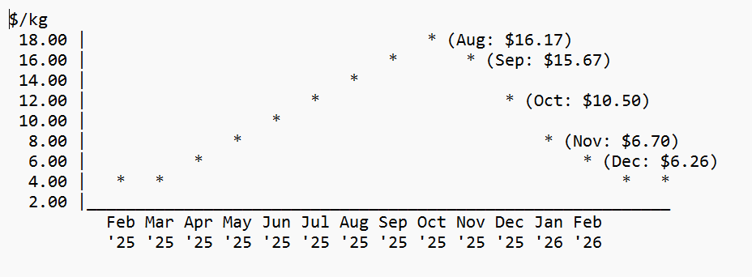
- Describe the overall pattern shown by your graph.
The price of tomatoes increased steadily from February 2025 until reaching a peak in August 2025. After August, the price decreased each month until February 2026. Overall, tomato prices rose sharply during the middle of 2025 before falling back towards early 2026.

  - Using the data answer the following questions.
- What was the price of tomatoes in February 2025?
$3.87/kg

- In which month were tomatoes the most expensive?
August 2025

- What was the highest price recorded?
$16.17/kg

- Calculate the increase in price from:
  - February 2025 to August 2025 $16.17-3.87=12.30$
Increase = $12.30/kg
  - March 2025 to July 2025 $14.22-4.46=9.76$
Increase = $9.76/kg

- Between which two months did the largest price decrease occur?
The largest decrease was from September 2025 to October 2025
15.67 – 10.50 = 5.17/kg

- Calculate the percentage decrease from September 2025 to October 2025.
$$\frac{15.67-10.50}{15.67}×100 \\ \frac{5.17}{15.67}×100=32.99\%$$
Percentage decrease ≈ 33%

- Calculate the average tomato price across the 13 months.
Prices added together:
$$3.87+4.46+5.53+8.73+13.55+14.22+16.17+15.67+10.50+6.70+6.26+5.72+5.45=120.86$$ $120.86÷13=9.30=$ Average price = $9.30/kg

  - Use your graph and data to discuss:
- Why do you think tomato prices increased between February and August 2025?
- Poor weather conditions may have reduced tomato production.
- There may have been fewer tomatoes available due to seasonal changes.
- Increased demand may have caused prices to rise.
- Higher farming, fuel, or transport costs may have increased prices.

- Why might prices have fallen after August 2025?
- More tomatoes became available as growing conditions improved.
- Supply increased, causing prices to drop.
- Seasonal production increased.
- Demand may have decreased.

- Suggest three factors that could influence the price of tomatoes.
- Weather conditions (lack of sunshine, temperature)
- Supply and availability of tomatoes.
- Transport and production costs such as energy, labour and other input costs
- Consumer demand.
- Import changes.
- Labour costs.

- If you were a tomato grower, which months would you prefer to sell your tomatoes? Explain your answer.
Around August 2025 because the price was highest at $16.17/kg, meaning I could earn more money for each kilogram sold.

- Predicting the future.
The price in February 2026 was $5.45/kg.
- Possible prediction: About $5.00–$5.50/kg
- The price has been gradually decreasing from August 2025 onwards. Since the price was $5.45/kg in February 2026, it is likely to stay similar or decrease slightly in March.

- Tomato production levels.
- Grower supply information.
- Consumer demand data.
- Transport, fuel, energy and other input costs

- Real-world connection
Tomato prices increased because tomatoes became more expensive to produce and there may have been fewer tomatoes available. The supermarket may respond by finding different suppliers, offering promotions on other vegetables, or adjusting prices. Customers may buy fewer tomatoes or choose cheaper alternatives.

