Biosecurity Risk: Tomato Brown Rugose Fruit Virus (ToBRFV)
Tomato Brown Rugose Fruit Virus (ToBRFV) is a serious biosecurity threat to New Zealand's tomato industry. The virus can spread quickly through greenhouse crops, causing poor-quality fruit and potentially destroying entire crops. Growers are using strict hygiene practices and testing to reduce the risk of the virus entering and damaging the industry.

Read “Tomato industry develops hygiene guidelines” and answer the questions.
- Why are Tomatoes New Zealand and NZ Plant Producers developing new hygiene guidelines for tomato nurseries?
- What is Tomato Brown Rugose Fruit Virus (ToBRFV), and why is it considered a serious threat to New Zealand's tomato industry?
- According to the article, what steps should service providers take before entering a tomato greenhouse? Why are these measures important?
- How can testing tomato seedlings for ToBRFV help protect growers and the industry?
- Dinah Cohen says that good hygiene practices can stop the spread of many plant diseases. Give two examples of hygiene practices mentioned in the article and explain how they help reduce the risk of disease.

Tomato industry develops hygiene guidelines
https://www.farmersweekly.co.nz/news/tomato-industry-develops-hygiene-guidelines/
July 25, 2025
Service providers urged to don full PPE when coming onsite, to protect the crop from disease.
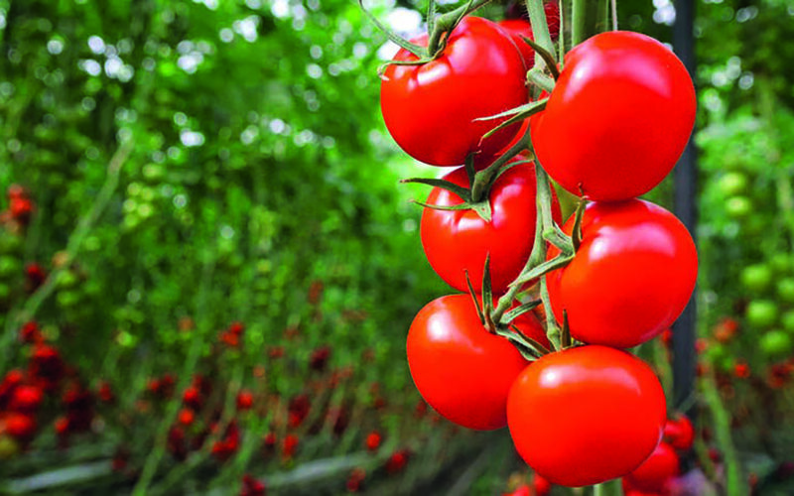
Tomatoes NZ general manager Dinah Cohen says in some cases disease can mean total crop loss in tomato plants. Proposed guidelines should help alleviate the chance of diseases for local growers. File photo

Tomatoes New Zealand and NZ Plant Producers are creating hygiene guidelines for nurseries to incorporate into their management systems.
Tomatoes NZ general manager Dinah Cohen said the guidelines include offering testing for pathogens.
In June, the tomato industry was concerned that the Ministry for Primary Industries was not doing enough to protect it from tomato brown rugose fruit virus (ToBRFV), which could decimate the local tomato crop if it entered New Zealand through capsicum imports from Australia.
While the guidance is being reviewed, growers can already request that their seedlings be tested for ToBRFV.
Conducting these tests before seedlings are released provides some assurance seedlings are free of ToBRFV.
Cohen said they want all service providers to consider biosecurity threats when working with the tomato industry.
“Service providers are urged not to ask to enter greenhouses.
“Ideally anyone needing to meet with a tomato grower should do so off-site but if strictly necessary to go onsite, all suppliers should wear full PPE (Personal Protective Equipment) including new disposable overshoes and gloves.”
Cohen said tomato plants are particularly susceptible to fungal, bacterial and viral diseases and that in some cases this can lead to 100% crop loss on affected plants.
The biggest threat to the industry at the moment is from ToBRFV, while PepMV and Liberibacter are diseases that growers learn to live with.
Some of these diseases can be managed with resistant seed varieties but generally good hygiene practices will stop the spread, she said.

Sample answers
- Why are Tomatoes New Zealand and NZ Plant Producers developing new hygiene guidelines for tomato nurseries?
They are developing the guidelines to help prevent dangerous plant diseases from spreading through New Zealand's tomato industry. The guidelines encourage nurseries to include good hygiene practices in their daily operations and offer testing for harmful pathogens, such as Tomato Brown Rugose Fruit Virus (ToBRFV). By reducing the risk of disease, the industry hopes to protect growers from losing their crops and suffering major financial losses.
- What is Tomato Brown Rugose Fruit Virus (ToBRFV), and why is it considered a serious threat to New Zealand's tomato industry?
ToBRFV is a highly contagious virus that infects tomato plants. It can cause fruit to become discoloured, deformed, and poor quality, making it difficult or impossible to sell. In severe cases, the virus can destroy an entire tomato crop, leading to 100% crop loss. Because the virus has spread to many countries around the world and has been found in Australia, New Zealand growers are concerned it could enter the country and seriously damage the industry.
- According to the article, what steps should service providers take before entering a tomato greenhouse? Why are these measures important?
The article says that service providers should avoid entering tomato greenhouses whenever possible. Meetings should take place off-site if they can. If someone must enter a greenhouse, they should wear full personal protective equipment (PPE), including new disposable overshoes and gloves. These measures help prevent viruses, bacteria, and fungi from being carried into the greenhouse on people's shoes, clothing, or hands, reducing the chance of infecting tomato plants.
- How can testing tomato seedlings for ToBRFV help protect growers and the industry?
Testing seedlings before they are sent to growers provides confidence that they are free from ToBRFV. Healthy seedlings reduce the chance of introducing the virus into a greenhouse, where it could spread quickly from plant to plant. Early testing helps growers avoid costly crop losses and supports New Zealand's efforts to keep the virus out of the country for as long as possible.
- Dinah Cohen says that good hygiene practices can stop the spread of many plant diseases. Give two examples of hygiene practices mentioned in the article and explain how they help reduce the risk of disease.
- Avoiding unnecessary visits to greenhouses. Holding meetings off-site means fewer people enter growing areas, reducing the chance of bringing diseases into the greenhouse.
- Wearing full PPE, including disposable overshoes and gloves. This creates a barrier that prevents harmful viruses, bacteria, and fungi from being transferred from one location to another.

