Combating Leaf Mould and Powdery Mildew in Greenhouse Tomatoes
Leaf mould and powdery mildew are two common fungal diseases that can reduce tomato yield and fruit quality in greenhouse production. While resistant tomato varieties are helpful, they are not a complete solution because diseases can evolve and overcome resistance over time.
Successful disease management relies on an integrated approach rather than a single treatment.

Read the article “Combating Leaf Mould and Powdery Mildew in Greenhouse Tomatoes” and answer the questions below.
- Create a table listing at least six management strategies that growers can use to reduce the risk of leaf mould and powdery mildew. For each strategy, explain how it helps reduce the risk of disease.

- The article states that resistant tomato varieties are valuable but are not a complete solution. Explain why growers cannot rely only on resistant varieties to control leaf mould and powdery mildew.

- Why does the author recommend that growers regularly monitor and "keep walking the crop"? Explain how early detection can improve disease management.

- A tomato grower notices that the lower leaves of plants are becoming covered in leaf mould. The greenhouse has poor air circulation, the canopy is very dense, and humidity is high.
Describe four actions the grower should take to reduce the spread of the disease. Explain why each action would help.

- A new greenhouse tomato grower tells you: "I'll just buy a resistant variety and spray fungicide if I see disease."
Using information from the article, write a short paragraph explaining why this is not the best disease management strategy. Include at least four recommendations for a more effective approach.

- Imagine you manage a commercial greenhouse growing tomatoes. Develop a season-long disease management plan for leaf mould and powdery mildew. Your plan should include:
- Before planting
- During crop growth
- What you would monitor each week
- What you would do if disease was first detected
- How you would protect beneficial insects while managing disease
Explain why each part of your plan is important for producing a healthy, high-yielding tomato crop.

Combating Leaf Mould and Powdery Mildew in Greenhouse Tomatoes 2026
Technical
https://www.grower2grower.co.nz/combating-leaf-mould-and-powdery-mildew-in-greenhouse-tomatoes-2026/
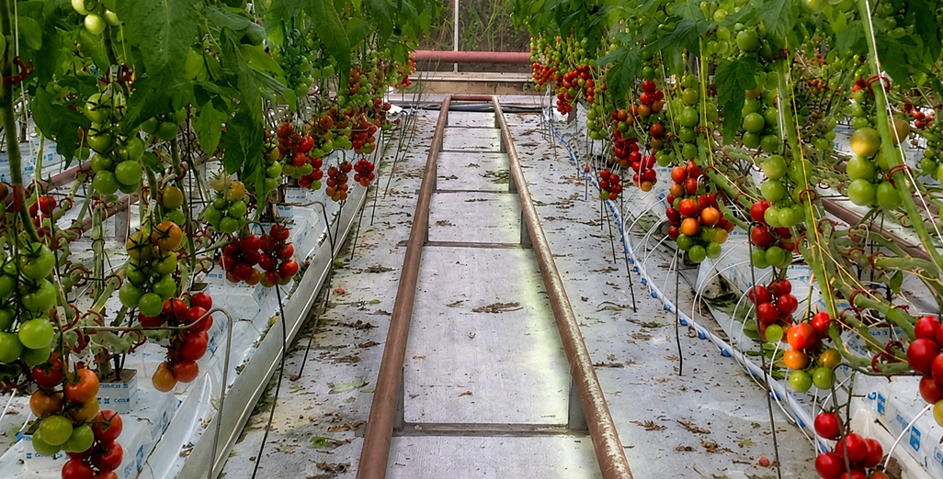
It’s been eight years since I first wrote about controlling leaf mould. While many of the principles still apply, growers now have more tools available, making it a good time to revisit what works and where disease management is heading.
By Stefan Vogrincic:

If you grow tomato cultivars susceptible to leaf mould or powdery mildew, you’ve likely already tried many products and techniques to control them.
Over many years, I’ve learned that once leaf mould is established, the goal often shifts. It becomes less about eradication and more about slowing its spread, reducing spore production, and keeping disease below a level that affects yield or fruit quality.
Ideally, we would avoid these diseases entirely—but tomato production is rarely that simple.
Years ago, I grew a cultivar with strong resistance to leaf mould. For three seasons, there was almost no disease. Then, unexpectedly, it reappeared. That experience reinforced a key lesson: resistance is valuable but never guaranteed.
No single solution
There is no single “magic bullet” for leaf mould or powdery mildew.
Effective control usually comes from combining several approaches:
- Choosing resistant cultivars
- Good greenhouse climate control
- Managing humidity and condensation
- Ensuring air movement through the crop
- Prompt removal of infected leaves
- Good crop hygiene
- Canopy management for light and airflow
- Biological, cultural, and chemical tools where appropriate
- Regular crop monitoring
The balance depends on the greenhouse, climate, and production system.
Climate control matters
Environmental control is one of the most powerful tools available.
Heating, ventilation, and humidity management all help reduce disease pressure. However, the crop itself creates a microclimate.
Even if greenhouse readings look acceptable, conditions inside a dense canopy can be very different—often more humid, still, and disease-prone. Crop and climate management must therefore work together.
Managing the canopy
Canopy management is critical.
In winter, overly vegetative crops may need selective leaf removal to improve light penetration. However, maintaining enough healthy leaf area is essential for photosynthesis, especially in low light.
With leaf mould, older lower leaves are usually affected first. Removing them early can slow upward spread, but over-removal can reduce yield.
The goal is balance: remove infected or unproductive leaves while maintaining a functional canopy.
Keeping the crop moving
Regular crop work helps prevent disease build-up.
Routine de-leafing, truss management, and maintaining an open canopy improve airflow and reduce infected material.
Timing is crucial. Waiting until disease is widespread makes control far more difficult, especially in large commercial crops.
Sulphur use
I eventually began using sulphur in heated pipe systems after initially avoiding it.
In my experience, it helped slow leaf mould and also had some effect on powdery mildew. However, results vary and sulphur must be used carefully.
Always check product labels, crop registrations, and compatibility with greenhouse materials and IPM programmes before use.
Powdery mildew differences
Powdery mildew behaves differently from leaf mould and does not require leaf wetness. It can thrive in relatively dry conditions.
Management options include registered fungicides, biological products, and some surface-altering treatments. Bicarbonates, soaps, and wetting agents are sometimes used, but must be applied carefully to avoid crop damage.
Always follow current label guidance.
Sulphur pots and alternatives
Where heating pipes are not available, sulphur pots or alternative release systems may be used.
Effectiveness depends on temperature, ventilation, and application method, so performance can vary significantly between systems.
Resistance is helpful—but not enough
Modern tomato varieties often have improved resistance to leaf mould, sometimes against multiple races.
However, resistance is not absolute. Pathogens evolve, and environmental conditions can reduce effectiveness.
Resistant cultivars should be seen as one part of an integrated strategy, not a standalone solution.
My approach in 2026
If managing these diseases today, I would focus on:
- Start with resistant genetics
Choose the best available cultivar for your system.
- Control the climate
Focus on humidity, temperature stability, and airflow.
- Watch the canopy microclimate
Conditions inside the crop often differ from greenhouse readings.
- Keep the canopy open
Remove infected and unproductive leaves promptly.
- Act early
Prevention is far easier than recovery.
- Use integrated control
Combine genetics, climate, hygiene, and treatments.
- Protect beneficial insects
Consider IPM impacts before spraying.
- Review each season
Adjust strategy based on performance and disease pressure.
The bottom line
There is still no single solution for leaf mould or powdery mildew.
Success comes from preventing disease establishment and managing conditions so it cannot spread easily.
In my experience, effective control depends on the whole system—not just sprays.
A resistant variety, good climate control, clean crop management, and regular monitoring all work together.
And most importantly: keep walking the crop.
Early detection always gives you more options.

Editor’s Note – 2026: Product labels, registrations, and permitted uses can change. Always check current local regulations before applying any treatment.

Answers
- Create a table listing at least six management strategies that growers can use to reduce the risk of leaf mould and powdery mildew. For each strategy, explain how it helps reduce the risk of disease.
Management strategy | How does this reduce disease risk?
Grow resistant cultivars | Resistant varieties are less likely to become infected, reducing disease levels and protecting crop yield. However, resistance is not permanent because pathogens can evolve.
Control greenhouse climate | Managing temperature, humidity, and ventilation creates conditions that are less favourable for fungal diseases to develop and spread.
Reduce humidity and condensation | Leaf mould thrives in humid conditions and on wet leaves. Reducing moisture lowers the chance of fungal spores germinating.
Improve air movement | Fans and good ventilation increase airflow through the crop, helping leaves dry more quickly and reducing disease development
Remove infected leaves promptly | Removing diseased leaves reduces the number of fungal spores available to infect healthy plants.
Maintain an open canopy | Pruning and de-leafing allow more light and air to reach the plants, reducing humidity inside the crop canopy.
Practise good crop hygiene | Removing dead plant material and cleaning equipment helps prevent disease from surviving and spreading within the greenhouse.
Monitor crops regularly | Frequent inspections allow growers to detect disease early and take action before it spreads throughout the crop.
Use biological or chemical controls when needed | Registered fungicides and biological products help reduce disease levels, but they work best when used as part of an integrated management programme rather than on their own.
Protect beneficial insects | Choosing treatments that are compatible with Integrated Pest Management (IPM) helps preserve natural predators that control insect pests.

- The article states that resistant tomato varieties are valuable but are not a complete solution. Explain why growers cannot rely only on resistant varieties to control leaf mould and powdery mildew.
Resistant tomato varieties help reduce the likelihood of disease, but they do not guarantee complete protection. Fungal pathogens can evolve over time, producing new strains that are able to infect varieties that were previously resistant. Environmental conditions such as high humidity, poor ventilation, and dense plant canopies can also increase disease pressure and reduce the effectiveness of plant resistance.
For these reasons, growers need an integrated disease management programme that combines resistant varieties with good greenhouse climate control, crop hygiene, canopy management, regular monitoring, and appropriate biological or chemical treatments. Using several strategies together provides much better disease control than relying on resistance alone.

- Why does the author recommend that growers regularly monitor and "keep walking the crop"? Explain how early detection can improve disease management.
Regularly walking through the crop allows growers to inspect plants closely and detect disease at the earliest possible stage. Diseases such as leaf mould often begin on the older, lower leaves before spreading upwards through the plant.
Early detection allows growers to:
- Remove infected leaves before large numbers of spores are produced.
- Improve ventilation or reduce humidity before disease spreads.
- Apply biological or chemical controls while the infection is still small.
- Prevent large sections of the crop from becoming infected.
If disease is detected early, it is much easier and less expensive to manage. Once disease has spread throughout the greenhouse, it becomes very difficult to control and can significantly reduce yield and fruit quality.

- A tomato grower notices that the lower leaves of plants are becoming covered in leaf mould. The greenhouse has poor air circulation, the canopy is very dense, and humidity is high. Describe four actions the grower should take to reduce the spread of the disease. Explain why each action would help.
- Remove infected lower leaves.
Removing infected leaves eliminates many of the fungal spores that can spread the disease to healthy plants.
- Thin the canopy by removing excess leaves.
A less dense canopy allows better airflow and more sunlight to reach the plants, helping leaves dry more quickly and reducing humidity around the foliage.
- Improve greenhouse ventilation and humidity control.
Opening vents, using fans, or adjusting heating systems reduces humidity and condensation, making conditions less favourable for leaf mould.
- Monitor the crop regularly and apply approved treatments if needed.
Frequent inspections help detect any new infections quickly. If disease continues to spread, registered fungicides or biological products can help reduce disease levels as part of an integrated management programme.

- A new greenhouse tomato grower tells you: "I'll just buy a resistant variety and spray fungicide if I see disease." Using information from the article, write a short paragraph explaining why this is not the best disease management strategy. Include at least four recommendations for a more effective approach.
Buying a resistant variety is a good first step, but it is not enough to prevent leaf mould and powdery mildew. Fungal diseases can evolve and overcome plant resistance, especially if environmental conditions favour disease development. Waiting until disease appears before taking action often allows it to spread throughout the crop, making control much more difficult. A better strategy is to combine resistant varieties with good greenhouse climate control, careful humidity management, regular crop monitoring, prompt removal of infected leaves, and good crop hygiene. If treatments are needed, growers should choose products that fit within an Integrated Pest Management (IPM) programme and minimise harm to beneficial insects. Using all of these methods together provides much more reliable disease control.

- Imagine you manage a commercial greenhouse growing tomatoes. Develop a season-long disease management plan for leaf mould and powdery mildew.
Stage of Production | Management Plan | Why It Is Important
Before planting | Select resistant tomato varieties. Clean and disinfect the greenhouse. Remove old crop debris and check that fans, vents, and heating systems are working properly. | Reduces disease sources before planting and creates a clean growing environment.
During crop growth | Maintain correct temperature and humidity. Provide good ventilation and airflow. Prune plants and remove excess leaves to keep the canopy open. Practise good hygiene when handling plants | Creates conditions that are less favourable for fungal diseases while promoting healthy plant growth.
Weekly monitoring | Walk through the crop at least once a week. Check lower leaves for early symptoms of leaf mould and inspect all plants for powdery mildew. Record disease levels and greenhouse climate conditions. | Early detection allows action before disease
If disease is detected | Remove infected leaves immediately. Improve airflow and reduce humidity. Continue monitoring closely and use registered biological or chemical treatments if needed, following label instructions. | Prevents disease from spreading and reduces the number of fungal spores in the greenhouse.
Protect beneficial insects | Choose disease control products that are compatible with Integrated Pest Management (IPM). Spray only when necessary and follow label | Preserves natural predators that help control
End of season | Remove all crop residues, clean the greenhouse thoroughly, and review disease records to improve management for the next crop. | Reduces the chance of disease surviving between crops and helps improve future disease management.

Why this plan works?
This disease management plan combines prevention, monitoring, environmental control, hygiene, and appropriate treatments. Rather than relying on one method, it uses an integrated disease management (IDM) approach. By reducing the conditions that favour disease, detecting problems early, and protecting beneficial insects, growers can produce healthier tomato plants, maintain high fruit quality, reduce crop losses, and achieve higher marketable yields.

