Notes on a visit to J. S Evers
- Rural Delivery https://www.youtube.com/watch?v=IU4kruzmx80
- https://jsewers.co.nz/
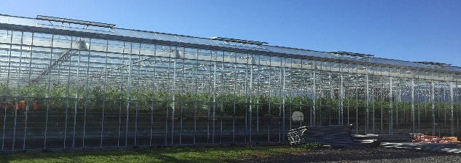
- Owners are MG Trust
- 500-600 hectares apples
- 12 hectares greenhouses
- Old glasshouses
- Energy transition
  - thermal screens, buffer tank, coal fired boilers (from 8 to 2), heating hot water tank which is used in the glasshouse.
  - Grant to change energy $4M ($9M project) to wood pellets
  - Be carbon neutral
  - Changing heating systems has increased efficiencies.
  - Thermal screens saved 1 ½ tonnes of coal
  - Computer upgrade as well.
  - No diffused glass
  - Use whitewash on sides of glasshouse. Use thermal screens instead of whitewash on ceiling.
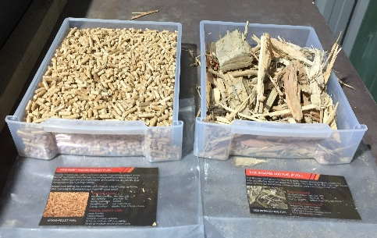
  - Biomass burners / boilers
    - 3 stories
    - Kms of heating pipes
    - Instant hot water
    - Draw off the tank
    - Maximum efficiency
    - Aswood Supplies wood slash to burn
      - Higher volume of wood than coal
      - Same CO₂ outputs
      - Higher truck movements for wood x 7 than coal
    - Waste
      - biodegradable clips and string – cost three times as much
      - cannot use GM products
      - Burn all waste.
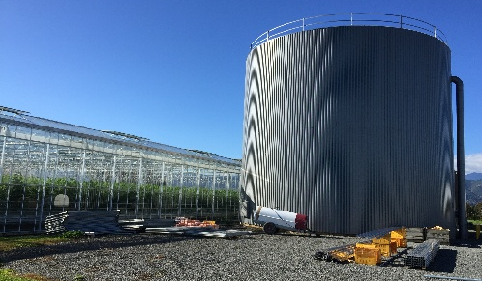
- Water tank storage
  - biofilter removes wastewater from glasshouses
  - no wastewater into the ground but sprinkler on the lawns e.g., 33,000 litres
  - drawing from aquifers 1M litres per day
  - water storage required
- 22 growing environments
- CO₂ enrichment not done as it is too costly and inefficient.
  - But have a CO₂ scrubber to capture CO₂ to put back into the glasshouse.
  - Cost prohibitive
- Plants sourced from Zealandia for 27 years.
  - Do a good job.
- Job board
  - Scan in for each job – start and finish
  - 5% increase straight away,
  - better efficiencies of staff
- 80 staff
  - 63 permanents
  - More RSE workers for outside work
  - Not many kiwis
  - Over the minimum wage
  - New and good workers
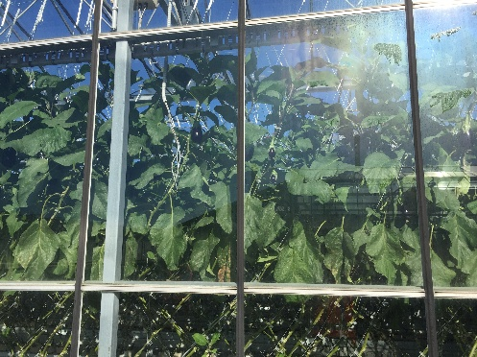
  - Positive reinforcement works well
  - 5–6-month contracts, go to apples, then back here.
  - Covid-19 – 6 different entity bubbles.
- 7 days to turn a house around to clean
- Automatic roof washer, also underside roof washer
- Eggplants
  - ½ hectare
- Capsicums
  - 3 hectares
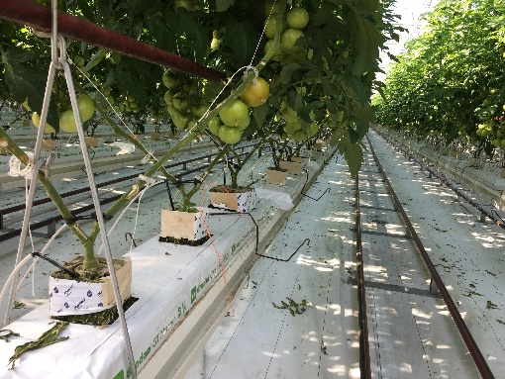
- Tomatoes
  - Annual value $20+M of tomatoes
  - 7-8 hectares
  - Prepack
  - Varieties
    - Cherry, truss, loose, bagging (30-55mm)
  - Main production is loose – 6-week production cycle
  - 4, 5, 6 weeks for production cycle
  - Complicated processes
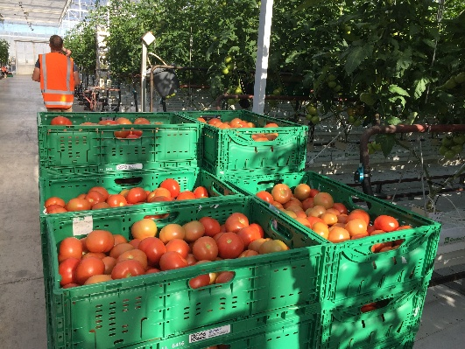
  - New crops planted November – August, then change.
  - Machine removed – cost $250,000
  - Plants
    - Grow for one year
    - 3 cubes per growing bag
    - 2.76 plants per square metre, normally 2.3 plants per square metre for better light penetration.
    - 2 stems per cube / plant
    - Some 3 stems
      - Gain better fruit size and stem production particularly in winter to meet winter production.
      - Increase in money
      - Carry out leaf picking to increase yield.
      - 10-15% increased production and better fruit health, size, yield, and colour
    - Close internodes, change generative growth to reproductive growth. Constantly changing between the two.
      - Change by high temperatures – hover between the 2 stages.
      - Big drinks for apart to regenerative
  - Fruit truss
    - Picked on the 7th truss
    - Fruit pruning – 3 trusses with 3 fruits
  - Feed – Biogro – hot water warms fruit and therefore is a sugar sink
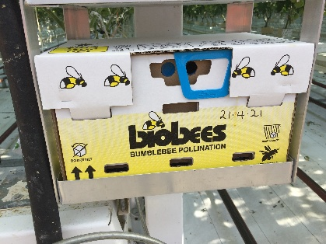
  - 50 tonnes per glasshouse average
  - Rock wool slabs – inert, add nutrients, irrigation, and temperature
  - No lighting – too expensive and also will need CO₂ enrichment
  - Venting, heating, pruning, humidity
  - Pollination by bumble bees
    - Mites affected the bees
    - Had to hand pollinated
    - Had to deleaf to get bigger size.
  - Botrytis, calidis diseases
    - Spray for them
    - No disease pressure therefore low spraying
    - Biocontrol – 26 intervals without spraying

