New Tomato Varieties for New Zealand
South Pacific Seeds – Back in the Game
Key points
- South Pacific Seeds has developed new tomato varieties for greenhouse growing in New Zealand.
- Many of the new varieties have high or intermediate resistance to Tomato Brown Rugose Fruit Virus (ToBRFV), helping protect crops from disease.
- The company works with plant breeders from Europe and Canada to bring improved tomato genetics to New Zealand.
- New varieties include:
  - Cherry tomatoes
  - Cocktail tomatoes
  - Special coloured tomatoes (pink, black, and orange)
  - Large red tomatoes (200 g or more)
- The new tomatoes are designed to produce high yields, have good disease resistance, and perform well in different growing conditions.
- They also have excellent flavour and texture, making them attractive to consumers.
- Some of these varieties are already being grown successfully in Europe and the United Kingdom.
South Pacific Seeds encourages growers to trial the new varieties to see which perform best in New Zealand.

Read “Back in the Game” and discuss the key points.
In groups discuss these questions and then share your answers with the class.
- Why is it important for tomato growers to use varieties that are resistant to diseases such as Tomato Brown Rugose Fruit Virus (ToBRFV)?
- Besides disease resistance, what other qualities do growers and consumers want in new tomato varieties? Give at least two examples.
- How can developing new tomato varieties benefit both growers and customers? Explain your answer using information from the article.

Back in the Game
Classifieds, Seeds
https://www.grower2grower.co.nz/back-in-the-game/
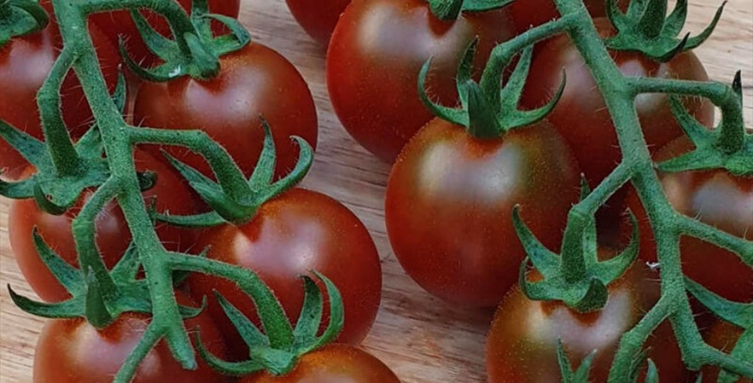
South Pacific Seeds Launches a New Generation of Tomato Genetics

South Pacific Seeds is currently in a significant development phase within our covered tomato programme for both high tech and med-low tech production. Through strategic partnerships with leading global breeding companies, we are proud to offer a diverse range of tomato varieties in the New Zealand market.
These genetics feature high and intermediate resistance to Tomato Brown Rugose Fruit Virus (ToBRFV), addressing one of the industry’s most pressing challenges.
Looking back, South Pacific Seeds experienced a pivotal shift in 2016 when Enza Zaden made the decision to move direct into the New Zealand market, ending our distribution of their greenhouse tomato range. While this change presented immediate challenges, it also marked the beginning of a new chapter.
Since then, our team has been focused on sourcing and developing new genetics tailored to both active and low-tech greenhouse systems in New Zealand conditions. We are now proud to represent emerging breeding companies with highly experienced teams, bringing strong expertise from Dutch, Canadian, and broader European markets.
These new-generation varieties offer a comprehensive disease resistance package, including advanced ToBRFV resistance (up to five-gene resistance), alongside a range of unique characteristics that are already gaining attention from major UK and European retail programmes.
Our portfolio includes a strong selection of cherry, cocktail, specialty-coloured (including pink, black and orange), and large 200 gram plus weighted red varieties. All lines within this programme combine ToBRFV resistance with proven yield performance across multiple global markets.
Importantly, these varieties maintain exceptional eating quality – delivering on flavour and texture – while also offering distinctive traits that can provide growers with a valuable point of difference in the marketplace.
Answers
- Why is it important for tomato growers to use varieties that are resistant to diseases such as Tomato Brown Rugose Fruit Virus (ToBRFV)?
Disease-resistant tomato varieties help protect crops from serious diseases such as Tomato Brown Rugose Fruit Virus (ToBRFV). When plants are resistant, they are less likely to become infected, which means growers lose fewer plants and produce more healthy tomatoes. This can reduce the need for disease control measures, save money, and provide a more reliable harvest.

- Besides disease resistance, what other qualities do growers and consumers want in new tomato varieties? Give at least two examples.
Growers want tomato varieties that produce high yields. They also want plants that grow well in different conditions and produce fruit that is uniform in size and shape, making harvesting and packing easier.
Consumers want tomatoes with good flavour, a firm texture, and an attractive appearance. The new varieties described in the article also include different colours and sizes, giving shoppers more choice. These qualities make the tomatoes more appealing to buy and eat.

- How can developing new tomato varieties benefit both growers and customers? Explain your answer using information from the article.
Developing new tomato varieties benefits growers by providing plants that are more resistant to diseases, produce higher yields, and perform well in different growing conditions. This helps growers produce more tomatoes with fewer losses and can improve their profits.
Customers benefit because the new varieties have excellent flavour, good texture, and attractive colours and shapes. They have more choices when buying tomatoes and can enjoy high-quality fruit.

