Wattie’s cuts more Hawke’s Bay crops
Read “Wattie’s cuts more Hawke’s Bay crops” and discuss and answer questions.
- Why has Heinz Wattie's decided to reduce the number of tomatoes, corn, and beetroot it buys from New Zealand growers?
- How have cheaper imported products affected New Zealand fruit and vegetable growers?
- What reasons did Heinz Wattie's give for carrying out its annual crop intake review?
- What is MBIE investigating, and why is this investigation important for New Zealand growers?
- How could reducing the number of locally grown processing tomatoes affect growers and rural communities in Hawke's Bay?
- Imagine you are a Hawke's Bay tomato grower who supplies Heinz Wattie's. If the company reduces the number of tomatoes it buys from you, what changes could you make to keep your farm profitable? Give at least two ideas and explain your reasoning.
- Why is it important for New Zealand to continue growing processing tomatoes locally instead of relying only on imported tomato products? Consider the impacts on growers, jobs, the local and national economy, and food security in your answer.

Wattie’s cuts more Hawke’s Bay crops
October 15, 2025
https://www.farmersweekly.co.nz/markets/watties-cuts-more-hawkes-bay-crops/
Wattie’s New Zealand is further reducing local fruit and vegetable crops, citing an ongoing struggle against cheaper imports.
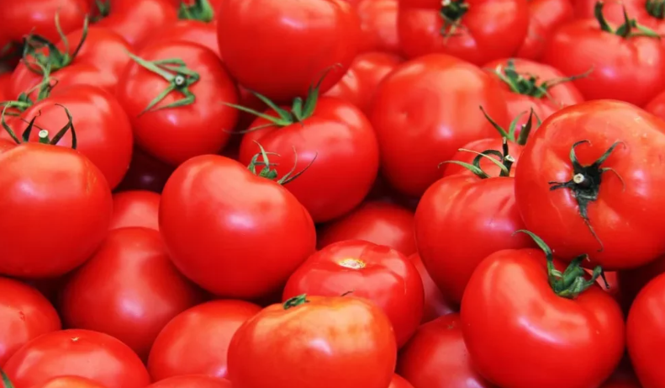
Wattie's New Zealand is cutting down on local produced crops, including tomatoes, corn and beetroot. Photo: Supplied / RNZ / Pixabay

Wattie’s New Zealand is further reducing fruit and vegetable crops it sources from its home of Hawke’s Bay, citing an ongoing struggle against cheaper imports.
Growers of key crops beetroot, corn and tomatoes will be affected by its recent crop intake review.
Just last month, it announced it would reduce production of its canned peaches.
A spokesperson for the brand, owned by food giant Kraft-Heinz of the United States, said it carried out these reviews each year to respond to market demand, increased competition from imported goods and rising input costs.
“In recent years, Wattie’s has seen a reduction in demand for home-grown canned fruit products and has not been able to recover to the levels it saw prior to the cyclone,” she said.
“Our desire, of course, is for Kiwis to return to the Wattie’s locally grown favourites, but until such time as we see an increase in demand, we are forced to adjust our intake, which has impacted crops such as peaches, beetroot, tomatoes and corn.”
She said it contacted affected growers directly, many of them had been partners for years.
“We recognise this is a difficult time for them and their businesses and are committed to helping them through this transition phase.”
The decision to reduce peach production garnered upset among New Zealand consumers online.
However, the company had already warned the government that alleged dumping of cheaper imports from countries like China into the New Zealand market would affect local production.
A spokesperson for the Ministry of Business, Innovation and Employment (MBIE) confirmed it was investigating these claims after Heinz Wattie’s filed an application in July into alleged product dumping.
“MBIE is currently progressing step 1 of the [trade remedy] investigation in accordance with its standard process, with input from participating stakeholders,” it said.
It was working to compile preliminary findings, essential facts and conclusions report for the applicant by 7 November.
And the findings would be presented to the Minister for Commerce and Consumer Affairs for decision, by 31 January.
“MBIE is also considering a request from [Heinz Watties] for provisional measures during the course of the investigation, in line with statutory provisions.”
It followed an earlier investigation several years prior.
Anti-dumping duties on preserved peaches from China were lifted in 2017.
Newsroom reported that Stats NZ data included in the Heinz application showed Chinese peach import volumes increased from 300,000 kilograms a quarter in 2018, to a peak of just below 831,000 kilograms in the final quarter of 2024.

Answers
- Why has Heinz Wattie's decided to reduce the number of tomatoes, corn, and beetroot it buys from New Zealand growers?
Heinz Wattie's has reduced the amount of locally grown tomatoes, corn, and beetroot it purchases because demand for some New Zealand-grown canned products has fallen. The company is also facing increased competition from cheaper imported products and higher production costs. As a result, it has adjusted the number of crops it buys from local growers to match market demand.

- How have cheaper imported products affected New Zealand fruit and vegetable growers?
Cheaper imported products make it harder for New Zealand growers to compete because supermarkets and consumers may choose the lower-priced imported products instead of locally grown ones. This reduces demand for New Zealand-grown crops, meaning growers may sell fewer vegetables, earn less income, and must reduce production. Over time, this can threaten the profitability of local farms and food processing businesses.

- What reasons did Heinz Wattie's give for carrying out its annual crop intake review?
Heinz Wattie's explained that it reviews the number of crops it buys each year to:
- Respond to changes in consumer demand.
- Compete with cheaper imported products.
- Manage increasing production costs.
- Match the amount of fruit and vegetables it purchases with the products it expects to sell.
The company said it would like consumers to continue buying locally grown Wattie's products, but until demand increases it must reduce crop intake.

- What is MBIE investigating, and why is this investigation important for New Zealand growers?
The Ministry of Business, Innovation and Employment (MBIE) is investigating whether imported preserved peaches from China are being "dumped" into New Zealand. Dumping occurs when products are sold in another country at unfairly low prices, making it difficult for local producers to compete.
This investigation is important because if dumping is proven, the Government may introduce anti-dumping duties (extra import charges). These duties could help create fairer competition for New Zealand growers and processors, making it easier for them to remain profitable and continue producing food locally.

- How could reducing the number of locally grown processing tomatoes affect growers and rural communities in Hawke's Bay?
If Heinz Wattie's buys fewer locally grown tomatoes, growers may lose income and reduce the amount of land planted in tomatoes. Some growers may need to switch to other crops or reduce staff. This could affect contractors, transport companies, machinery operators, irrigation suppliers, and other local businesses that support the tomato industry.
In the long term, fewer processing tomatoes could reduce employment opportunities, weaken the local economy, and decrease the amount of New Zealand-grown food available for processing.

- Imagine you are a Hawke's Bay tomato grower who supplies Heinz Wattie's. If the company reduces the number of tomatoes it buys from you, what changes could you make to keep your farm profitable? Give at least two ideas and explain your reasoning.
A grower could:
- Grow different crops. They could replace some tomato paddocks with crops such as sweetcorn, squash, onions, or maize if these have stronger market demand. This reduces reliance on one buyer.
- Improve farm efficiency. Using precision irrigation, better fertiliser management, or improved tomato varieties could lower production costs and increase profitability.
- Diversify the business. The farm could include livestock or additional horticultural crops to spread financial risk.
Making these changes would reduce dependence on a single processor and help maintain income during periods of lower demand.

- Why is it important for New Zealand to continue growing processing tomatoes locally instead of relying only on imported tomato products? Consider the impacts on growers, jobs, the local and national economy, and food security in your answer.
Growing processing tomatoes in New Zealand provides many benefits. Local production supports growers, seasonal workers, transport companies, contractors, and food processing factories such as Heinz Wattie's. These businesses create jobs and contribute to the economies of Hawke's Bay and New Zealand.
Buying locally grown tomatoes also helps keep money within New Zealand, supporting rural communities and encouraging investment in local agriculture.
Producing food locally improves food security, meaning New Zealand is less dependent on imported food. If international supply chains are disrupted by natural disasters, trade restrictions, or global events, locally grown tomatoes help ensure a reliable food supply.
Although imported products may sometimes be cheaper, maintaining a strong local processing tomato industry supports employment, strengthens the economy, and helps ensure New Zealand can continue producing high-quality food in the future.

