Topic 2
Location of Commercial Vegetable Production in New Zealand Teachers’ Guide
Key learning outcomes: Students will be able to
- Explain where and why commercial vegetable crops are grown in New Zealand.
- Identify major vegetable growing regions and the crops they specialise in.
- Explain why the location of vegetable production in New Zealand has changed over the past 40–50 years.

Supporting resources
- PowerPoint Topic 2 Activities.
- Commercial Vegetable Production Glossary.

Recommendations
Within this topic, there are multiple activities for students to complete. We recommend selecting the activity or activities that best suit your students.

Find out what your students know.
- Why do you think certain vegetables are grown in some parts of New Zealand but not others? (Tip: - Think about climatic conditions, soil, water).
- What vegetables do you think are grown in our local region, and why might they grow well here?
- How do you think, vegetable growing today, is different from how it was 50 years ago?

Where vegetables are grown in New Zealand
Over the past 40–50 years, the location of vegetable production in New Zealand has changed significantly. In the past, most vegetables were grown close to major cities so they could be sold quickly before spoiling. Today, improvements in refrigeration, transport, packaging, and processing mean vegetables can be grown further away and distributed efficiently across the country.
As a result, production is now concentrated in several large horticultural hubs that supply the domestic markets year-round.
Northland is the centre of kūmara production, growing about 97% of the country’s crop. The region’s warm climate makes it ideal for kūmara, but this also creates risk. Severe weather events in Northland such as storms or heavy rainfall can significantly reduce national supply.
In the Auckland region, particularly Pukekohe, potatoes are grown year-round. Potatoes are also produced in Waikato, Manawatū-Whanganui, and Canterbury. They store well in cool conditions, which helps maintain stable prices. Around two-thirds of New Zealand’s potato crop is processed into products such as chips and frozen fries.
Most of New Zealand’s tomatoes around 93% are grown in the North Island, mainly in heated glasshouses. This allows for consistent supply, but winter heating costs often increase prices. Lettuce is grown both indoors and outdoors ensuring a year-round supply for the domestic market
Gisborne is one of New Zealand’s key horticultural regions, with over 5,000 hectares dedicated to vegetable production. Its warm climate supports crops such as sweetcorn, squash, broccoli, and leafy greens. The region plays a major role in both domestic supply and export markets.
The Horowhenua district, particularly around Levin, is known for its fertile soils and reliable growing conditions. It produces a significant share of New Zealand’s leafy greens, brassicas (such as cabbage, broccoli, and cauliflower), root vegetables, and asparagus. Its soil quality allows for productive, year-round cultivation.
Canterbury is one of the country’s most important vegetable-growing regions. It produces both fresh and processed vegetables and is New Zealand’s main centre for vegetable seed production. Major crops include carrots, potatoes, peas, onions, brassicas, and buttercup squash.
Approximately half of New Zealand’s carrots and parsnips are grown in Canterbury. The region’s cold winters improve the flavour of root vegetables by increasing their natural sugar content.
Southland’s cool climate supports crops such as carrots, potatoes, parsnips, peas, onions, broccoli, and cauliflower. During winter, Southland can become the primary supplier of carrots to the domestic market when other regions are unable to harvest.
Vegetable production in New Zealand is structured to ensure year-round supply. Different regions specialise in crops that suit their soil types and climates. For example, onions are grown across several regions including Auckland, Waikato, Canterbury, and Hawke’s Bay and are New Zealand’s largest vegetable export crop.
Although modern transport systems make nationwide distribution possible, relying too heavily on one region can create risks. Weather events, pests, and plant diseases can disrupt supply chains. By spreading production across multiple regions, New Zealand reduces this risk and strengthens food security.
Today’s vegetable industry is highly organised, technologically advanced, and regionally specialised. Each area contributes to a coordinated national system designed to provide a steady, sustainable supply of fresh and processed vegetables throughout the year.
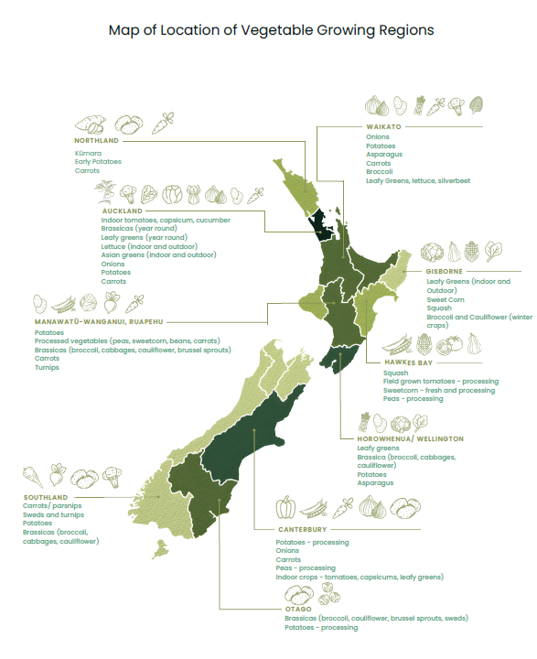

Topic 2: Activities - Also see PPT Topic 2 Activities.

Activity 1: What vegetables are grown where?
Using the Map of Location of Vegetable Growing Regions, briefly discuss some key vegetable growing regions.
- Northland – kumara
- Pukekohe – potatoes
- Gisborne – sweetcorn, squash, broccoli
- Horowhenua district – leafy greens and brassicas
- Canterbury – carrots, onions, peas
- Southland – carrots and root vegetables

Discussion questions:
- Why do some vegetables grow better in specific regions?
- What vegetables are grown commercially in our region?
- Why are these vegetables grown here?
- How do the vegetable crops grown in our region differ from another region?
- Why do growers choose different crops to grow?
- Discuss the advantages and risks of having vegetable production concentrated in certain areas.
- Suggest ways to reduce risk if a region experiences a severe weather event or pest outbreak.

Students
- Name your Region:
- Write a list of vegetables grown commercially in your region.
- Draw a star diagram of why these vegetables grow well in your region?
Consider;
- Soil type
- Climatic conditions
  - Temperature
  - Rainfall
  - Sunshine hours
  - Frost free
- Close to cities / markets

Activity 2: Supply chain and year-round production analysis (for advanced students).
- Using the map to identify which regions produce specific vegetables during different months of the year.
- Create a timeline or table that shows which regions produce specific vegetables during different months of the year.
- Identify which vegetables rely heavily on glasshouse production and which rely on outdoor growing.
- Discuss the following questions as a class or in small groups.
- How modern transport, refrigeration, and processing allow vegetables to reach domestic markets year-round.
- The potential risks to supply if one key region is affected by extreme weather, pests, or disease.
- In groups;
- Develop a strategy to improve food security for vegetables in New Zealand using the regional map as a reference.

