Topic 3
Identification and Classification of Vegetables Grown in New Zealand
Teachers’ Guide
Key learning outcome: Students will be able to -
- Recognise a range of vegetables grown in New Zealand.
- Name common vegetables.
- Understand that vegetables are grouped by the part of the plant that is eat.
- Know that some vegetables can belong to more than one group.

Supporting resources
VegetablesNZ have excellent visual resources on vegetable and vegetable groups. There is a list of resources below that are included in this topic, but others can be found at https://www.vegetables.co.nz/resources/downloads
- PPT - Name these vegetables
- PPT - lesson 3 Vegetable groups
- ROOTS-POSTER-WEB-A4
- BULBS-AND-SEEDS-POSTER-A4
- FRUITS-AND-FLOWERS-POSTER-A4
- LEAVES-POSTER-A4
- TUBERS-AND-STEMS-POSTER-A4
- A4-VEGETABLES-TE-REO-PRINT-large
- Fualaau-faisua-Vegetables-in-Samoan
- Ngaahi-vesitapolo-Vegetables-in-Tongan
Recommendations
Within this topic there are multiple activities for students to complete. We recommend you select the activity or activities that best suit your students.
Find out what your students know.
- Name vegetables that are;
- Leaves
- Stems
- Roots
- Flowers
- Fruit
- Seeds

- How do we group vegetables?

- Use the PowerPoint Name these vegetables and do Activity 2 and 3.
Vegetable groups
Vegetables are commonly classified according to the part of the plant that we eat: roots, stems, leaves, flowers, fruits, seeds, bulbs, and tubers.
This method helps us understand the diversity and unique characteristics of different vegetables. However, classification is not always straight forward. Some vegetables belong to more than one group because multiple parts of the plant are edible. For example, both the root and the leaves of beetroot and taro can be eaten.
The edible part of a vegetable can also vary depending on culture, region, or personal preference. While carrot roots are widely consumed, the leaves are also edible but less commonly used. Similarly, pumpkin leaves are eaten in some cultures but not others. This variability makes strict classification more complex.
New or less common vegetables may not fit neatly into existing categories, especially when several parts of the plant are edible or used differently in cooking.
Although fungi are not plants or animals they belong to their own biological kingdom. They are grouped with vegetables in culinary contexts. Edible mushrooms are considered vegetables in cooking and supermarkets because they are used in savoury dishes alongside plant-based vegetables. (Fungi will not be covered in this unit of work)
Parts of the plant we eat
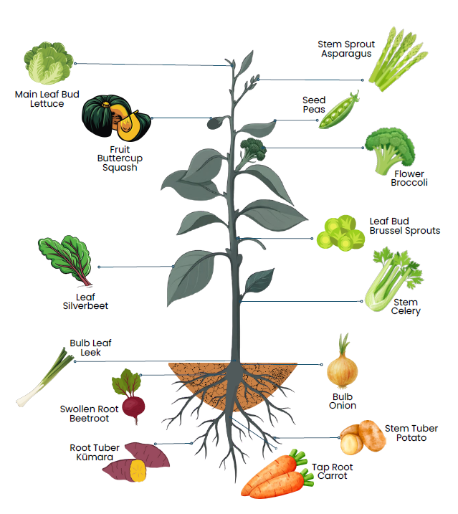
This lesson explores vegetables in eight main groups: roots, stems, leaves, flowers, fruits, seeds, bulbs, and tubers.

Root vegetables
Root vegetables are the underground taproots of plants. They store nutrients and energy for plant growth, making them often dense and nutritious.
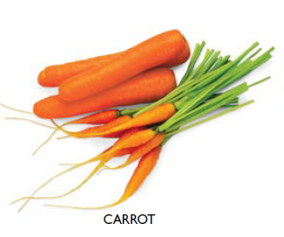
They are typically long or round and can be quite hardy, storing well for extended periods.
Examples are.
- Carrot
- Beetroot
- Radish
- Parsnip
- Swede

Stem vegetables
Stem vegetables are grown for their edible stalks or shoots. They often have a crisp texture and may contain fibrous strands.
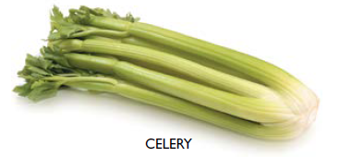
Many stem vegetables are eaten raw or lightly cooked.
Examples are.
- Asparagus
- Celery

Leaf vegetables
Leaf vegetables are grown for their edible leaves. They can range in texture from crisp to tender.
Examples are.
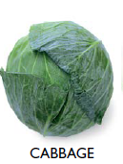
- Lettuce
- Cabbage
- Brussels sprouts
- Silver beet
- Spinach
- Bok choy
- Kale

Flower vegetables
Flower vegetables are harvested before the flowers fully bloom. The edible parts are usually tightly packed flower buds or immature flowers.
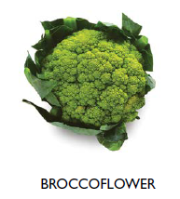
Examples
- Broccoli
- Cauliflower
- Broccoflower
- Gai lan

Fruit vegetables
Fruit vegetables develop from the flower of the plant and contain seeds. They are typically fleshy and come in a wide variety of shapes, sizes, colours, and flavours.
Botanically, these are fruits, but they are classified as vegetables in cooking because they are usually used in savoury dishes.
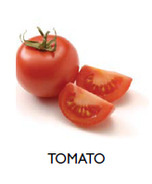
Examples
- Pumpkin
- Eggplant
- Capsicum
- Tomato
- Zucchini
- Cucumber
- Squash

Seed vegetables
Seed vegetables grow in pods and are often harvested when the seeds are immature and tender. In some cases, both the seeds and the pod are eaten.
Examples
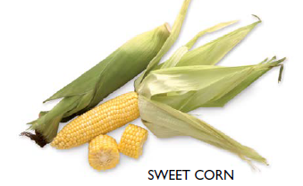
- Beans
- Peas
- Broad beans
- Snow peas
- Sweet corn

Bulb vegetables
Bulb vegetables grow just below the soil surface. They store nutrients in underground structures made of modified leaves arranged in layers. These layers protect the plant’s growing point and act as a food reserve.
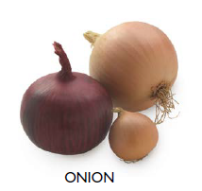
Examples
- Onion
- Shallot
- Garlic
- Spring onion
- Leek

Tuber vegetables
Tubers grow underground as swollen storage organs attached to the plant’s roots. They are usually high in starch and provide significant energy.
Tubers vary widely in size, shape, and colour and are staple foods in many cultures around the world.
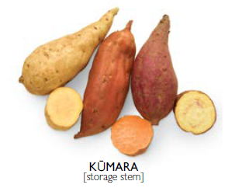
Examples
- Potato
- Yam
- Kūmara (sweet potato)

Classification of vegetable activities
Activity 1: Word searches
Easy
- vegetables-word-search-activity-student-copy-1
- vegetables-word-search-activity-teacher-copy

Harder
- Vegetable work search.

Activities 2-4 PowerPoint - Name these vegetables.
Activities 2–4 are based on the PowerPoint resource “Name these vegetables.” This resource uses photos of vegetables to support recognition and classification.
There are many ways to use slides or photos of vegetables in the classroom. Activities can be easily adapted to suit the age, experience, and learning needs of your students. These tasks are designed to build confidence in recognising a and grouping vegetables.
Select photos of vegetables that are appropriate for the age group of your students. These can be printed off or used electronically. Using these images, students can engage in a range of learning activities:

Activity 2: Naming vegetables:
Students name the vegetables shown on the slides.

Activity 3: Classification by parts we eat:
Students group vegetables based on the part of the plant we eat.
- Leaf
- Stem
- Root
- Flower
- Fruit
- Bulb
- Tuber

Activity 4: Classifying by plant family:
Students identify and group vegetables that belong to these plant families.
- Brassicaceae - Brassica family Cabbage, Broccoli, Cauliflower, Kale, Brussels sprouts
- Solanaceae - Nightshade family Tomato, Eggplant (Aubergine), Capsicum, Potato
- Fabaceae - Legume family Peas, Beans
- Cucurbitaceae - Cucurbit family Cucumber, Pumpkin, Squash, Zucchini
- Amaryllidaceae - Allium family Onions, Garlic, Leeks, Shallots
Activity 5: AI Research
- Choose ONE research topic
Pick one of the following and turn it into your investigation:
- Plant families and what vegetables in these groups have in common
- The Nightshade family and how some parts can be toxic
- Cool-season versus warm-season crops
- Why onions belong to the Amaryllidaceae family
- AI Research question
Write your topic as a strong AI research question.
Example
“How and why…?” or “To what extent…?” or “What patterns…?”
Example questions:
- How and why do vegetables in the same plant family share similar characteristics?
- How can people safely eat vegetables from the Nightshade family even though parts of the plant are toxic?
- How does climate affect whether crops are grown as cool-season or warm-season vegetables?
- What characteristics explain why onions belong to the Amaryllidaceae family?
- Guidelines for using AI
When using AI tools (like ChatGPT or Gemini), follow these rules:
Use AI to:
- Get explanations of ideas
- Find examples
- Help organise your notes
- Check your understanding
Do Not:
- Copy and paste answers as your own
- Use AI without checking the information
- Submit AI writing without editing it

Good practice:
- Ask follow-up questions
- Compare AI answers with other sources (books/websites)
- Rewrite information in your own words
- Keep your work accurate and clear
- Record how you used AI
Include a short record of your AI use: Write at least 2–3 examples of your AI use
Example Table:
What I asked AI | What AI told me | How I used it
What is the Nightshade family? | It explained the plants and examples | Helped me understand the topic
Which parts are toxic? | Leaves and unripe fruit can be toxic | Used in my explanation

- Apply your knowledge
Now answer this application question:
“Using what you have learned, explain how understanding plant families or growing conditions helps growers or gardeners grow vegetables more successfully.”
- Give at least one real example
- Explain your thinking clearly
- Use key vocabulary from your research

Activity 6: Dichotomous key
A dichotomous key is a scientific tool used to identify organisms or objects by choosing between two contrasting, observable characteristics at each step. It acts as a guide, narrowing down options to help classify specimens such as plants or animals. A dichotomous key can also be used to identify vegetables based on the parts of the plant that we eat.
Dichotomous key for identifying the parts of plants we eat
1a. The edible part grows below the ground → go to 2
1b. The edible part grows above the ground → go to 5
2a. The edible part is a swollen underground stem used for storing food → Tubers
2b. The edible part is not a swollen underground stem → go to 3
3a. The edible part is a swollen underground structure made of layered leaves → Bulbs
3b. The edible part is a true root growing downward into the soil → Roots
5a. The edible part contains seeds or develops from a flower → Fruits
5b. The edible part does not contain seeds → go to 6
6a. The edible part is the reproductive structure of the plant → Flowers
6b. The edible part is a vegetative part of the plant → go to 7
7a. The edible part is flat, green, and used for photosynthesis → Leaves
7b. The edible part is not flat and leafy → go to 8
8a. The edible part is the main support structure of the plant above the ground → Stems
8b. The edible part is the mature reproductive structure inside a fruit → Seeds

- Provide students with a range of photos of vegetables. Students;
- Look carefully at each vegetable photo. Think about which part of the plant it might come from.
- Start at step 1 of the dichotomous key. Read both options (a and b) and choose the one that best describes the vegetable you are identifying.
- Continue following the instructions in the key until you reach the name of the plant part (for example: root, leaf, fruit).
- Write the name of the vegetable and the plant part we eat in the table
Table
Vegetable | The part we eat

Discussion questions
- Which vegetables grow above the ground?
- Which vegetables grow below the ground?
- Which plant part do we eat the most often?
- Was the dichotomous key easy or difficult to use? Why?

Extension Activity
Students create their own dichotomous key to identify vegetables in a family e.g. The Brassicas family. Students can use the diagram Brassica oleracea to help them.
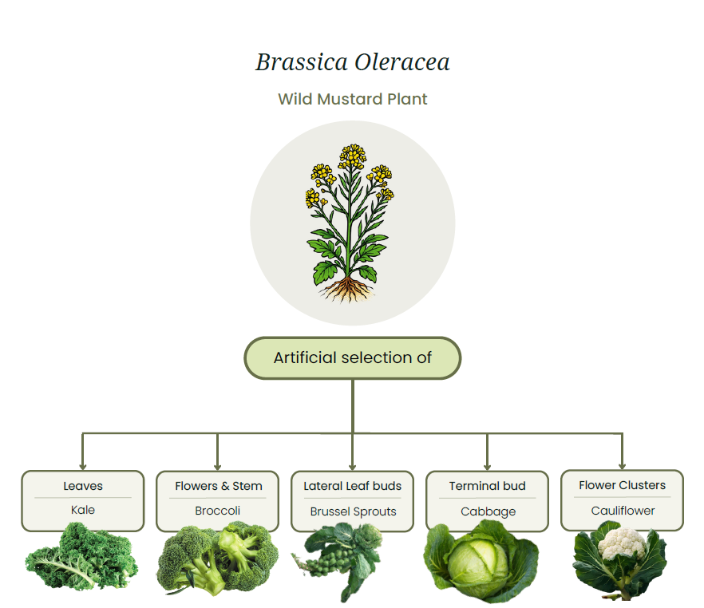

Answers
Activity 3: Classification by parts we eat:
Bulb | Flower | Fruit | Leaf | Seed | Root | Stem | Tuber
Onion | Broccoli | Pumpkin | Lettuce | Peas | Carrot | Asparagus | Potato
Garlic | Cauliflower | Squash | Cabbage | Beans | Beetroot | Celery | Kumara
Spring Onions | Broccolini | Eggplant | Brussel Sprouts | Sweet Corn | Radish |  | Yams
Leek |  | Capsicum | Silver beet | Snow Peas | Parsnip
 |  | Zucchini | Spinach |  | Swede
 |  | Tomatoes | Bok Choy
 |  | Cucumber | Kale

Activity 4: Classifying by plant family:
Brassicaceae (Brassica family)
- Cabbage
- Broccoli
- Cauliflower
- Kale
- Brussels Sprouts
- Bok Choy
- Swedes
Solanaceae (Nightshade family)
- Tomato
- Eggplant
- Capsicum
- Potatoes
Fabaceae (Legume family)
- Peas
- Beans
Cucurbitaceae (Cucurbit family)
- Cucumber
- Pumpkin
- Zucchini
- Squash

Amaryllidaceae (Allium family)
- Onions
- Garlic
- Leeks
- Shallots

Activity 6:
Sample answer
1a. Plant forms a tight round head of leaves → Go to 2
1b. Plant does not form a tight round head of leaves → Go to 3
2a. Large single head made of tightly packed leaves → Cabbage
2b. Small round heads growing along the stem → Brussels sprouts
3a. Plant grown mainly for its flowering head → Go to 4
3b. Plant grown mainly for its leaves → Kale
4a. Flower head is green with small buds → Broccoli
4b. Flower head is white and compact → Cauliflower

