Topic 4
Principles of Vegetable Production in New Zealand Teachers’ Guide
Learning outcomes: Students will be able to -
- Describe the difference between seasonal and year-round crops.
- Understand what affects vegetable production.
- Describe why climate, soil type, and water availability are important for growing vegetable crops.

Supporting resources
- PPT- Topic 4 activities
- NZ Vegetable Growers Story

Recommendations
Within this topic there are multiple activities for students to do. We recommend you select the activity or activities that suit your students.

Find out what your students know.
- What vegetable crops are grown outdoors in fields?
- Name vegetable crops that are commonly grown in greenhouses.
- Why are some crops grown in greenhouses?
- Why is New Zealand able to grow a large range of vegetable crops.
- Most vegetables are annual crops. What does this mean?
- Asparagus is a perennial crop. What does this mean?
- What type of land are vegetables generally grown on and why?

Watch: NZ Vegetable Growers Story
Stop the video when not relevant to your students;
- Why is vegetable production important in New Zealand?
- What challenges are vegetable producers facing?

Principles of Vegetable Production in New Zealand
Commercial vegetable production in New Zealand operates under a range of systems designed to ensure a consistent, high-quality, year-round supply to both domestic and export markets. Production systems range from high-technology indoor hydroponic greenhouses to large-scale, soil-based outdoor systems.
New Zealand’s varied climate and fertile soils allow growers to produce a wide variety of crops efficiently and competitively.

Key commercial growing methods in New Zealand

Greenhouse production
Greenhouse production is widely used for high-value crops such as tomatoes, capsicums, cucumbers, Asian greens, and eggplants, particularly in the North Island.

Key Features
- Production is typically hydroponic (soilless systems).
- Growing media may include rockwool, coconut fibre (coir), pumice, or other inert substrates.
- Nutrients are delivered through precise fertigation (nutrient-trickle systems).
- Environmental conditions (temperature, humidity, light, and CO₂ levels) are carefully controlled.
- Enables reliable year-round production.
- Highly capital- and energy-intensive, particularly for heating and supplementary lighting during winter.
- Biological control agents are widely used to manage pests.

Greenhouse systems allow growers to:
- Extend growing seasons.
- Improve product quality and uniformity.
- Increase yield per square meter.
- Reduce weather-related risk.
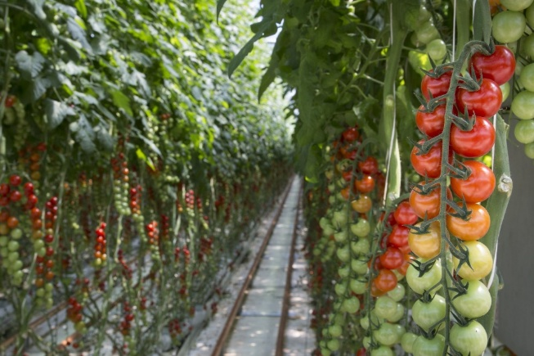

Outdoor / Market gardening
Open-field production remains the dominant system for many vegetable crops, especially leafy greens, brassicas, and root vegetables. These systems rely on natural soil conditions and seasonal climate patterns. Mechanisation is used, particularly for planting, cultivation, and harvesting. Open-field systems are generally less capital-intensive than greenhouse systems but are more exposed to climatic variability such as drought, heavy rainfall, frost, and wind.

Crop categories
Crops can be categorized into the following categories.
Annual crops – short-term: These crops have short production cycles and are often planted weekly or fortnightly to ensure continuous supply. Multiple crops can be grown on the same land within a single year.
Examples: Lettuce, Broccoli, Cauliflower

Annual crops – long-term: These crops require a longer growing period and typically produce one harvest per year as part of a planned crop rotation.
Examples: Potatoes, Kumara, Onions

Perennial crops: Perennial vegetables remain productive for several years once established.
Example: Asparagus - Asparagus beds can produce commercial harvests annually for up to 15–20 years.

Outdoor seasonal crops
These crops grow in field systems and are strongly influenced by seasonal conditions.
Examples: Leeks, Sweetcorn, Yams, Zucchini, Squash
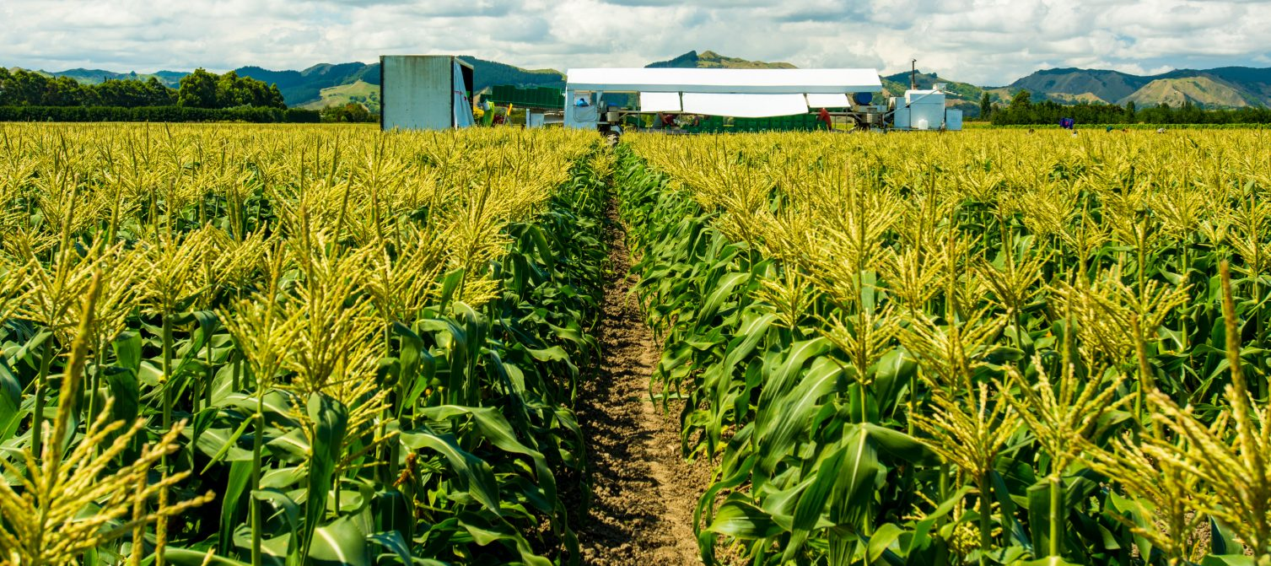

Location and climate factors
Successful vegetable production depends heavily on location and climate.
Commercial vegetable production is generally found on:
- Flat to gently rolling land
- Free-draining, friable soils
- Areas with reliable irrigation water
- Regions with good access to transport and processing facilities.

Proximity to processing facilities is particularly important for perishable crops such as leafy greens. However, improvements in refrigerated transport have reduced the impact of distance to market.
Some crops e.g., broccoli and cabbage can be grown year-round in suitable regions. Others, such as kumara, potatoes, squash, sweetcorn, and asparagus, are strongly seasonal.
Greenhouse heating and environmental control systems are used to extend growing seasons and supply markets during winter.

Commonly produced vegetables in New Zealand
Outdoor crops
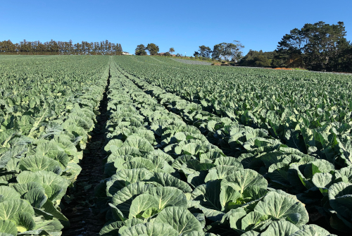
- Onions (a major export crop)
- Carrots
- Parsnips
- Broccoli
- Cauliflower
- Cabbages
- Potatoes
- Squash
- Leafy greens

Greenhouse crops
- Tomatoes
- Capsicums
- Cucumbers
- Fancy lettuce
- Asian greens and specialty greens

Key management practices in sustainable vegetable production.
Find out what your students know.
- What are management practices?
- Name management practices vegetable grower would use to grow crops.
- Outdoor vegetable growers use crop rotation. What is crop rotation and why do growers use one?

Management practices
Sustainable vegetable production focuses on maintaining soil health, improving resource efficiency, and minimising environmental impact.

Crop rotation
Crop rotation is an important part of outdoor vegetable farming. It means growing different crops on the same piece of land in a planned order over time.
For example, a paddock might be planted with potatoes one year, oats the next year, and carrots after that. Instead of growing the same crop again and again, farmers change what they grow each season.
Crop rotations often include cover crops. These are plants that are not harvested but are grown to improve the soil. They are left to break down and add organic matter back into the soil.
Some rotations also include animals, such as grazing pasture, which can help improve soil health.
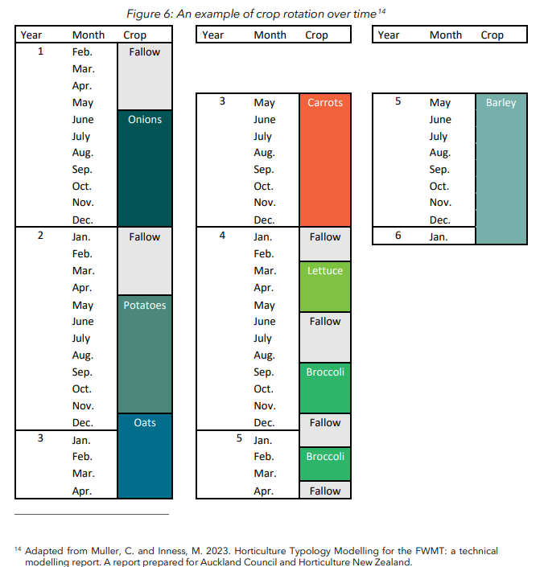
In commercial vegetable farming, crop rotations can be quite complex and carefully planned. Some rotations last 8–12 years and require good decision-making to keep the soil healthy and productive.

Crop rotation helps to -
- Maintain soil fertility.
- Reduce soil-borne diseases.
- Minimize pest build-up.
- Improve soil structure.
- Break weed cycles.

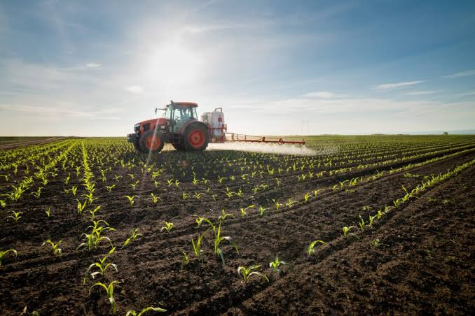
Soil cultivation and soil health
Successful vegetable production depends on:
- Fertile, free-draining soils.
- Good soil structure.
- High water-holding capacity.
- Regular soil testing to guide fertiliser applications.

Increasingly, growers are adopting reduced tillage and regenerative practices to improve long-term soil health. Practices include:
- Minimising soil compaction
- Maintaining organic matter levels
- Using cover crops to protect soil
- Avoiding over-cultivation

Irrigation and nutrient management
Vegetable crops have high water and nutrient demands.
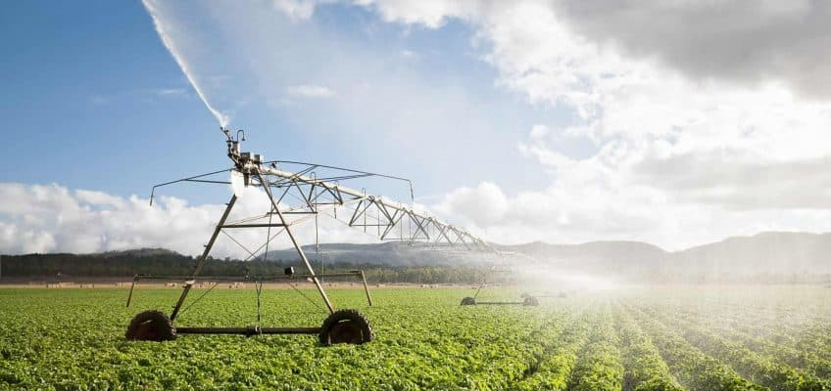
- Precision irrigation systems and technology are commonly used to ensure optimal soil moisture.
- Nutrient inputs are carefully managed to maximise yield and minimise nutrient leaching.
- Fertigation is widely used in greenhouse systems.
- Nutrient budgeting helps reduce environmental impact, particularly nitrogen loss.
- Water management is especially important in regions prone to drought.

Pest, disease, and weed control
Pest, disease and weeds can significantly impact crop yield and quality. Modern vegetable production relies on integrated pest management (IPM).
Key strategies include:
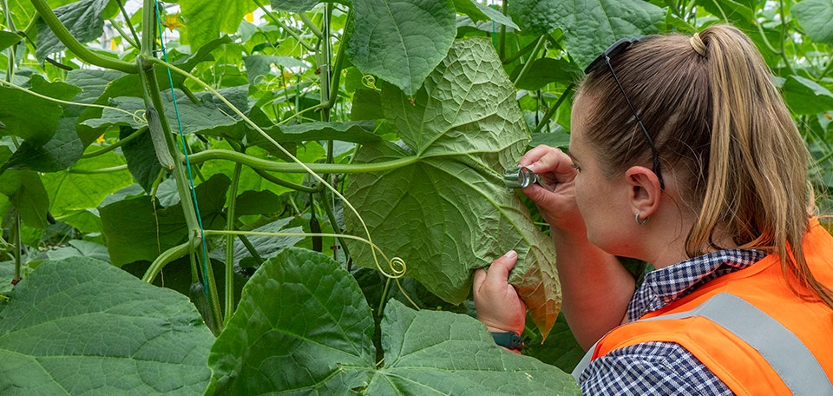
- Biological control agents
- Crop monitoring and threshold-based spraying.
- Use of resistant varieties
- Crop rotation
- Mechanical / robotic weed control
- Targeted herbicide application

Emerging technologies are improving efficiency, and can reduce chemical inputs including:
- Robotics for weeding and harvesting
- Drone technology for crop monitoring
- GPS-guided machinery
- Precision spraying systems

Year-round supply strategies
To ensure consistent supply to domestic supermarkets:
- Planting times are staggered.
- Production is spread across different climatic regions.
- Fast-growing crops such as lettuce and Asian greens are planted in succession.
- Greenhouse heating and environmental controls supply markets during winter.
- Cold storage facilities allow some crops e.g., onions and potatoes to be stored for extended periods.

Mechanisation
Large-scale mechanised planting, harvesting and grading systems are widely used in commercial vegetable production. Mechanisation improves efficiency and reduces labour requirements, although manual labour remains important for harvesting delicate crops.

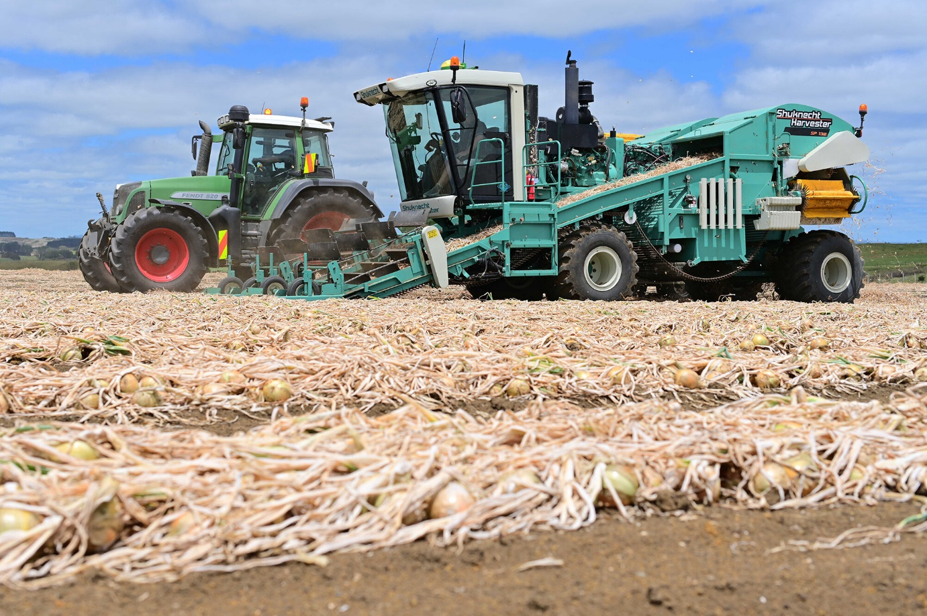

Activity 1: Summary of the Vegetable Production in New Zealand
Use the Words in the box to fill in the gaps to summarise vegetable production in New Zealand.
fresh, harvest, fields, outdoors, hydroponics, year-round, weather, soil, sunlight, frost, wind, plant, carrots, tomatoes, broccoli, lettuce, cabbage, capsicums, cucumbers, eggplants, greenhouse, open, temperature, light, water, drought, season

Vegetables in New Zealand are grown using two main methods: ____________ growing and ____________-field growing.
Greenhouse vegetables are grown ____________ in special buildings called greenhouses. Growers carefully control the ____________, ____________, ____________, and nutrients.
Many greenhouse vegetables are grown without ____________ using a system called ____________. This method helps vegetables grow ____________ ____________ and protects them from bad ____________.
Some vegetables commonly grown in greenhouses include:

Open-field vegetables are grown ____________ in ____________. Growers plant vegetables in large ____________ and rely on natural ____________, rainfall, and seasonal ____________.
Machines are often used to ____________ and ____________ crops. However, these vegetables can be affected by ____________, ____________, ____________, or ____________.
Examples of vegetables grown in open fields include:

Both growing systems help provide ____________ vegetables for people in New Zealand throughout the ____________.

Answer
Vegetables in New Zealand are grown using two main methods: greenhouse growing and open-field growing.
Greenhouse vegetables are grown indoors in special buildings called greenhouses. Growers carefully control the temperature, light, water, and nutrients.
Many greenhouse vegetables are grown without soil using a system called hydroponics. This method helps vegetables grow year-round and protects them from bad weather.
Some vegetables commonly grown in greenhouses include:
- tomatoes
- capsicums
- cucumbers
- eggplants
Open-field vegetables are grown outdoors in soil. Growers plant vegetables in large fields and rely on natural sunlight, rainfall, and seasonal weather.
Machines are often used to plant and harvest crops. However, these vegetables can be affected by drought, rain, frost, or wind.
Examples of vegetables grown in open fields include:
- carrots
- broccoli
- cabbage
- lettuce
Both growing systems help provide fresh vegetables for people in New Zealand throughout the year.

Activity 2: Crop type sorting
- Read the descriptions of crop categories.
- Place each vegetable into the correct category.
Asparagus, Broccoli, Cauliflower, Kumara, Lettuce, Onions, Potatoes,

Crop Category | Examples
Annual crops (short-term
Annual crops (long-term)
Perennial crops
3. Discuss why growers plant short-term crops more frequently during the year?

Activity 3: Designing a market garden
Scenario
You are a commercial vegetable grower planning to start a market garden in your region. Your aim is to choose crops that will grow well in your area and could be sold at local farmers markets or to supermarkets.
- Choose three vegetables you want to grow in your market garden.
- Explain why you chose these vegetables
- Modern horticulture aims to reduce environmental impacts while maintaining productivity.
- List two sustainable management practices you would use in your market garden.
- Explain how these practices help protect the environment or improve soil health.

- Draw a simple layout of your market garden showing:
- crop areas
- implement sheds
- packhouse
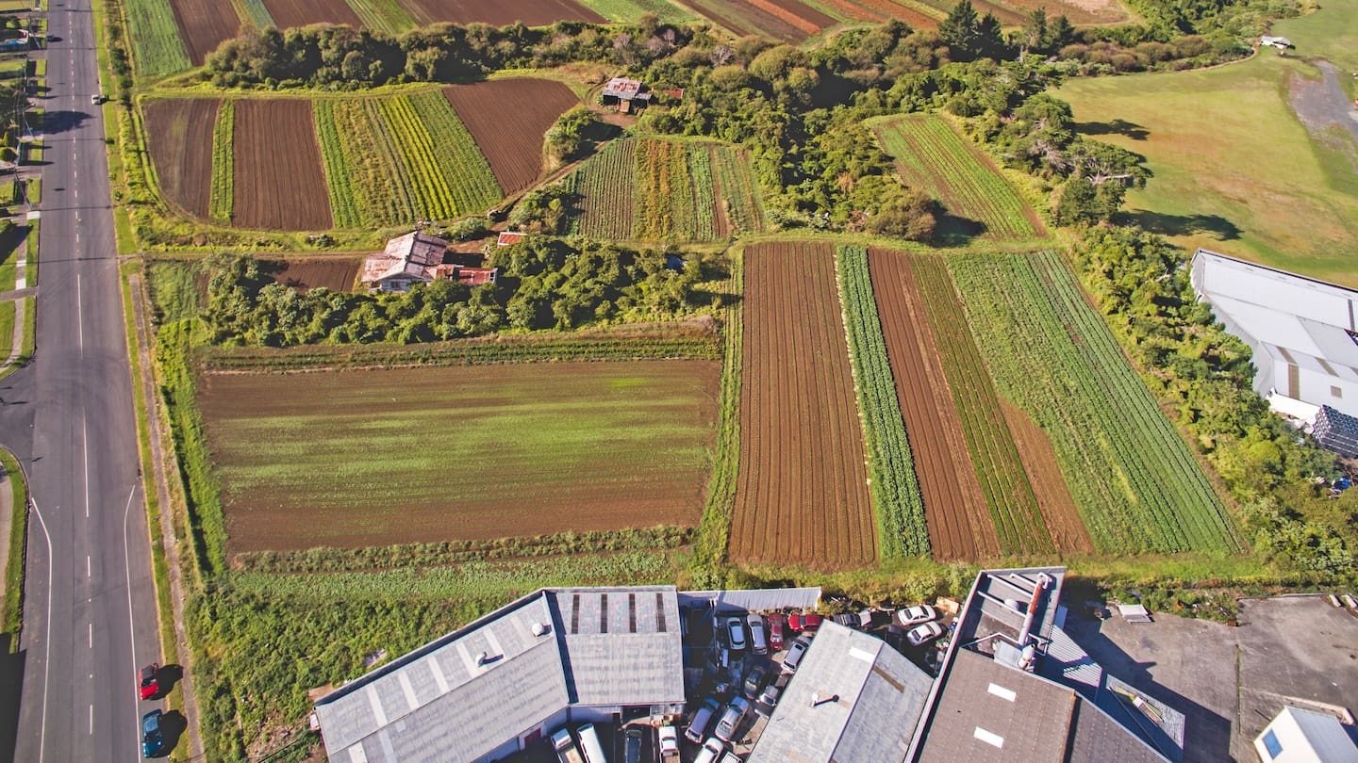
- irrigation

