Topic 5
Growing Media in Vegetable Production Teachers’ Guide
Key learning outcome: Students will be able to -
- Name different growing media used in vegetable production.
- Describe the characteristics of different growing media.
- Understand how growing media influence plant growth and the quality of crops.

Supporting resources
- The junior Soil Science unit of work has more information, resources and activities. The key concepts covered in this unit are:
- Soil is an essential component to life
- Soil composition and components
- Soil investigation on soil properties
- Alternative growing media
- PPT Lesson 5 activities

Recommendations
Within this topic, there are multiple activities for students to complete. We recommend selecting the activity or activities that best suit your students.

Find out what your students know.
- What is growing media?
- What is soil?
- Is soil all the same?
- What makes soils different?
- How would this affect plant growth?
- Plants grown in a greenhouse are generally grown hydroponically. What is hydroponics?
- What advantages does hydroponics have over soil.
- Do activity 1: Mix and match soil and growing media terms
Growing Media in Vegetable Production
Growing media are fundamental to successful vegetable production, as they directly influence plant growth, yield, and produce quality. In New Zealand, commercial vegetable systems operate either in large-scale soil-based open fields or in high-technology hydroponic greenhouses. Despite the differences between these systems, both rely on carefully managed growing media to provide plants with essential support, water, air, and nutrients. Whether it is well-structured, fertile soil in field production or precisely controlled soilless substrates in hydroponics, the choice and management of growing media are critical to achieving consistent, high-quality crop production.

Soil-based production systems
Field production is still the main system used for many vegetable crops, especially leafy greens, brassicas such as cabbage and broccoli, and root vegetables such as carrots and potatoes.
These systems rely on soils that are:
- Well-structured
- Friable (crumbly and easy to work)
- Free draining
- Fertile
- Able to hold enough water for plant growth

The land is usually flat or gently rolling to allow machinery to operate easily and to reduce erosion.
Growers carefully manage their soils to keep them healthy and productive. Sustainable soil management helps maintain soil structure and long-term fertility.
Common soil management practices include:
- Minimising soil compaction
- Maintaining organic matter levels
- Using cover crops to protect and improve soil
- Avoiding over-cultivation
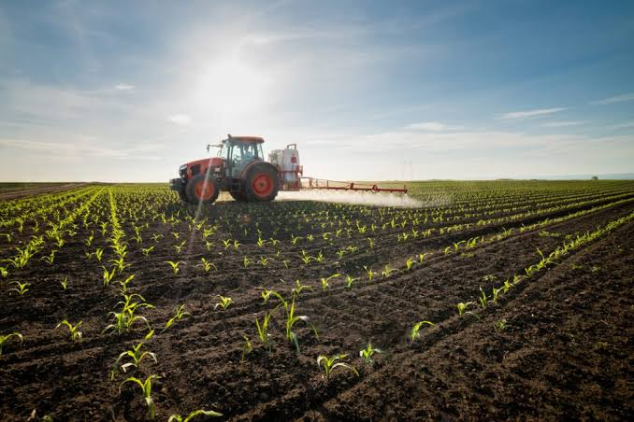
Soil structure
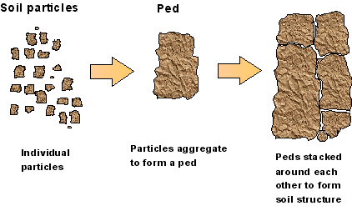
Soil particles naturally stick together to form small lumps called peds.
The way these particles group together into peds is called soil structure.
The size and strength of these peds affect soil quality.
- Small, crumb-like peds create more pore spaces.
- Pore spaces hold air and water.
- Good pore space allows water to drain properly.
- Roots can grow more easily through well-structured soil.

Soil structure can be described as:
- Weak – breaks apart too easily.
- Firm – hard and compacted.
- Friable – crumbly and ideal for plant growth.

Friable soil is best because:
- It is easy to cultivate.
- Plant roots grow easily through it.
- It is less likely to form a hard surface crust.
- It is less likely to be eroded by wind or water.
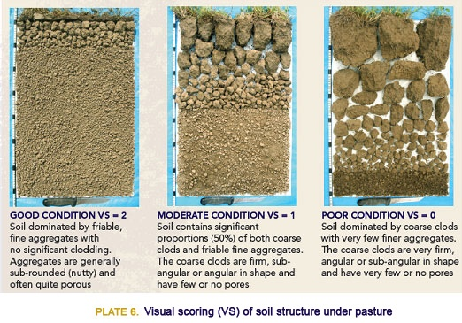
Soilless growing media (Hydroponics)
Greenhouse production is commonly used for growing high-value crops such as tomatoes, capsicums, cucumbers, Asian greens, and eggplants to provide a year-round supply.
Instead of growing in soil, greenhouse crops are grown in soilless media using hydroponic systems.
In hydroponics:
- Plants grow in an inert (non-soil) material.
- Water and nutrients are delivered directly to the roots.
- This is usually done through a fertigation system (nutrient solution delivered through drip irrigation).

Common growing media include:
- Rockwool
- Coconut fibre (coir)
- Pumice

Characteristics of common soilless media

Rockwool
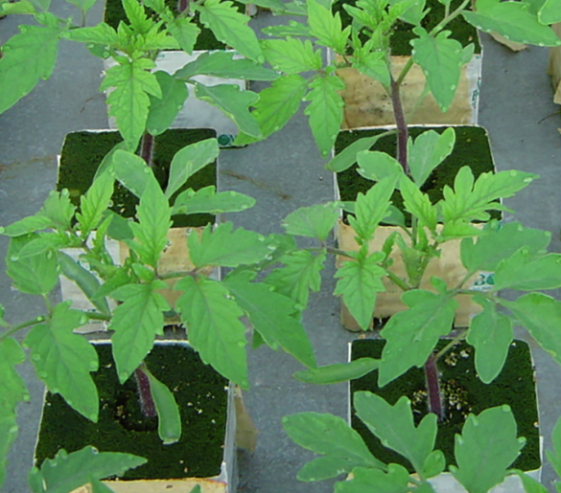
Characteristics:
- Sterile and inert
- Very high porosity (lots of air spaces)
- High water-holding capacity
Advantages:
- Plants can still access water even when it dries out
- Lightweight
- Good control of nutrient levels (EC control)
- Excellent aeration
Disadvantages:
- Naturally high pH (around 8)
- Requires careful nutrient management
- Disposal can be difficult

Coconut fibre (Coir)
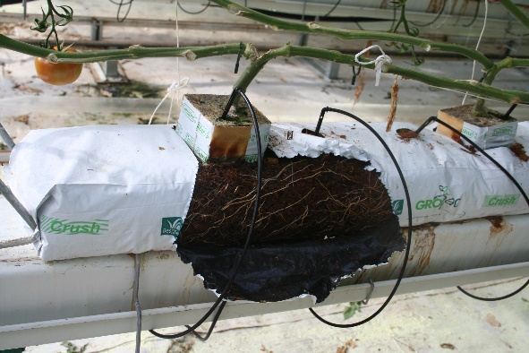
Characteristics:
- Made from coconut husks
- High water-holding capacity
- Good oxygen retention
- High cation exchange capacity (can hold nutrients)
Advantages:
- Renewable and biodegradable
- More sustainable than many inorganic media
- Good balance of water and air
- Slightly acidic to neutral pH (5–6.8)
Disadvantages:
- May contain high salt levels (sodium and chloride)
- Can break down over time

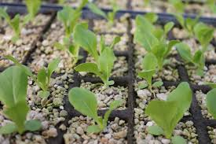
Pumice
Characteristics:
- Lightweight volcanic rock
- Porous and inorganic
- Good drainage
Advantages:
- Sterile and inert
- Neutral pH (6.5–7.5)
- Improves aeration and drainage
Disadvantages:
- Holds less water than rockwool or coir
- Can be sharp and may damage roots if not handled carefully

Topic 5: Growing media activities
The junior Soil Science unit of work has more information, resources and activities. The key concepts covered in this unit are
- Soil is an essential component to life
- Soil composition and components
- Soil investigation on soil properties
- Alternative growing media

Activity 1: Mix and match soil and growing media terms
- There is a drag and drop version in the PPT lesson 5 activities
Draw a line from the term to match the correct definition
Term | Definitions
Soil structure | Spaces in soil that hold air and water
Friable soil | A growing system where plants are grown without soil
Pore spaces | Crumbly soil that is easy to work and ideal for root growth
Soil peds | Small clumps of soil particles grouped together
Compaction | Material that does not supply nutrients on its own
Hydroponics | Delivery of nutrients through irrigation water
Fertigation | A lightweight volcanic material that improves drainage
Inert media | The arrangement of soil particles into clumps
Rockwool | A sterile growing medium with high water-holding capacity
Coconut fibre | Plant and animal material that improves soil fertility
Pumice | A renewable growing medium made from coconut husks
Organic matter | When soil becomes dense and hard, reducing air spaces

Answer
Term | Definitions
Soil structure | The arrangement of soil particles into clumps
Friable soil | Crumbly soil that is easy to work and ideal for root growth
Pore spaces | Spaces in soil that hold air and water
Soil peds | Small clumps of soil particles grouped together
Compaction | When soil becomes dense and hard, reducing air spaces
Hydroponics | A growing system where plants are grown without soil
Fertigation | Delivery of nutrients through irrigation water
Inert media | Material that does not supply nutrients on its own
Rockwool | A sterile growing medium with high water-holding capacity
Coconut fibre | A renewable growing medium made from coconut husks
Pumice | A lightweight volcanic material that improves drainage
Organic matter | Plant and animal material that improves soil fertility

Activity 2: What makes good soil?
- There is a version in the PPT lesson 5 activities.

- Read the list of words in the box and highlight or circle the words that describe good soil for growing vegetables.
hard, friable, fertile, dry like dust, free-draining, crumbly, holds water for plants,
loose, compacted

- What does friable soil mean?
- Why do plants grow better in soil with pore spaces?
- Draw a picture of healthy soil.
Label:
- soil crumbs (peds)
- plant roots
- air spaces
- water
Activity 3: Growing media investigation
Learning objective
Investigate how different growing media hold water and support plant growth.

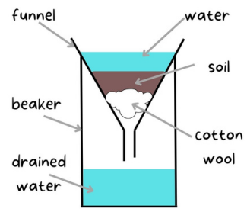
Materials
For each group:
- 3 clear funnels
- 4 measuring cylinders or beakers
- Cotton wool
- Garden soil
- Coconut fibre or use potting mix
- Pumice
- Water

Make a prediction
Before starting, students write their prediction.
Which growing media do you think will hold the most water and why?
- Soil
- Coconut fibre (coir) or potting mix
- Pumice

Method
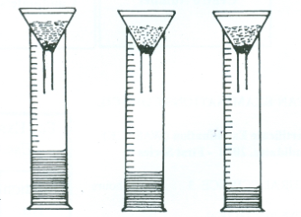
- Place a small piece of cotton wool into each funnel as shown in the diagram above
- Place the funnels into a beaker or measuring cylinder
- Fill each funnel with either soil, coconut fibre (coir) or use potting mix and pumice
- Pour the same amount of water into each funnel e.g. 40ml
- Observe what happens.
- Measure the volume of water in the measuring cylinder after 10 mins

- Observation and results

 | Soil | Coconut fibre  or  potting mix | Pumice
Volume of water after 10 minutes

- Which growing media holds the most water?
- Which growing media drains the fastest?

- Discussion questions
- Why might growers grow plants in coconut fibre or pumice instead of soil?
- Why is it important that plant roots get both water and air?
- Which growing media is best for growing vegetables in greenhouses?
- Why do you think this is the best growing media for growing vegetables in greenhouses?

Sample answers for discussion questions.
- Why might growers grow plants in coconut fibre or pumice instead of soil?
Growers use coconut fibre or pumice because they are usually sterile, and easier to control than soil. They also drain well and let growers control exactly how much water and nutrients plants get, which helps plants grow better. Soil varies in texture and structure and can contain pests, diseases, weeds and have variable nutrients which make them more difficult to manage.

- Why is it important that plant roots get both water and air?
Roots need water to absorb nutrients that help the plant grow. But they also need air to carry out respiration, which releases energy for growth. If roots don’t get enough air (for example, if they are waterlogged), they can rot and the plant may die.

- Which growing media is best for growing vegetables in greenhouses?
There isn’t just one “best” option, but coconut fibre is one of the most commonly used growing media for vegetables in greenhouses because it is inert, free of pests, diseases and nutrients and has good drainage and water holding capacity. Coconut fibre is biodegradable after being used, is 100% renewable and is a sustainable resource.

- Why do you think this is the best growing media for growing vegetables in greenhouses?
Coconut fibre is a good choice because it holds water well but also allows plenty of air to reach the roots. It is lightweight, easy to handle, and free from most pests and diseases. It also works well with controlled feeding systems, so growers can give plants exactly the nutrients they need for fast and healthy growth.

Activity 4: Test yourself questions
- What is growing media, and why is it important for plant growth?
- List two differences between soil-based production systems and hydroponic systems.
- What are four key characteristics of good soil for vegetable production?
- What is soil structure, and how does it affect plant growth?
- Why is friable soil considered ideal for growing vegetables? Give two reasons.
- What is hydroponics, and how are nutrients supplied to plants in this system?
- Name two types of soilless growing media used in hydroponics.
- Choose one soilless growing medium (rockwool, coir, or pumice) and describe one advantage and one disadvantage.

Answers
- What is growing media, and why is it important for plant growth?
Growing media is the material in which plants grow. It is important because it provides support, water, air, and nutrients needed for plant growth and affects crop quality and yield.

- List two differences between soil-based production systems and hydroponic systems.
- Soil-based systems grow plants in natural soil, while hydroponic systems use soilless media.
- In soil systems, nutrients come from the soil, while in hydroponics, nutrients are supplied through a nutrient solution (fertigation).

- What are four key characteristics of good soil for vegetable production?
- Well-structured
- Friable (crumbly)
- Free draining
- Fertile
- Able to hold enough water

- What is soil structure, and how does it affect plant growth?
Soil structure is the way soil particles group together into small lumps called peds. Good soil structure creates pore spaces that allow air and water movement, helping roots grow easily and improving plant growth.

- Why is friable soil considered ideal for growing vegetables? Give two reasons.
- It is easy for roots to grow through
- It allows good air and water movement
- Easy to cultivate
- What is hydroponics, and how are nutrients supplied to plants in this system?
Hydroponics is a method of growing plants without soil using inert media. Nutrients are supplied directly to plant roots through a liquid nutrient solution, usually via a fertigation system.

- Name two types of soilless growing media used in hydroponics.
- Rockwool
- Coconut fibre (coir)
- Pumice

- Choose one soilless growing medium and describe one advantage and one disadvantage.
Example Rockwool:
- Advantage: Holds a lot of water and provides good aeration
- Disadvantage: Difficult to dispose of

