Topic 6
Vegetable Plant Structure Teachers’ Guide
Key learning outcome: Students will be able to
- Understand that vegetable plants are made up of cells, tissues, and organs.
- Know that the vegetables we eat are plant organs.
- Identify and name the main parts of a plant cell.
- Describe the function of cell parts in simple terms.
- Recognise some special types of plant cells and their functions.
- Understand how the shoot and root systems work together in a plant.

Supporting resources
More information, resources and activities on the structure and function of parts of a plant can be found in the junior unit of work Plant Form and Function .
The key concepts covered in this unit are;
- Uses of plants
- Plants can be classified into groups
- Plant parts have specific functions
- PPT Topic 6 activities
- The plant cell and its parts - Natural Science - Educational video for kids
- All About Plant Cells for Kids | Middle School Science | Twinkl USA
- Plant cells are tiny solar factories
- Palisade and Roots hair cell
- PLANT TISSUES | EASY to UNDERSTAND (suitable for senior students)
- Plant organs | The basic structure and function of each

Recommendations
Within this topic, there are multiple activities for students to complete. We recommend selecting the activity or activities that best suit your students.

Find out what your students know.
- What are all plants made up from?
- What are the main functions of the roots, leaves and stem of a plant?
Do Activity 1: What part of the plant do we eat?

Vegetable Plant Structure
Vegetable plants may look very different from one another, but they all share the same basic structure. Every plant is made up of cells, tissues, and organs that work together to help it grow, develop, survive, and reproduce.
Each plant part has a specific function. The vegetables we eat are actually different plant organs, such as roots (carrots), leaves (lettuce), stems (celery), flowers (broccoli), fruits (tomatoes), or seeds (peas).
Carrot  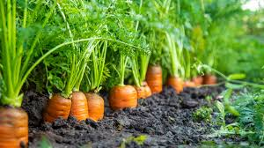 | Lettuce  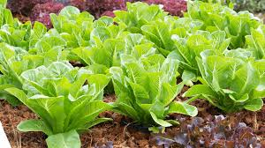
Celery  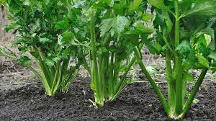 | Broccoli  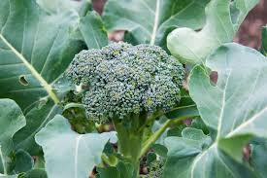
Tomatoes  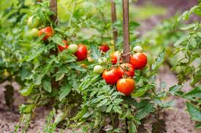 | Peas  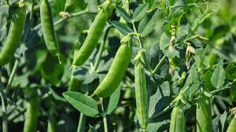

The relationship between structure, how something is built and function, what it does is very important in plants. The way cells are shaped and organised allows them to perform specialised jobs that help plants grow, develop, survive, and reproduce.

The cell level
All plants, including vegetable plants, are made up of microscopic units called cells. Plant cells have special structures that help them function efficiently.
Watch
The plant cell and its parts - Natural Science - Educational video for kids
Other videos
- All About Plant Cells for Kids | Middle School Science | Twinkl USA
- Plant cells are tiny solar factories

Basic plant cell structure
All plant cells have
- Cell wall – A rigid outer layer that provides support and shape.
- Cell membrane – Controls what enters and leaves the cell.
- Cytoplasm – A jelly-like substance that contains the cell organelles such as the nucleus and is where chemical reactions occur.
- Nucleus – Contains DNA, which controls the cell’s activities.
- Chloroplasts – Contain chlorophyll and carry out photosynthesis.
- Large central vacuole – Stores water and helps keep the plant firm (turgid).

Simple plant cell diagram
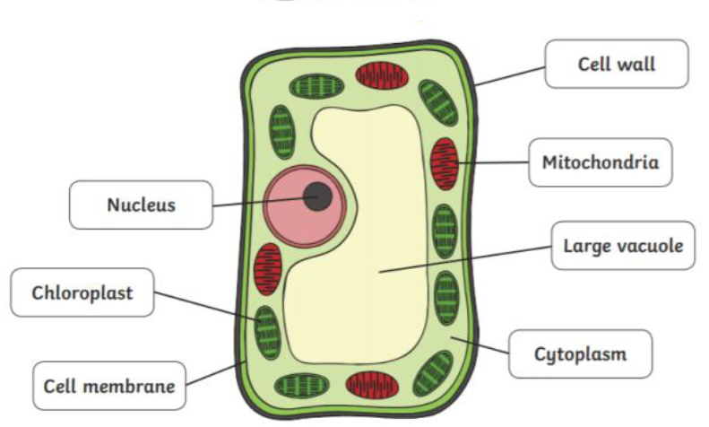

Do
- Activity 2: Inside a plant cell.
- Activity 3: Looking at plant cells

Specialisation of cells
Most cells, when they have finished dividing and growing, become specialised. When cells are specialised;
- they do one particular job
- they develop a distinct shape
- they carry out specific kinds of chemical change in their cytoplasm
Examples of specialised cells are mesophyll, xylem and phloem.

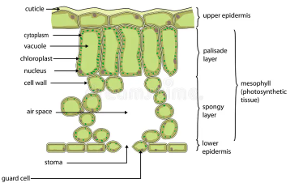
Leaf cells
Leaves contain specialised cells that carry out photosynthesis called mesophyll cells.
Mesophyll cells
- are packed with chloroplasts.
- is the main site of photosynthesis.
- convert light energy into chemical energy (glucose).

Stem cells
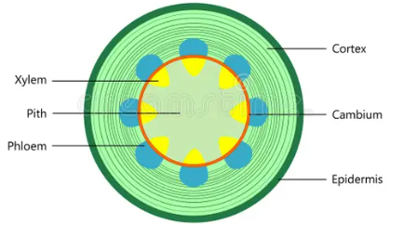
The stem contains specialised cells for transport and support.
Xylem cells
- Carry water and minerals upward from the roots
- Provide structural support due to thick lignified walls
Phloem cells
- Transport sugars from the leaves to the rest of the plant
- Deliver nutrients to growing tissues such as buds and roots
Parenchyma cells
- Found in the cortex and pith of the stem
- Store food (starch) and water
- Help maintain the structure of the stem
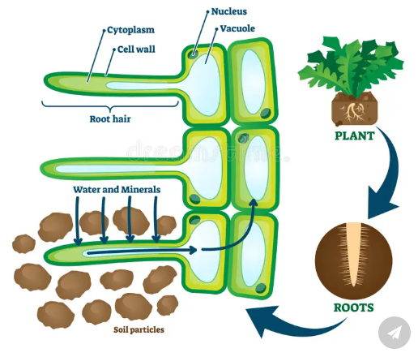
Root cells
Roots contain specialised cells that absorb water and transport substances through the plant.
Root hair cells
- Have long extensions that increase surface area
- Absorb water and minerals from the soil
Xylem cells
- Transport water and minerals from the roots to the leaves.
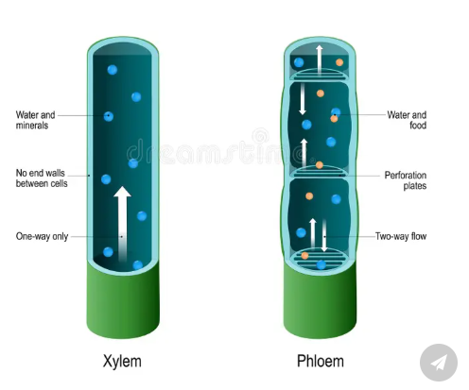
- Made of dead cells forming long, hollow tubes
- Walls are strengthened with lignin for support
Phloem cells
- Transport sugars made in the leaves to other parts of the plant.
- Movement occurs up and down the plant supplying food to growing regions and storage organs (e.g. roots)

Watch Palisade and Roots hair cell
https://www.youtube.com/watch?v=_N2raYmlmzQ

The tissue level
Tissues are groups of similar specialised cells that work together to perform a specific function. These cells have similar structures that enable them to carry out their roles efficiently.

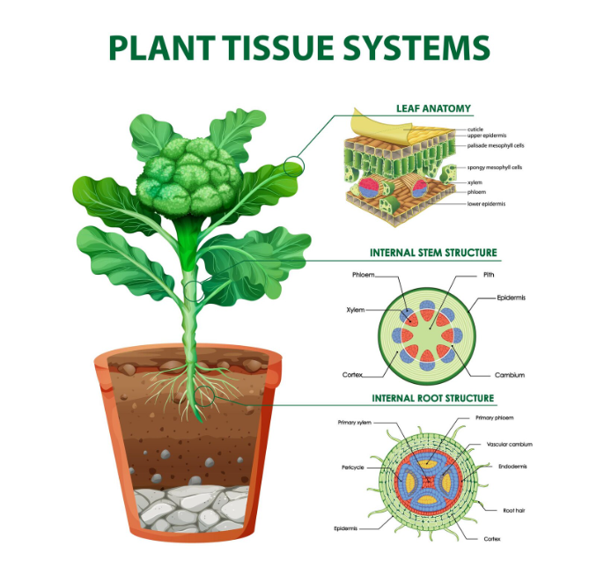

https://www.freepik.com/free-vector/diagram-showing-plant-tissue-systems_13225510.htm

Leaf tissues
Mesophyll tissue
Contains many chloroplasts and is the main site of photosynthesis.
- Palisade mesophyll: tightly packed cells for maximum light absorption
- Spongy mesophyll: loosely arranged with air spaces for gas exchange
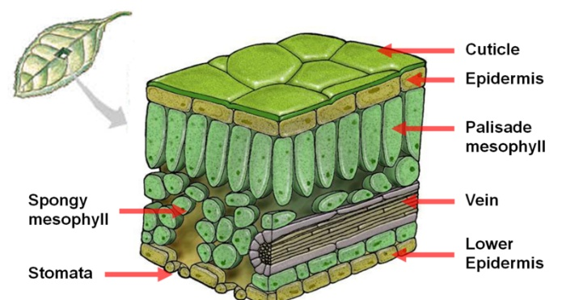
Epidermal tissue
Forms the outer protective layer of the leaf. Contains stomata, tiny pores that allow gas exchange and guard cells control the opening and closing of stomata.

Stem tissues
Vascular tissue
Also contains xylem and phloem, arranged in vascular bundles. These tissues transport water, minerals, and food up and down the plant.
- Xylem is usually located toward the inside
- Phloem is toward the outside
Ground tissue (cortex and pith)
- Cortex: found just inside the epidermis; helps with storage and support
- Pith: located in the centre of the stem; stores nutrients and helps maintain structure
Epidermal tissue
The outer layer that protects the stem and reduces water loss, often covered by a waxy cuticle.
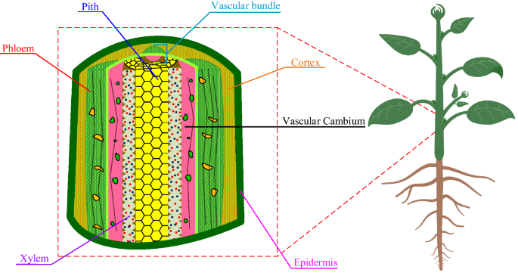

Taken from https://www.nature.com/articles/s41598-022-06737-z
Root tissues
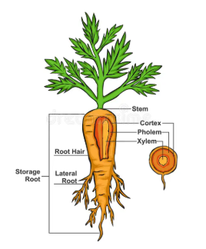
Vascular tissue
Made up of:
- Xylem: transports water and mineral ions from roots to the rest of the plant
- Phloem: transports sugars (food) from leaves to other parts of the plant
Together, they form a continuous transport system throughout the plant.
Cortex tissue
Located between the outer epidermis and the vascular tissue. Stores carbohydrates (energy reserves), often in the form of starch.

Watch video- suitable for senior students
Prior to showing this video to students, identify the sections of the video suitable for your students.
PLANT TISSUES | EASY to UNDERSTAND

Plant organs
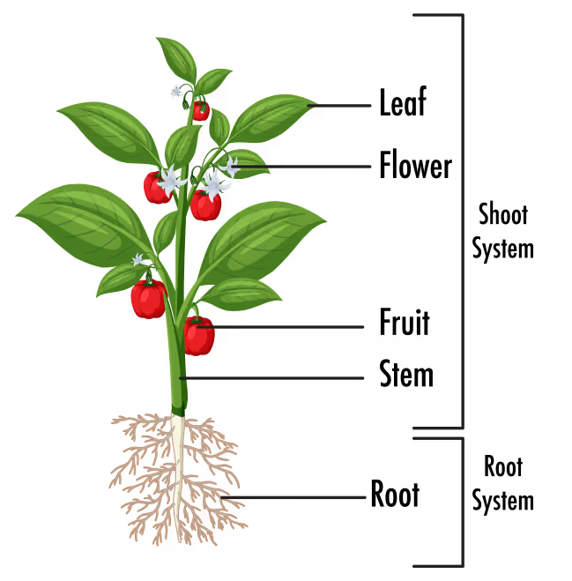
Plant organs are formed when different types of tissues work together to carry out a specific job. In plants like vegetables, these organs are organised into two main systems: the shoot system and the root system. The shoot system grows above the ground and includes the vegetative parts, such as stems and leaves, which help the plant make food through photosynthesis, as well as the reproductive parts like flowers and fruits. The root system is usually found below the ground, where it anchors the plant and absorbs water and minerals from the soil. Together, these systems allow the plant to survive, grow, and reproduce.

Plant organs diagram
Watch video- suitable for senior students
Prior to showing this video to students, identify the sections of the video suitable for your students.
Plant organs | The basic structure and function of each

Activities
More information and activities on the structure and function of parts of a plant can be found in the junior unit of work Plant Form and Function .
The key concepts covered in this unit are
- Uses of plants
- Plants can be classified into groups
- Plant parts have specific functions

Activity 1: What part of the plant do we eat?
- A drag and drop activity in PPT Lesson 6 Activities
- Write the vegetables beside the correct plant part.
Carrot, lettuce, celery, broccoli, tomato, peas, beetroot, cabbage, sweetcorn, cauliflower, radish (add to this list or change the vegetables)
Plant parts | Vegetables
Root
Leaf
Stem
Flower
Fruit
Seed

Activity 2: Inside a plant cell.
- Adapted to a drag and drop activity in PPT Lesson 6 Activities
Plant cells are made up of organelles.
Nucleus, Cell wall, Large vacuole, Chloroplast, Cell membrane,
Cytoplasm, Mitochondria

- Label the diagram of a plant cell using the words in the box

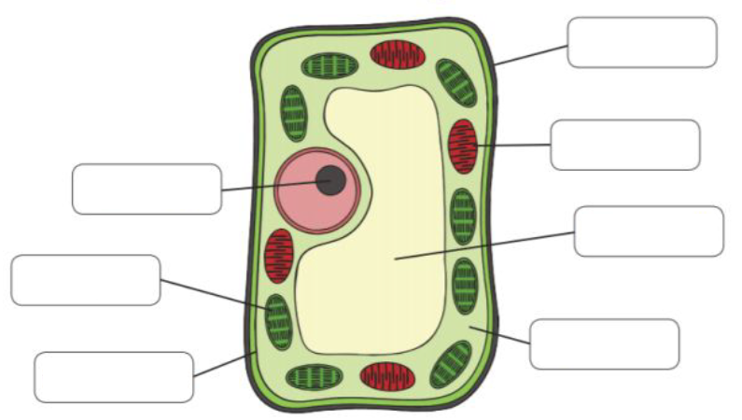

Activity 3: Looking at plant cells
Students observe plant cells under a microscope and identify key structures such as the cell wall, cytoplasm, and nucleus.
How to prepare an onion cell peel slide
Watch - Onion Epidermal Cell Peel Slide Preparation Practical Experiment-Start at 1.49
https://www.youtube.com/watch?v=kjU4GXFCSig
Materials
- Fresh vegetable e.g., onion or celery
- Microscope or magnifying lens
- Microscope slides and cover slips
- Dropper
- Water
- Iodine solution (optional, to make cells easier to see)
- Tweezers

Method
- Take a thin slice an onion, peel a thin layer of skin, epidermis).
- Place the slice on a microscope slide.
- Add a drop of water to keep it moist.
- Add iodine solution to stain the cells and make them easier to see.
- Carefully place a cover slip on top.
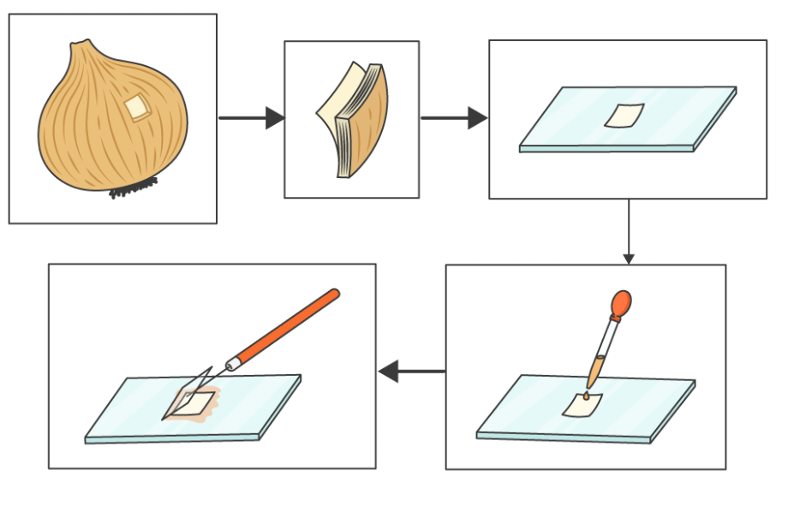
- Observe under the microscope
- Start with low power to locate the cells.
- Switch to higher power to see details.

- Look for key structures
- Cell wall – the rigid outer layer that gives the cell shape
- Cytoplasm – jelly-like substance inside the cell
- Nucleus – the control centre that contains DNA
- Vacuole – stores water and helps the plant stay firm
- Draw what you see
- In your book, draw a few cells.
- Label the cell wall, cytoplasm, and nucleus.

Discussion questions
- Why do you think the cell wall is important for plants?
- How does the vacuole help vegetables like carrots stay firm?

Discussion questions- Samples answers
- Why do you think the cell wall is important for plants?
The cell wall is important because it gives plant cells strength and support. It helps the plant keep its shape and stand upright instead of collapsing. The cell wall also protects the cell and stops it from bursting when it takes in water.

- How does the vacuole help vegetables like carrots stay firm?
The vacuole is a large space inside plant cells that stores water. When it is full of water, it pushes against the cell wall and makes the cell firm. In vegetables like carrots, this pressure keeps the cells stiff, which is why they feel crisp. If the vacuole loses water, the cells become soft and the carrot goes limp.
Activity 4: Exploring xylem and phloem in vegetables
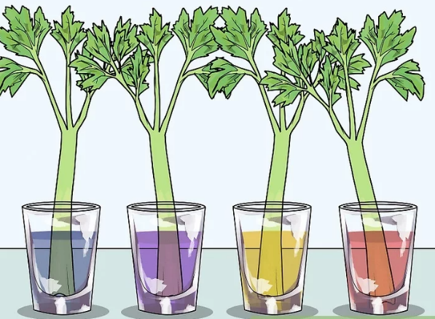
Students observe how water and nutrients move through plants using xylem and phloem.
Materials
- Celery stalks with leaves
- Water
- Food colouring e.g. red, blue, yellow or green
- Clear cups or jars
- Knife (for teacher use only)

Method
- Fill a clear cup, jar or beaker with water.
- Add a few drops of food colouring to the water.
- Trim the bottom of the celery stalk to make a fresh cut.
- Place the celery in the coloured water.
- Leave the celery in the coloured water for 2–4 hours or overnight for best results.
- Observe what happens to the celery stalk and leaves.

Discuss observations
- What part of the celery changes colour first?
- How does the water move through the celery?

Questions
- Which plant tissue carries water and minerals from the roots to the leaves?
- Which plant tissue carries food (sugars) from the leaves to other parts of the plant?

Sample answers
- Which plant tissue carries water and minerals from the roots to the leaves?
Xylem tissue moves water and dissolved minerals from the roots up through the plant to the leaves.

- Which plant tissue carries food (sugars) from the leaves to other parts of the plant?
Phloem tissue transports sugars made in the leaves during photosynthesis to other parts of the plant where they are needed for energy and growth.

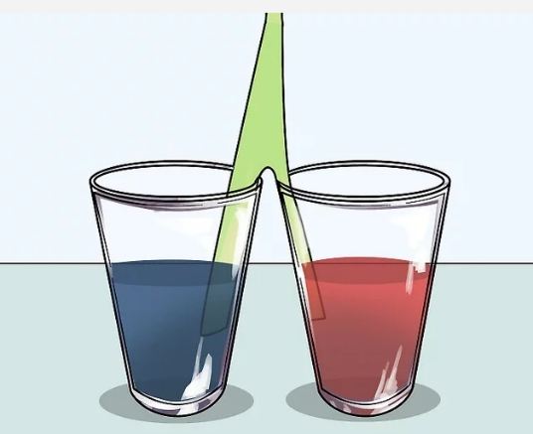
Extension: Mixing two colours with one celery stalk
Method
- Trim the bottom of the celery stalk to make a fresh cut.
- Use scissors to cut stalk in half up to 3cm from the top of the leafy part
- Place one half in one colour and the other half in another colour
- Leave the celery in the coloured water for 2–4 hours or overnight for best results.

Discussion
- Discuss what you think will happen.
- How is this experiment different than just having the whole celery stalk on one colour?

Activity 5: Summary
Plants are made of cells, tissues, and organs. Use these words to fill in the missing words:
Plants are made of tiny units called __________.
Groups of cells working together form __________.
Groups of tissues form plant __________ such as roots, stems, and leaves.

Activity 6: Test yourself questions
- What are all plants made up of?
- What is a plant organ?
- Name two plant organs that we eat as vegetables.
- What is the function of the cell wall in a plant cell?
- What does the nucleus do in a plant cell?
- Which part of the plant cell carries out photosynthesis?
- What is the main function of roots in a plant?
- What do xylem cells transport?
- What is the difference between the shoot system and the root system?
- Why are root hair cells important for plants?

Test yourself question answers
- Plants are made up of cells, tissues, and organs.
- A plant organ is a part of a plant made of different tissues that work together to do a specific job.
- Examples: roots (carrot), leaves (lettuce), stems (celery), flowers (broccoli), fruits (tomato), seeds (peas). Any two
- The cell wall provides support and gives the cell its shape.
- The nucleus controls the activities of the cell and contains DNA.
- Chloroplasts carry out photosynthesis.
- Roots anchor the plant and absorb water and minerals from the soil.
- Xylem cells transport water and minerals from the roots to the rest of the plant.
- The shoot system is above ground and makes food; the root system is below ground and absorbs water and anchors the plant.
- Root hair cells increase surface area to absorb more water and minerals from the soil.

Activity 7: Multiple-Choice Quiz: Vegetable Plant Structure
- What are all plants made up of?
A. Water and air
B. Cells, tissues, and organs
C. Leaves and roots only
D. Soil and sunlight

- What is a plant organ?
A. A type of soil
B. A part of a plant made of tissues that do a specific job
C. A single cell
D. A type of leaf

- Which of the following are plant organs we eat?
A. Rocks and soil
B. Roots and leaves
C. Water and sunlight
D. Air and minerals

- What is the function of the cell wall?
A. To carry water
B. To make food
C. To give support and shape
D. To control the cell

- What does the nucleus do?
A. Makes sugar
B. Controls the cell’s activities
C. Absorbs water
D. Transports minerals

- Which part of the cell carries out photosynthesis?
A. Nucleus
B. Cell membrane
C. Chloroplast
D. Cytoplasm

- What is the main function of roots?
A. To make flowers
B. To produce seeds
C. To anchor the plant and absorb water
D. To capture sunlight

- What do xylem cells transport?
A. Sugar
B. Oxygen
C. Water and minerals
D. Carbon dioxide

- What is the shoot system?
A. The part of the plant underground
B. The roots only
C. The above-ground parts like stems and leaves
D. The soil around the plant

- Why are root hair cells important?
A. They make seeds
B. They help the plant grow taller
C. They increase absorption of water and minerals
D. They protect the plant from insects

Answers
- B
- B
- B
- C
- B
- C
- C
- C
- C
- C

