CASE Study - Prawn Farm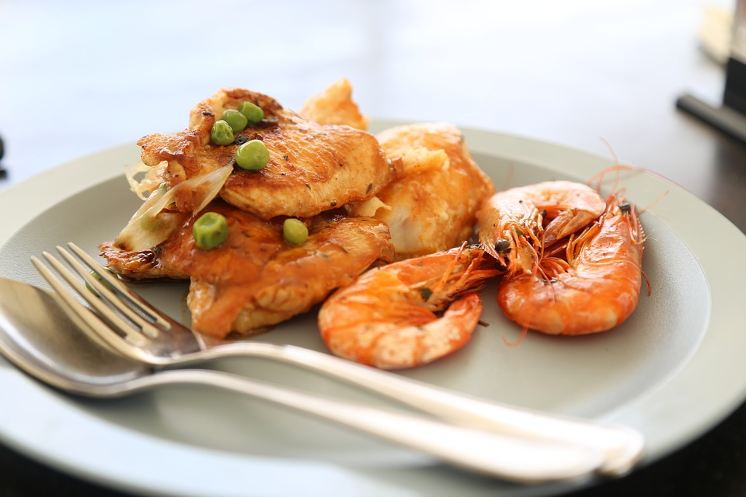
Paula Tails runs a prawn farm in Wairakei, Taupo. Her business had been expanding so she decided to approach the bank for a loan to help her build a new breeding pool.
The loan of $100,000 was approved in January and the funds were made available at the beginning of February (INFLOW - $100,000 Loan Feb). As the floating interest rates were currently lower than the fixed interest rates, Paula decided to float her loan at 5.25% pa.
The following information and estimates are available:
 | Sales  (Credit) | Sales  (Cash) | Prawn Farming Expenses  (credit 20%) | Prawn Farming Expenses  (cash 80%)
January |  | 60,000 60,000 | 2,800 | 12,800 16,000
February |  | 60,000 60,000 | 3.200 | 12,800 16,000
March |  | 70,000 90,000 | 3,200 | 19,200 24,000
April | 20,000 | 75,000 95,000 | 4,800 | 19,200 24,000
May | 20,000 | 80,000 100,000 | 4,800 | 40,000 50,000
June | 20,000 | 85,000 105,000 | 10,000 | 48,000 60,000
# sales include cash and credit

Working Tables -
 | January | February | March | April | May | June
Inflows
Cash Sales | 60,000 | 60,000 | 70,000 | 75,000 | 80,000 | 85,000
Credit Sales |  |  |  | 20,000 | 20,000 | 20,000
Outflows
Cash Expenses | 12,800 | 12,800 | 19,200 | 19,200 | 40,000 | 48,000
Credit Expenses | 2,800 | 3,200 | 3,200 | 4,800 | 4,800 | 10,000

- Paula is planning to start the build for the breeding pool in March. The build is to take two months and Paula will be required to make two payments of $50,000, one at the beginning of March and then another at the beginning of April. (OUTFLOW - $50,000 Build Mar and Apr)
· In order to help increase her sales, Paula will start to advertise in “FoodFirst”, a magazine for restaurants in New Zealand. This will cost her $7,000 in January and February, but decreases to $5,000 per month for the rest of the period. (OUTFLOW - $7,000 Advertising Jan and Feb and then Mar-Jun $5,000)
· Paula will also start to offer 30-day credit terms to the restaurant market. She anticipates that from March, $20,000 of sales each month will be on credit to restaurants. (INFLOW - Cash Sales/Credit Sales)
· 80% of the prawn farming expenses are paid in the month they are incurred and the remainder 20% are paid in the following month. December’s prawn farming expenses were $14,000. (OUTFLOW- Cash Expenses/Credit Expenses)

· Paula has a business mortgage on her prawn farm, which costs $14,450 per month. (OUTFLOW - Mortgage) Paula rents out the shop for a restaurant on site for $5,800 per month.(INFLOW - Rent)
· Currently Paula pays herself $8,000 per month (OUTFLOW - Drawings) and has three employees at a further $10,800 per month, though this rises from March to $14,400 (OUTFLOW - Wages $10,800 Jan-Feb, $14,400 Mar-Jun) Paula needs an extra employee for the new breeding pool.
· Operating expenses, such as electricity, vehicles, weed and pest control, repairs and maintenance, water, rates, communication, insurance etc. are currently $15,000 per month. (OUTFLOW - Operating Expenses $15,000 Jan-Apr, $18,000 May - Jun) Paula expects these to increase by 20% with the completion of the new breeding pool from the beginning of May.
· Other business expenses, miscellaneous and sundry items usually come to about $18,000 per year and are paid evenly throughout the year. (OUTFLOW - Business Expenses - 18,000/12 = $1,500 per month)
· The $100,000 loan was for a period of three years and with a floating interest rate of 5.25%, this would mean monthly repayments of principal and interest of $3,000 per month. (OUTFLOW - loan repayments Mar-Jun $3,000)
· Paula has an opening bank balance of $6,400.

YOU ARE REQUIRED TO
(a) On Sheet 1 prepare a cashflow forecast based on the information above

Paula did not know that she needed a consent for the new breeding pool and therefore had not factored this cost into her cash flow forecast when she applied for the initial bank loan. The consent fee is $12,000 and is to be paid in May. (OUTFLOW - consent fee $12,000 May)

YOU ARE REQUIRED TO
(b) Copy Sheet 1 into Sheet 2, and show the effect of the consent fee on Paula’s Prawn Farm

(c) Copy Sheet 2 onto Sheet 3 and show a possible response(s) of Paula’s Prawn Farm to the consent fee on the cash flow forecast.

(d) Explain and justify the possible response(s) of Paula’s Prawn Farm, using evidence from the cash flow forecast to support your explanation/s. Consider whether certain features of the Prawn Farm have affected its response to the unexpected invoice.

