
Excel 2013 – Basic Exercises
- Creating Simple Charts
Download and open the “Animal Numbers” spreadsheet from iLearn. Click on the “Table 2” Workbook.
Create a column / bar chart showing the total amount of Lamb in New Zealand for each year:
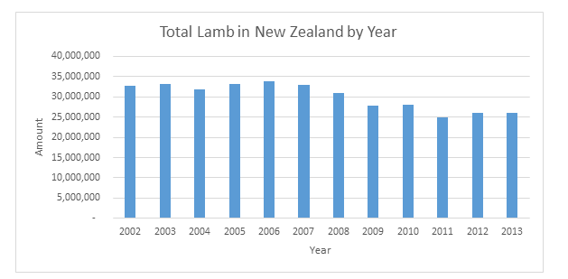
Make sure you use the correct axis labels and add a title. It should look the same as the screenshot above. Replace that chart with a copied version of your own. (Click on the chart in Excel, and copy about paste it above – it will paste as an excel object, not image)
Download and open the “Principal markets” spreadsheet from iLearn. Click on “2.01” Workbook. Create a Pie chart showing the top 10 Exports like the chart below. Replace that chart with a copied version of your own. (Click on the chart in Excel, and copy about paste it below – it will paste as an excel object, not image).
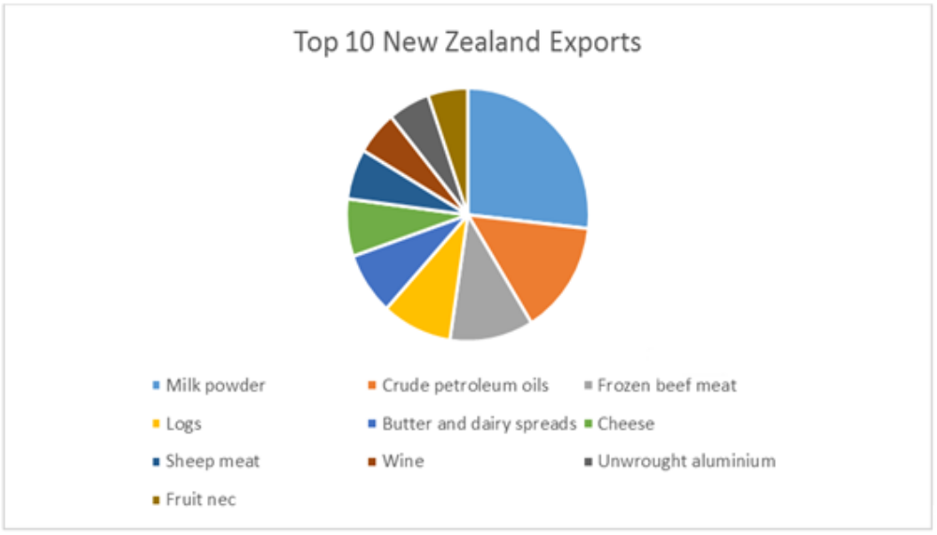

- Data Filters
Download and open the movies spreadsheet from iLearn, Select the title rows and use the auto filter feature to answer the following questions:
How many Sci-Fi movies are on the list?
Paste a screenshot of your filter in action below (crop it to make it look tidy).
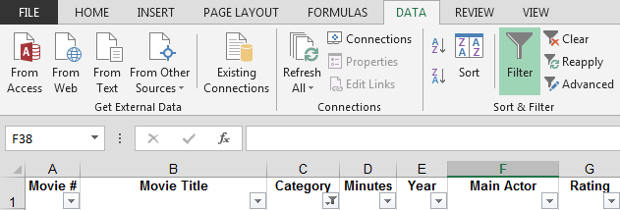
How many Comedy movies are on the list?
Paste another screenshot of your filter in action below (crop it to make it look tidy).
- Average Formula
Download and open the “Research and Development” spreadsheet from iLearn. Click on the “Table 2” workbook.
Create column on the right of the existing table. Use the format painter and borders to copy over the styles. The new column will be titled 2010 / 12 Average. In this cell work out the average for each individual category using the formula =average( ) and selecting the 2010 and 2012 values. If you have done this correctly your values should match the table below. You can copy the formula down using the filling handle.
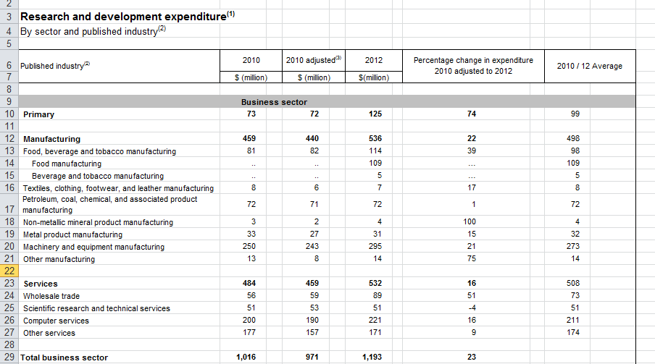

- IF Statements
Click on the “Table 4” workbook.
Your task is to create to IF statement to print a High or Low label conditional on the amount of spending. If total spending was above 100 it should print High, if is below it should print low. Your formula should be in column L. IF statements look like:
=IF(A1>=100,”Print this if condition met”,”Print this if condition not met”)
Where A1 is the cell being looked at
Where >= is any operator such as =, <, or >
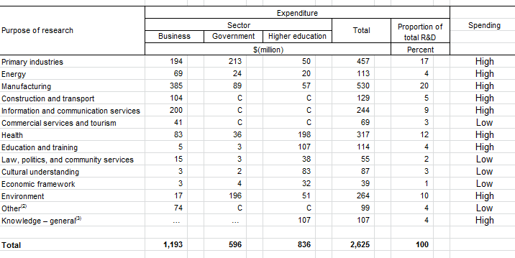
Replace the screenshot above with your own.
- Sum, Max, Min
Download and open the “Commodity” spreadsheet from iLearn. Click on the “Tab 3.01” workbook.
Using the formulas: Sum, Max and Min, create summaries in rows 63, 64 and 65 as shown in the screenshot. Replace the screen shot below with one of your own. Use different formatting than mine.
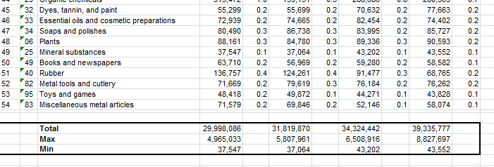
Submit this completed task to iLearn. There is a submit box under the Spreadsheet section.

