Marist College

Level 2 Accounting 2024

Answers

Agribusiness Cashflow As 91868

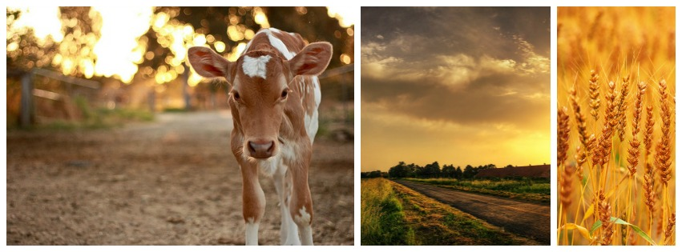

Record your final bank balance for each exercise here.
1 | 8795 |  | 8b | Various
2 | 31107 |  | 9 | 2000
3 | 16573 |  | 10 | 27000
4 | 500 |  | 11 | (24532)
4a | (1750) |  | 13 | (2110)
4b | Various |  | 14 | 5512000
5 | 20900 |  | 15 | Forecast | (50740)
6 | (950) |  | 15 | Actual | (179158)
6a | (1450) |  | 16 | Forecast | 1,000,000
6b | Various |  | 16 | Actual | 1,290,000
7 | (37400) |  | 17 | 50,000
7a | (49400) |  | 17a | Various
7b | Various |  | 18 | 175135
8 | 370 |  | 19 | 29560
8a | (9630) |  | 20 | 276024

Answers to Cashflow Forecasting exercises
Ex 1  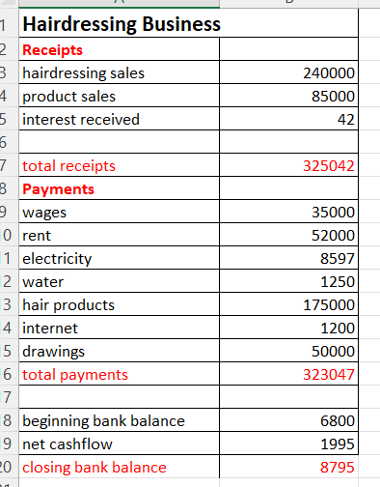 | 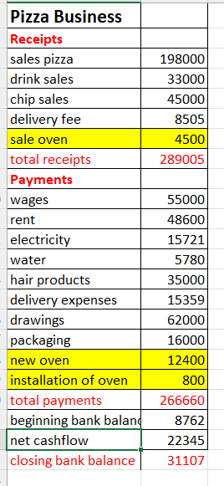 | 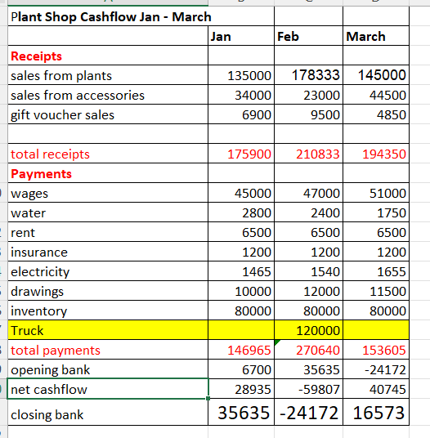

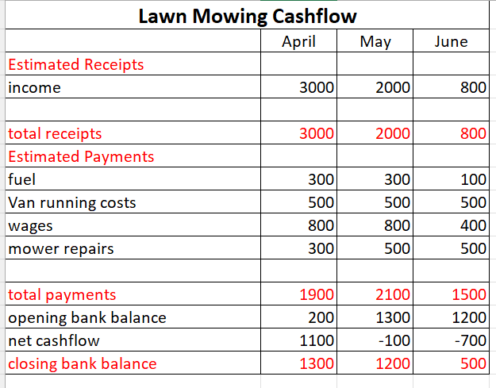  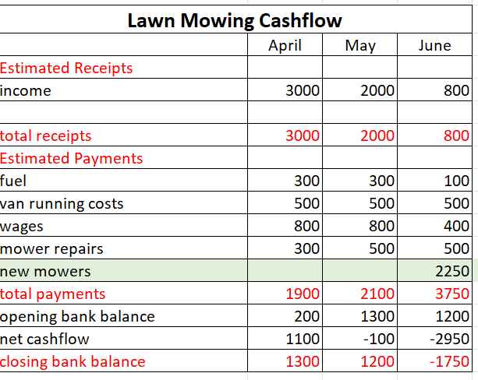 | 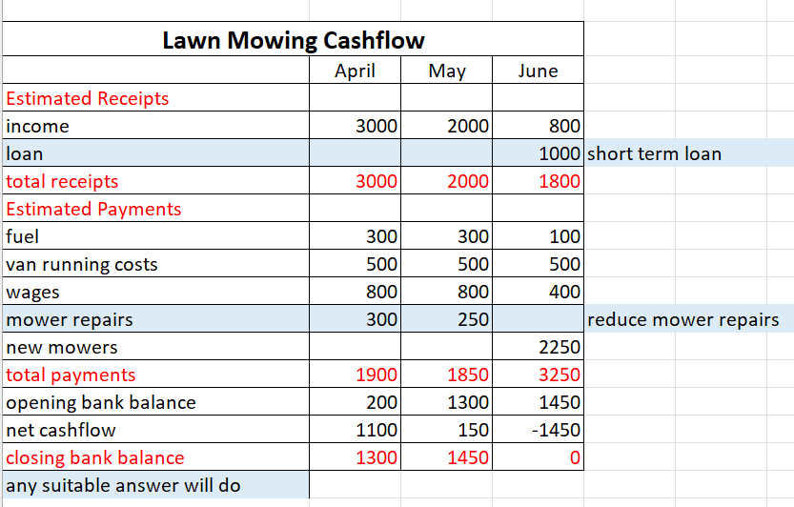

Ex 5 Ex 6

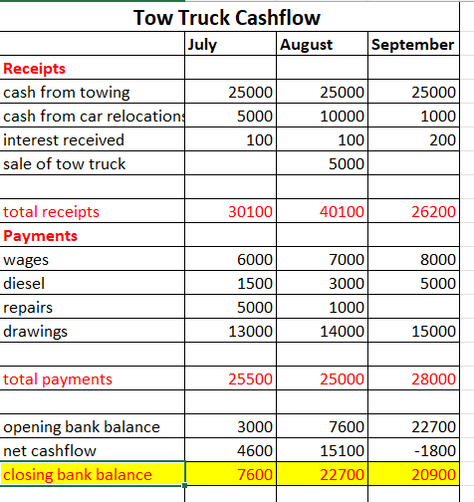 | 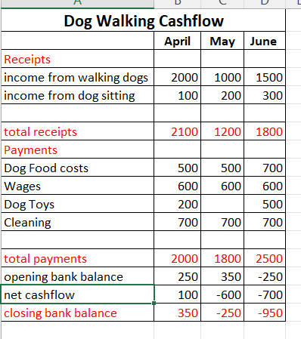

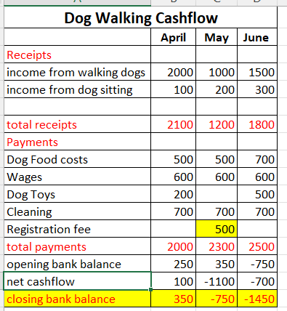 | 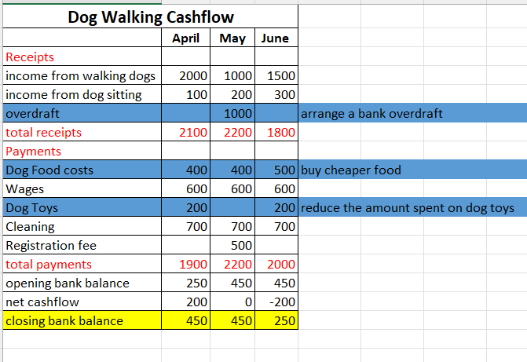

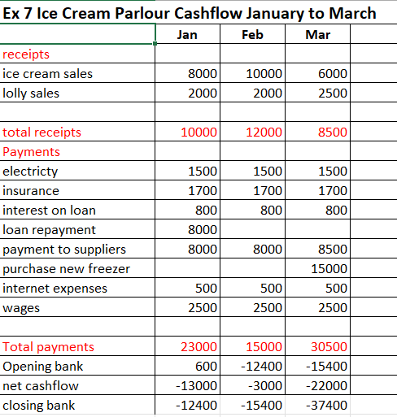 | 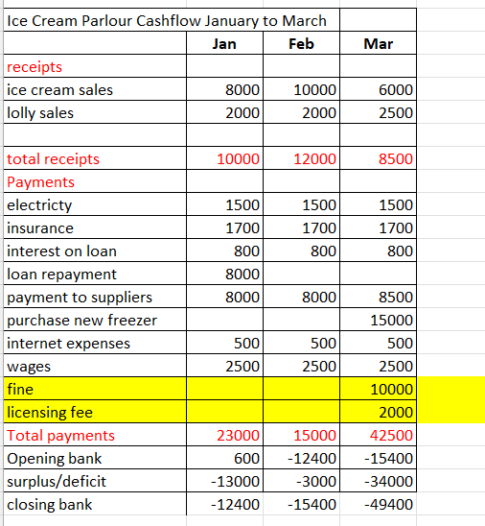

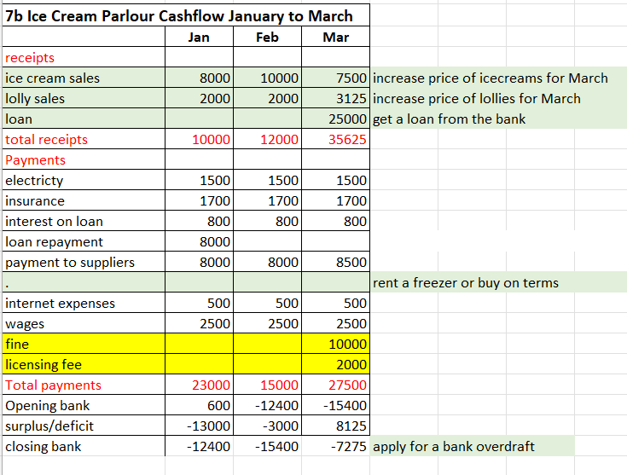
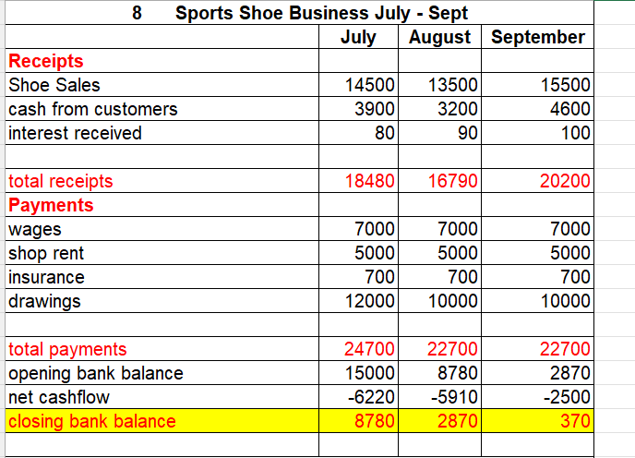 | 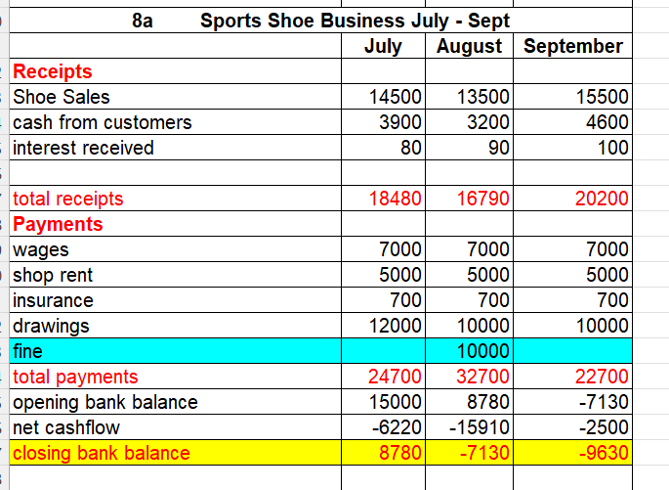

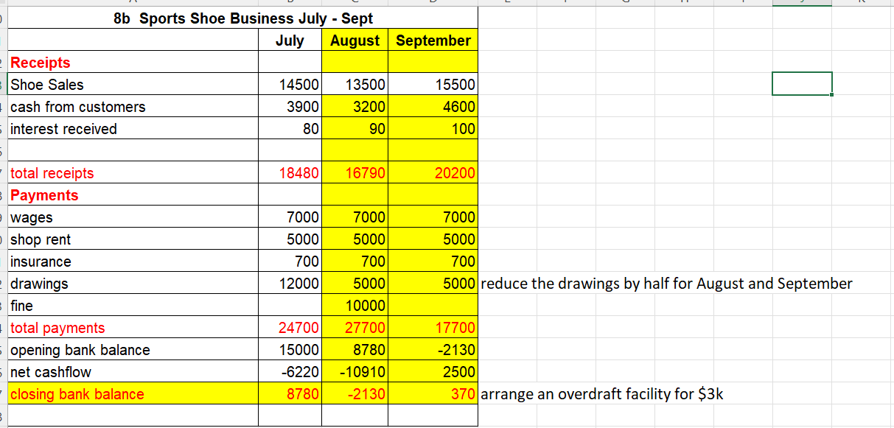

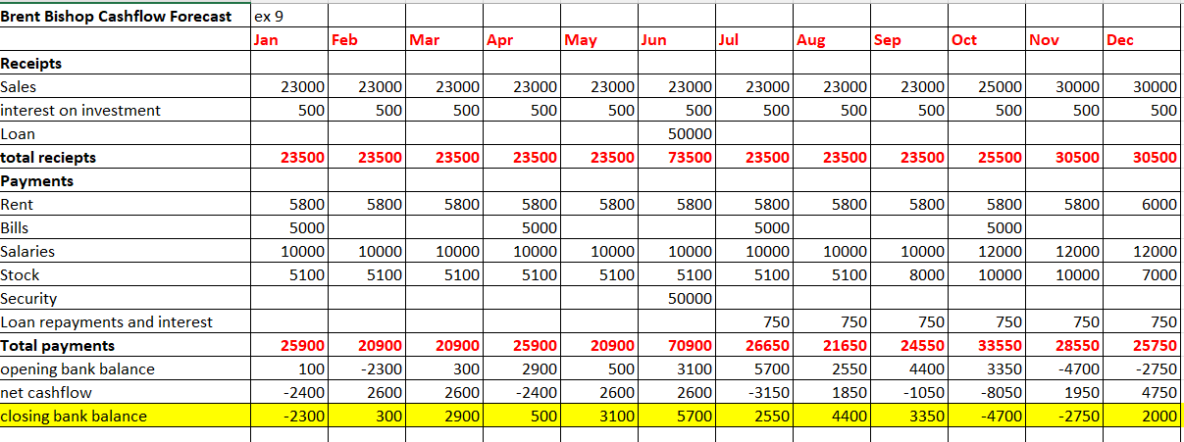

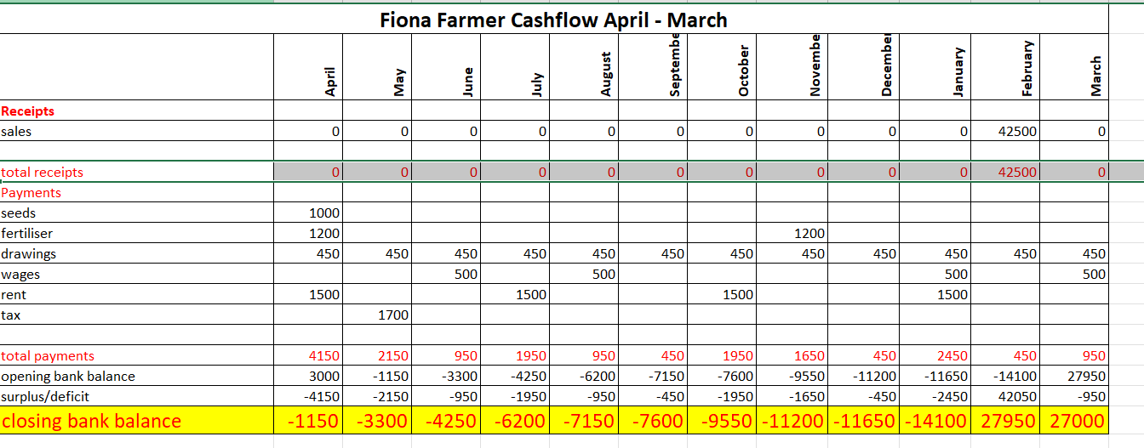

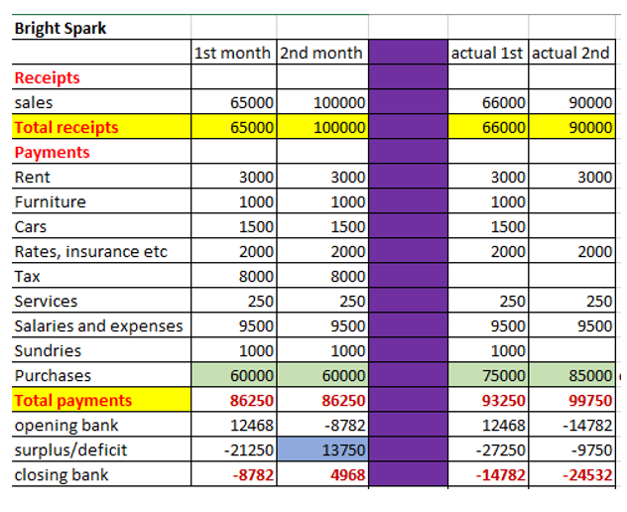
Activity 12 Cash Flow True/False
F | Cash is not as important as profit
T | Net cash flow equals receipts minus payments
F | To improve cash flow, businesses should aim to reduce cash inflows
T | Cash flow is the movement of cash into and out of a business
T | The closing balance can be calculated by combining the net cash flow with the opening balance
F | During a recession it is usually easy to borrow money
T | To improve cash flow businesses could negotiate longer payment terms with their suppliers
T | Receipts are inflows of cash from things like sales of goods and interest on investments
F | Poor cash flow is rarely a reason why businesses fail

Actual cashflow is not looking very good
No tax paid
Some expenses: Furniture, Cars, Sundries also not paid
When tax and expenses paid will make a deficit nearly $40,000
Sales not meeting budget
Expenses well over budget
Recommendations:
Increase the $10000 overdraft
negotiate better price, find cheaper supplier, etc
Sack Suzanne
Arrange a long term loan

.
What do we mean by The Primary Sector?

Extraction and production of raw materials e.g. farming, fishing, forestry

What is a forecast?

Predict or estimate future events or financial trends

What forecasts would a farmer need, and why would they need them.

Weather, market, crop yield, pest and disease, financial forecast

What information would they need for a Cash Flow Forecast?

Helps manage their finances effectively – predicting cashflow payments and bank balances. Allows them to make strategic decisions about investments, loans and budget allocation
List some Cash Receipts for:

A dairy farm milk sale, calf sales, cream sales, livestock sales
A beef farm – cattle sales, calves’ sale, manure or hay sales
An orchard – sale of fruit, juice, jam, trees and pick your own
A salmon farm salmon sales, fish, fillets, baby salmon (smalt), roe sales, smoked salmon, jerky, pate

List several different items of expenditure for:
A dairy farm utility, equipment, loan repayments, feed, forage, vet care, labour tax
A beef farm breeding, fuel, insurance, and all of the above
An orchard spray, trees, irrigation, maintenance, packing, tax
A salmon farm fish feeding, insurance. Labour, infrastructure, environmental monitoring

What might cause farming cash inflows to fluctuate
Weather, market price, yield, government policy, exchange rate, consumer demand
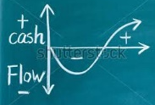
What might cause farming cash outflows to change?
Input costs, repairs. Seasons, labour, environmental, technology, repairs, capital, tax, interest rate, fuel prices
What are some external factors that may affect the business?

Weather, floods, storms, climate, earthquakes, labour force, market demand and prices, govt policy, technological advancement
If a farmer wanted to buy a new tractor costing $150,000, how would they know when in the year would be the best time to buy it?

Availability of tractor, when sales were on, after the farmer has sold their product so they can see whether they can afford it, after a tax refund. Budget planning, seasonal workload

Ex 13
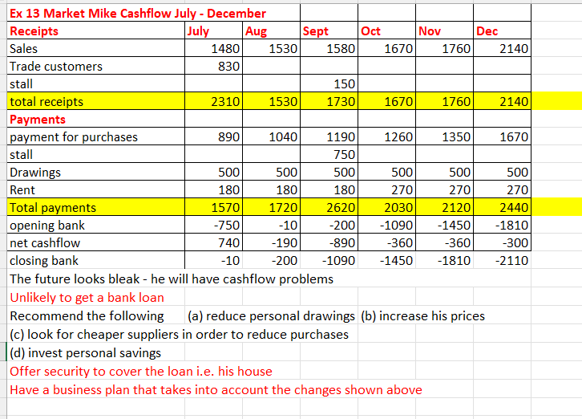

Ex 14
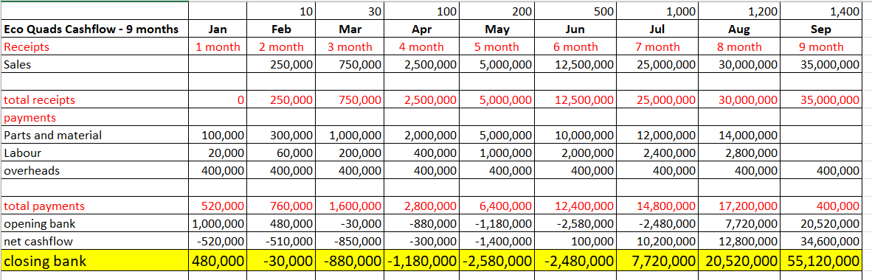
Example – Cash from Customers April - June
Janie’s Landscaping Business completes most of its work on credit. The firm finds that, on average, 60% of its sales are cash and 40% are paid in the month following.
The amounts paid in the following month are called Cash from Customers
Month | Total Sales | Cash 60% | Credit 40% | April | May | June
March | 44,000 | 26,400 | 17,600 | 17,600
April | 38,000 | 22,800 | 15,200 |  | 15,200
May | 36,000 | 21,600 | 14,400 |  |  | 14,400
June | 32,000 | 19,200
Total | 150,000
Fill in the figures below April – June
Receipts | April | May | June
Cash sales | 22800 | 21600 | 19200
Cash from Customers | 17600 | 15200 | 14400

Ex 15 MAS
Income | Forecast | Actual | Actual | New Ideas
payout for MS | 521856 | 404438 | 404438 | 404438
Grain Sales | 160000 | 160000 | 160000 | 160000
Total Receipts | 681856 | 564438 | 564438 | 564438
less payments
Labour
Wages | 360000 | 360000 | 288000
ACC payments | 3000 | 3000 | 2400
Working expenses
animal health | 29000 | 34000 | 39000 | 5000
breeding | 16500 | 16500 | 16500
dairy shed | 7700 | 7700 | 7700
electricity | 16300 | 16300 | 16300
feed bailage | 24000 | 30000 | 30000 | 6000
feed grazing | 30000 | 30000 | 30000
feed other | 25000 | 25000 | 25000
fertiliser | 50000 | 50000 | 50000
regrassing | 7000 | 7000 | 7000
weed control | 3000 | 3000 | 3000
fuel | 15000 | 15000 | 15000
vehicle costs | 10000 | 10000 | 10000
repairs and maintenance | 35000 | 35000 | 35000
Other expenses
communication | 3000 | 3000 | 3000
accounting fees | 6000 | 6000 | 6000
legal fees | 3000 | 3000 | 3000
administration | 4000 | 4000 | 4000
rates | 16000 | 16000 | 16000
insurance | 10000 | 10000 | 10000
ACC Employer | 4000 | 4000 | 4000
Drawings | 60000 | 60000 | 30000
Other | 7000 | 7000 | 7000
Total Payments | 744500 | 755500 | 657900
opening bank balance | 11904 | 11904 | 11904
surplus/deficit | -62644 | -191062 | -93462
closing bank balance | -50740 | -179158 | -81558
 |  | -128418 | 97600

Ex 16
Drenched
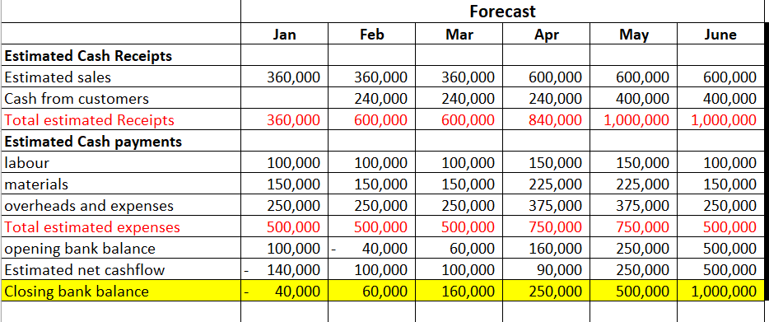
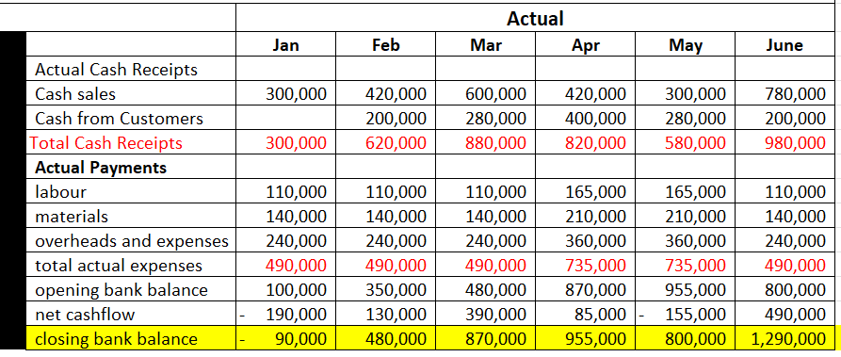

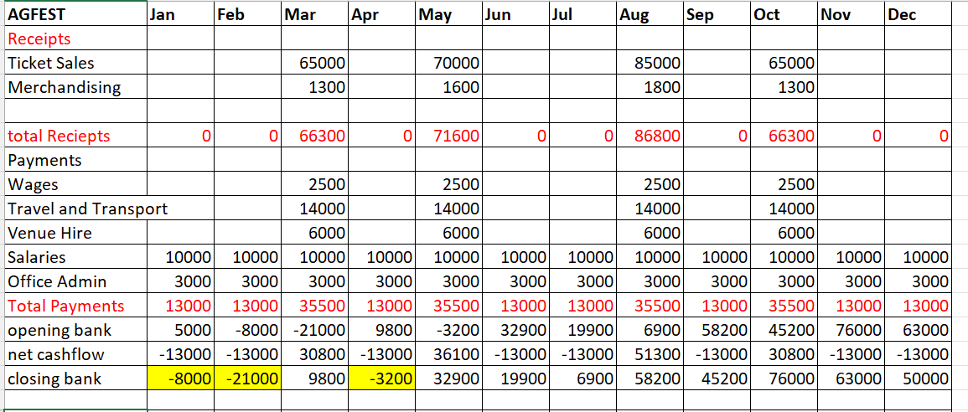

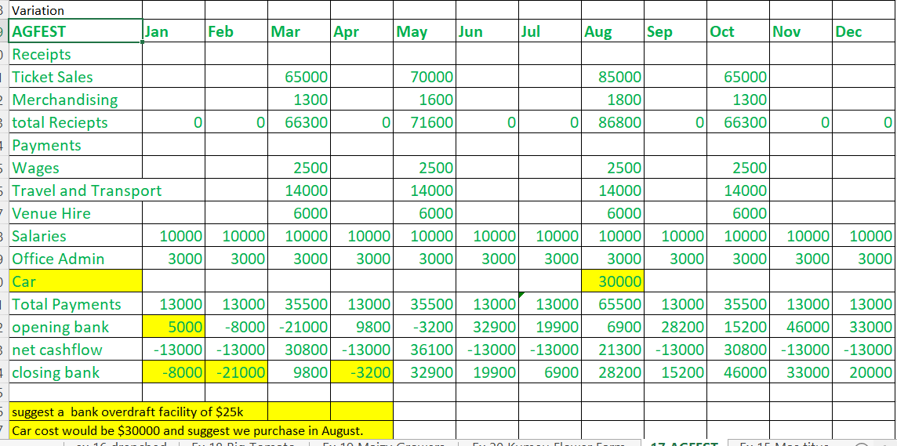

Ex 18

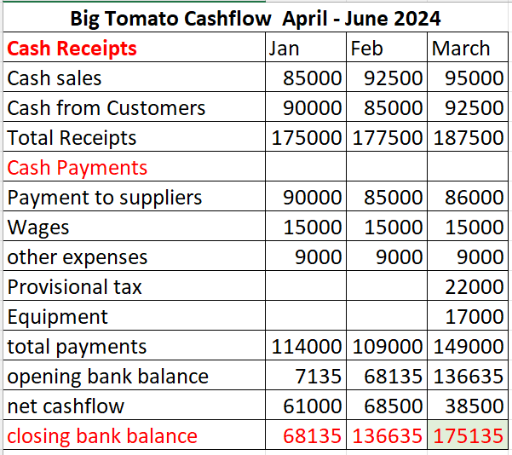
Ex 19
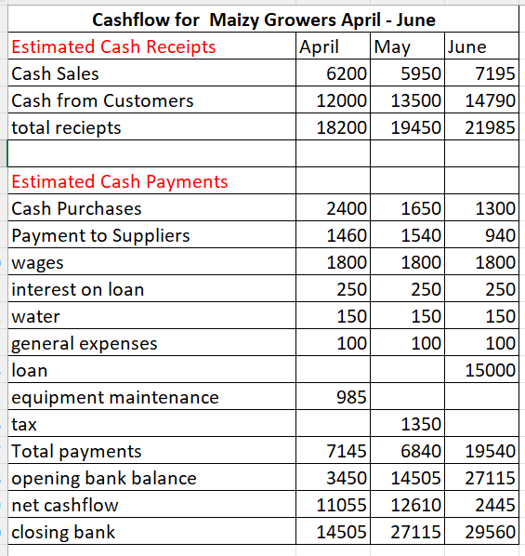

Ex 20

